When we first became interested in Highland cattle, I was personally intrigued by the fact that the breed standard included horns; show cattle were required to have horns; horns were an accepted part of the anatomy. This sounded, at the time, extremely appealing. During my training and earliest years following my veterinary education, I had performed dehorning on a number of animals; some young dairy heifers, up to 3 year old steers, and numerous baby goats. If there was anything more distasteful than the bloody mess involved in cutting horns off, it was the smell of burning flesh when using a hot cautery iron. So, with great interest and relief, we got our first Highland heifers with horns, and I didn’t have to do a thing with those horns, and all was right with the world.
Enter 2011, when a request is made that I write an article on dehorning for our Highland Cattle Association quarterly publication. I had to swallow hard; think back to when we first started looking at Highland cattle, reflect on the current need for the information, and found myself agreeing to the task.
That request was made, by the way, with only the most honorable of intentions. There are no plans in the works to allow the showing of dehorned breeding stock, or any other such thing. This is just a pragmatic approach for those breeders who are supplying a beef trade and are having difficulty locating a slaughter facility that will accept horned cattle. Industry standard facilities are not built for our breed, but for the commercial cattle trade that allows massive numbers of animals to be processed in a singular hour, let alone a day. Horns are not present on “commercial” cattle, either because those cattle are naturally polled, or those animals have been dehorned at some time in their life. Horns make the line go a lot slower, and in certain instances, will prohibit an individual animal from being able to enter a kill chute. There are facilities that will not slaughter horned animals.
More and more serious Highland breeders are finding lucrative outlets for their beef products, and are finding that they need to acquiesce to the requirements of the abattoir . Should the facility require hornless animals, there are reasonable methods available to meet that requirement. It is however, the owner’s responsibility to ensure humane treatment and safe completion of the dehorning procedure once started.
Disbudding (removing the horn producing area on the head before a horn is even present) at a very young age is the easiest and without doubt the least stressful to the animal. This can be accomplished either by burning the bud off with a hot iron, or chemically destroying the bud with a caustic paste. At older ages and larger sizes, cutting the horns off becomes necessary. This can be done using a variety of specialized veterinary instruments, designed to facilitate the job, or using instruments you may well have hanging around the house or barn. Cattle can be successfully dehorned at any age, but the smaller and younger the animal, the easier the procedure will be, both on the operator and the animal. If newborn calves are restrained for injections, tattooing and tagging, then they certainly can be dehorned at the same time.
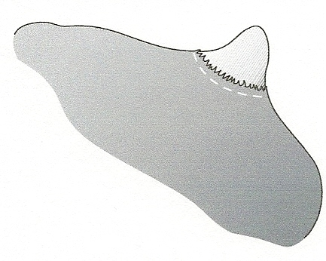
location for proper dehorning or disbudding
It can be argued that disbudding using either paste or a hot iron is so quick that sedation and painkillers are unnecessary. There is, however, no doubt that dehorning an animal using any of the cutting methods, is an extremely painful operation and some form of anesthesia is necessary, as well as extremely good restraint, either physical or chemical. I personally would not perform either disbudding or dehorning without local anesthesia. Lidocaine is a potent local anesthetic and the innervation to the horn comes almost exclusively from the cornual nerve branch, a nerve that can easily palpated and numbed. Your veterinarian may be willing to write you a prescription for a bottle of lidocaine and show you how to inject the cornual nerve. A good nerve block will numb the area for about an hour or more. Larger horns will require a ring block around the base of the horn as well, and your veterinarian can show you how to do this too. Sedation is easily accomplished using a potent drug like Rompun (xylazine), however, most veterinarians would not be comfortable writing a prescription for a medication with a high risk of complications when not closely monitored by trained personnel. If the animal is so large that use of a tranquilizer or sedative is needed for restraint, your veterinarian should be performing the procedure. Even though you can get away without sedation or local anesthesia, ask yourself what your customers would think if they had a chance to view a disbudding or a dehorning. If you think they might be offended, you should find a different way to accomplish what you need.
Pain relief for dehorning can include:
- the use of a short acting local anesthetic (lidocaine) which provides for 60-180 minutes of numbing to the area.
- a sedative such as xylazine (Rompun) given in conjunction with a local anesthetic. This provides analgesia for a few hours. This may reduce or eliminate the need for physical restraint
- a combination of local anesthetic, a sedative and a non-steroidal anti-inflammatory drug such as flunixin (Banamine) provides pain control for a longer duration. Other countries have approved the use of Ketoprofen in cattle, which is a very effective analgesic, but it is not presently approved for use in cattle in the US.

Using local anesthesia is a technique that is relatively simple to perform. The cornual nerve supplies sensation to the horn in the bovine. This nerve travels from immediately behind the eye to the base of the horn. It travels underneath a small, overhanging ridge of bone that is a part of the skull. This ridge of bone can be felt easily with slight finger pressure. A vein and artery travel with the nerve. Many veterinarians will train their clients in this technique, and supply them with the local anesthetic used as well. The nerve must be blocked on both sides of the head. To perform the actual block,
- Restrain the calf with either a halter tied to some stationary and stout object, the head gate of a chute or a specialty head restraint halter bolted to a fence.
- If sedation is available, use it
- Locate the injection site of the cornual nerve on each side of the face; you will feel a soft depression is you put your thumb on the skin just beside the outer corner of the eye; moving your thumb up towards the horn and you will feel a small groove that runs in the bone of the skull. The nerve runs right along and under this groove. Inject this groove about 2/3 of the way up to the horn.
- Disinfect the site with alcohol is desired.
- Use a 20 or 18 gauge 1-1.5 inch needle (bigger needle for bigger animal)
- Use a 6-12 cc syringe (bigger syringe, bigger animal)
- Inject between 3 and 10 cc of 2% lidocaine with epinephrine on each side of the face. (larger volume, bigger animal)
- Hold the head steady, and with the needle on the syringe, push the needle through the skin at the proper injection site. The needle should enter the skin at a 90 degree angle to the skull. Once through the skin, aspirate (pull back on the plunger) to make sure that no blood appears in your needle hub. If no blood is seen, inject about 1.5 cc of the lidocaine/epinephrine solution. Insert the needle another ¼ inch and inject another 1.5 cc. Push it yet another ¼ inch and inject the remaining lidocaine. If you hit the bone, withdraw the needle just slightly before injecting the remaining solution. Wait several minutes for the lidocaine to have its effect. If dehorning more than one calf, inject them all with the local, and then return and dehorn them in the order they were injected. Test to make sure your nerve block is effective by using a needle to prick the skin around the base of the horn. There should be no sensation felt by the calf. Also, the corner of the upper eyelid will usually droop slightly with a proper block 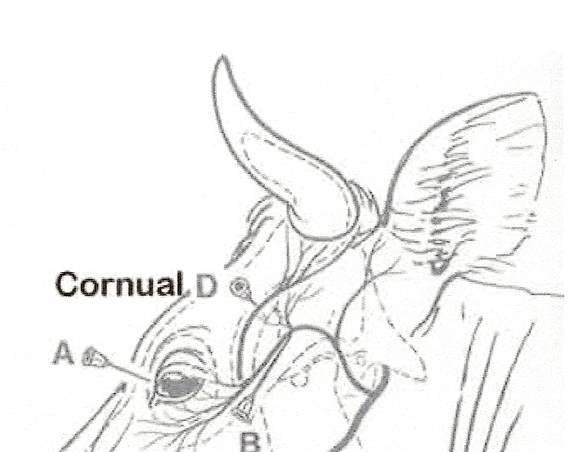
Nerve blocks of the head, with Cornual emphasized
With any surgery, timing is critical. Every method described in the following will leave a wound that will attract flies if they are present. Either the procedure should be done at a time of year without flies, or insecticides must be used to prevent the formation of maggots. There is also a risk of tetanus, particularly in techniques that are slow to heal, such as rubber banding. Instrument dehorning may expose the sinus cavity, particularly in large horns, which will delay healing and could lead to infection.
Calves should be dehorned when they are less than 2 months old. If done at an older age, they may require up to 2 weeks to regain the weight lost immediately following dehorning. Ideally, they should be less than 4 weeks of age to avoid set back and complications.
Proper restraint is necessary to insure the safety of both the calf and the operator. Calves less than 1 month old can be relatively easy to restrain simply by holding them down on their side. This will usually require an extra person and the ability to tie down a young calf. There are head restraints that are designed just for disbudding restraint in the young calf. A chain secures a metal cage around the calf’s head, and the apparatus is then clamped to a wall or sturdy fence. This will permit small calves to stand while being dehorned. 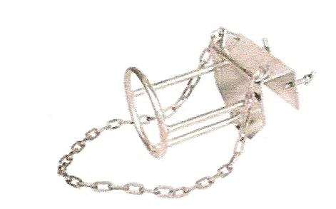Slightly larger and older calves will require either sedation or a squeeze chute and headgate for proper restraint. Many headgates come with a head and nose bar to restrict head movement. Electronic immobilization such as the RAU Animal Immobilizer or the one from Tephca may also be used for restraint, but remember that any form of restraint other than general anesthesia does not provide for pain relief and is not adequate alone for dehorning.
The horn grows from the skin at the base of the horn, much like a fingernail. To properly dehorn an animal, approximately ¼- ½ inch wide ring of skin removed at the base of the horn to prevent regrowth and scurs. All equipment should be sharp and clean, and disinfected before and between each animal. Chlorhexidine and povidine iodine are common disinfectants that can be used, but should be diluted to label directions in order to assure proper disinfection.
Chemical dehorning or disbudding, works well in the very young calf. A caustic chemical (usually sodium or potassium hydroxide, the active ingredients used to dissolve clogs in drains, also known as lye) is applied to the horn bud, and when done properly, will result in the complete destruction of the horn producing cells.
- It is best done before 3 weeks of age, and is very important to follow package directions carefully.
- The manufacturer recommends that the hair should be clipped or shaved around the horn bud to make a 1 inch diameter bald circle.
- Petroleum jelly such as Vaseline is applied all around the outer edge of the hairless area to prevent damage to more skin than necessary.
- The caustic material used is made especially for dehorning and comes as either a paste or a stick. It is carefully painted inside the circle of petroleum jelly, avoiding contact with anything other than the intended target.
- Some operators push the hair back out of the way and when finished applying the caustic replace the hair back over the horn bud. The hair will help keep the caustic in place and protect the dam’s udder from the caustic as well.
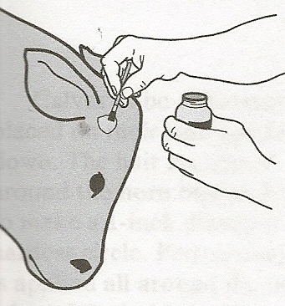
- Rubber gloves should be worn by the operator.
- The calf needs to be separated from its mother and other calves that might lick it until the paste is dry. (plan on 6 hours) The paste will become dry and hard. If not separated the paste may cause a burn on the mothers flank or udder.
- It is also recommended to keep the calf out of the rain for 2 days, to make sure that some of the caustic does not run down its face.
- Additional protection for the calf’s face and dam’s udder is to place a piece of duct tape over each horn bud, making sure the tape is attached to dry hair and not any Vaseline.
- This technique has the advantage of being bloodless, but is just a painful as other techniques.
Young calves can be successfully dehorned using a hot iron specifically made to dehorn calves; heated either by household current, batteries, wood fire or propane. The head of the iron is a hollow circle that will fit over the horn bud or the small horn.
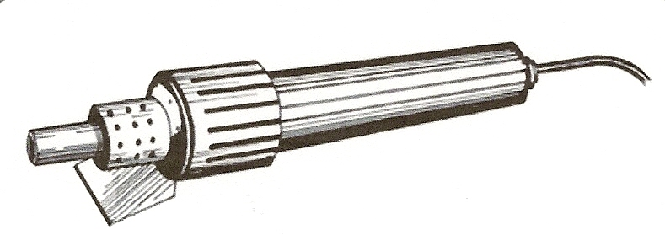
- This method works very well for calves less than 3 months of age, when the horn is less than 1 inch long.
- It is recommended that the hair be clipped around the horn where it meets the head. This prevents excess burning hair and makes the proper location and results of the dehorning easier to see.
- The dehorner is heated to the proper temperature until the iron is red .
- The calf must be adequately restrained.
- The hot iron is placed over the horn and held in place with firm pressure until the hair begins to smoke. At this point, the dehorner should be slowly rotated by twisting the wrist.
- Continue the application for about 10-15 seconds.
- The iron is then removed and the skin examined for the a copper colored ring around the horn where it was burned and a white ring of skin inside the burn mark next to the horn.
- If the burned ring does not appear to be copper colored, reapply the iron for an additional 10 seconds and check the color again.
- It is important to make sure that the iron is the correct size for calves; the iron should be able to completely encircle the horn, with a small ( ¼ inch) band of skin between the area to be burned and the horn.
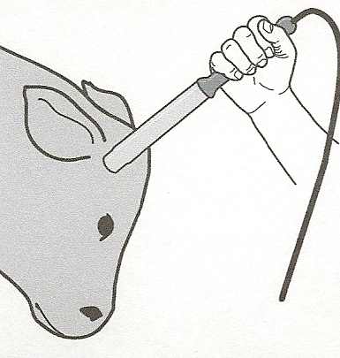
- Protect the ear from burns when performing this method.
- The horn bud or horn will slough off in about 4-6 weeks.
- This technique is bloodless as well, and can be used any time of the year.
Tube or Spoon dehorners do an excellent job of dehorning young calves less than 3 months of age. This is a bloody technique compared to paste or burning, but very effective.
- The Tube dehorner comes in several sizes and the proper size must be selected for the individual calf. The round end of the dehorner should be 1/8 -¼ inch larger than the base of the horn.
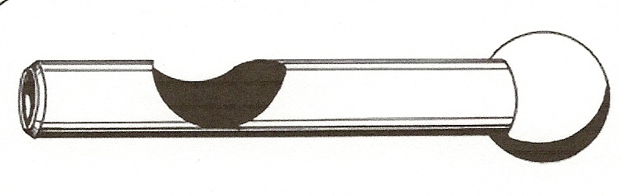
- Sedation and/or anesthesia is administered.
- The round cutting edge of the dehorner is placed straight down over the horn.
- Pressure is placed on the tube; push and twist the tube until the skin has been cut completely through in a circle around the base of the horn.
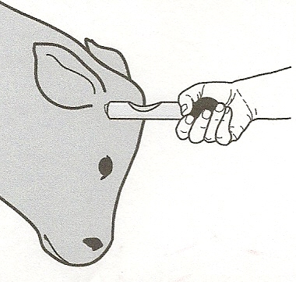
- The horn is then removed by leaning the dehorner on its side, and pushing the blade under the horn at the location of the previous cut, to remove the horn.
- This is a bloody technique and should be avoided during fly season.
- Clean and disinfect the dehorner between animals.
Barnes dehorners(also called scoop or gouge dehorners) work well on young cattle between about 2 -12 months of age. Again, these dehorners come in a variety of sizes, so the size must be appropriate for the size of the horn. The closed Barnes dehorners form an elliptical shape so that the widest part of the dehorner is aligned with the widest part of the horn. Again, ¼ to ½ inch circle of skin must be included in the cut when it is made to ensure removal of the horn producing skin cells. Adjusting the amount of opening of the Barnes dehorner jaws can also reduce the size of the initial bite should that be necessary.
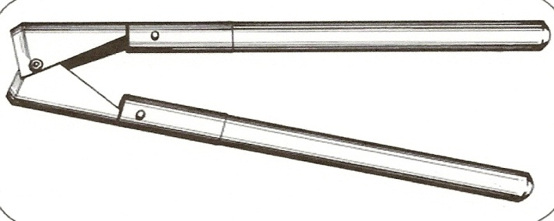
- Sedation and/or anesthesia is administered.
- The closed instrument is place over the properly restrained calf’s head; the jaws are aligned and adjusted as needed to remove a ring of skin surrounding the horn base.
- Press the dehorner gently against the skull.
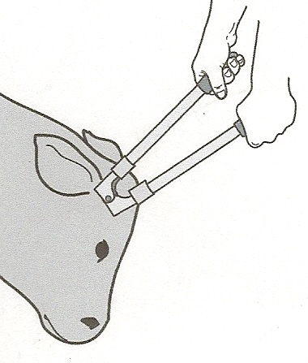
- The handles are quickly spread apart. A twisting motion as the handles are almost completely opened will ensure than the skin is cut through.
- Control bleeding by pulling the arteries with forceps, needle holders, or use a hot iron to cauterize the blood vessels.
- Clean and disinfect the dehorner between animals.
- This is a bloody procedure and should be avoided during fly season.
- This will open the sinuses on a larger calf.
Some improvisation in terms of equipment is possible for certain cases. I have been told that a good sharp pair of hoof trimmers, used to cut the horn off, can be very effective if cleanly done. Again, attention must be paid to removing a circle of skin at the base of the horn. Bleeding must be controlled as in other cutting methods.
Older cattle with larger horns can be dehorned using a handsaw, a Keystone dehorner 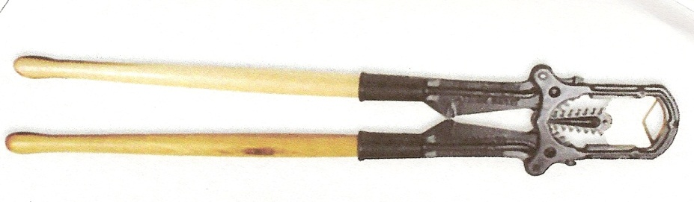
an electric dehorning saw or obstetrical wire (wire saw).

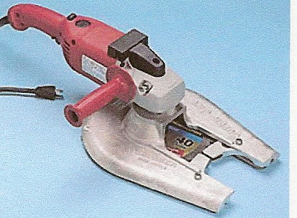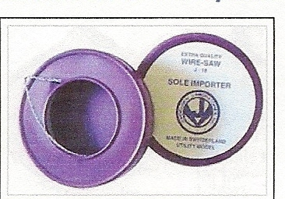
It is imperative that ½ inch of skin be removed along with the horn, to prevent regrowth. Keystone dehorners are specialized instruments that can cut through a very large horn, but it is possible to end up with shards and fragments left behind (more to do with the size and hardness of the horn than the type of dehorner.)The Keystone dehorner is also a large instrument that requires strength just ot hold in place. Closing the handles over a large horn requires more strength than many individuals have. Wire saw would probably be my first choice on a larger animal. Handles designed for use with the wire are much easier to use than hanging on to the wire with a couple of pairs of pliers. It is advisable to make a cut with a sharp blade or scalpel around the base of the horn where you want to start the wire cutting. Then you pull on the wire back and forth until you have sawn through the entire horn. Your angle must remain correct to make sure the ¼ - ½ inch of necessary skin is removed as well.
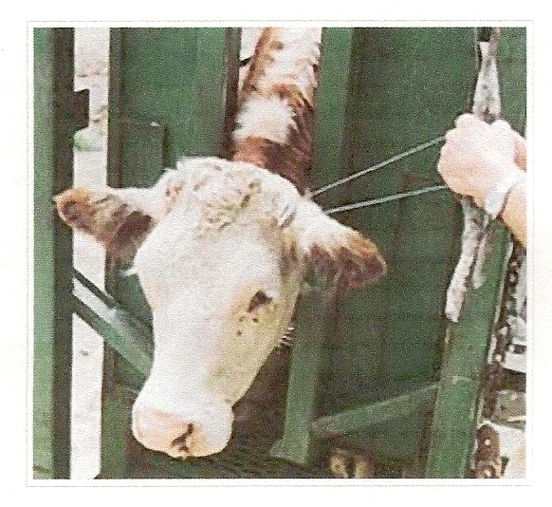
use of wire saw
Any of the cutting methods of dehorning result in a large wound that must heal closed. Obviously, the older the cattle and the larger the horn, the larger this wound will be. Bleeding will also be directly proportional to the size of the horn. With smaller horns, a little blood coagulation powder may be all that is necessary to control hemorrhage. On larger animals, and in any animal where the arteries are distinctly visible, the arteries can be pulled so that they snap off and the end remaining with the animal retract back into the head where pressure then stops the major bleeding. Artery clamps or needle holders can be purchased from livestock supply houses or your veterinarian. If you purchase these from your veterinarian, request needle holders, rather than hemostats. Needle holders and effective artery clamps will have smooth edges which will hold the artery while it is being pulled. Hemostats will effectively clamp the artery closed, but their serrated jaws will rip the artery walls so that it can’t be pulled out effectively. The pulsing cornual artery is found at the lower front part of the wound. It is grasped with the tip of the clamp, and then slowly pulled out of the skull. It can also be twisted around the forceps much like a piece of spaghetti until it breaks. If the artery is not visible, just blood coming from the center of the ring of horny tissue, you have not taken the horn off deep enough and you need to remove more of it down to a deeper level. After bleeding has slowed or stopped, the wound is dusted with blood coagulation powder and fly spray. Close observation is necessary for at least 10 days; until the wound is closed; continued fly control is necessary until there is no risk of fly infestation. It is possible to open the sinuses when dehorning; this usually occurs if the cattle are over 2 months of age. . This is not generally a major problem,; although the first time you see it you may think you have gone completely through the skull into the cranial vault. Exposing the sinus cavity does certainly slow the healing and with large exposures it may be weeks before the wound is healed over. It is also possible to get foreign debri into the sinus cavity and it this appears to be a possibility (bedding on shavings or sand; overhead hay feeders) the wound should be bandaged.
There are times when you just want to remove the ends of the horns. Many times if just the tips are removed, there will be no bleeding at all. However, if you are cutting off most of the horn, you will have considerable hemorrhage, but the arteries are encased in the boney horn and you cannot pull them. There are two methods to control hemorrhage in these cases. One is to put round toothpicks into the holes from which the bleeding occurs. The second is to “cord” the horns. I have never actually seen this done, but it makes sense that it would work. A baling twine is tied very tightly around the poll, just under the horn . Then another twine is taken over the top of the head to pull up on the first twine both front and back. This effectively tightens the first twine very tight. The twine is then removed 2-3 days later, when bleeding won’t start up and healing has begun. I have also heard that a baling twine run in a figure eight around the horns will also effectively control hemorrhage. You would have to make sure that there is enough of a ledge of tissue for the twine to catch. If removing virtually all the horn, it has been said that it is easier to cord the horns after removal because the twine may be damaged if in place before dehorning. There is no other reason for cording afterwards and it could be done prior to horn removal, as long as you don’t disrupt the twine during the dehorning process.
Lastly, an elastrator has been successfully used to dehorn cattle.
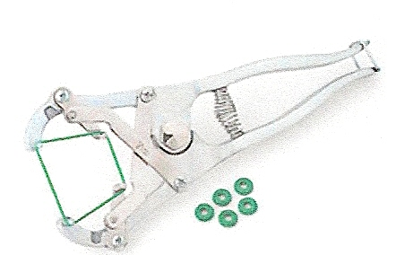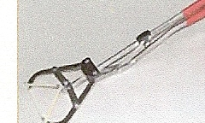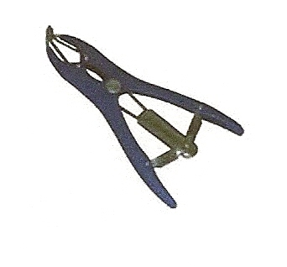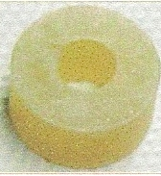
I have never used this technique, but I have seen cattle that have been successfully dehorned with this method. An elastrator band is stretched over the horn and down onto the skin at the very base of the horn. Securing the band so that it stays in place seems to be the most difficult hurdle when using this technique. A groove can be made in the base of the horn, but that will leave some of the germinal epithelium and horn regrowth will occur. I have been told that duct tape can be used above the bands to secure them to the head. The horn then will fall off after an extended period of time.
Alternately; a Callicrate bander can be used to dehorn large cattle.
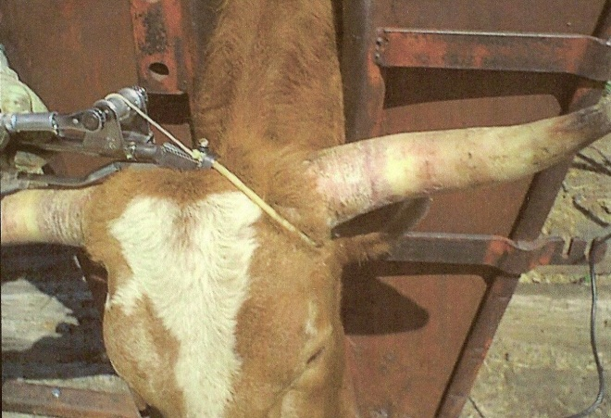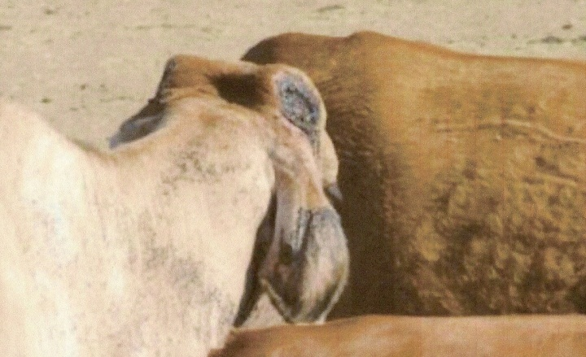
Callicrate bander large defect after a band dehorning

I have sung the praises of the Callicrate bander when used for castration of larger calves, yearlings and even older bulls. The company’s website (www.nobull.net) devotes a page to the description of using their high tension bander for dehorning large horns, with a detailed slide show as well. The horns will fall off in 20-30 days if small to medium in size, but larger horns may take up to 50 days or so to fall off. By the time the horn actually falls off, healing has begun at the base of the horn and usually there will be a healthy layer of granulation tissue covering the wounds, with no opening into the sinuses. Remember though, that even though your goal of dehorning the animal is accomplished when the horns fall off, there is still a large wound that must slowly fill in and heal over with scar tissue. This method involves a protracted healing period. Anytime you are using a high tension bander or elastrator, you do run a higher risk of tetanus. Animals should receive a tetanus toxoid with a booster at the appropriate interval according to the manufacturer’s recommendations. If no tetanus toxoid has been give previous to the actual date of dehorning, it is advisable to give tetanus antitoxin (preformed antibodies against tetanus) as well as the toxoid.
Dehorning cattle is distasteful to many individuals, and there is no doubt that it is an unpleasant procedure for the operator and the animal. It is also true that all methods of dehorning or disbudding cause pain and side effects. Every effort should be made to provide pain relief for the procedure. With thoughtful planning and care, Highland cattle can be humanely and safely dehorned.

Thanks to the folks at Nobull.net for permission to use their photos of the Callicrate Bander in use for dehorning.

