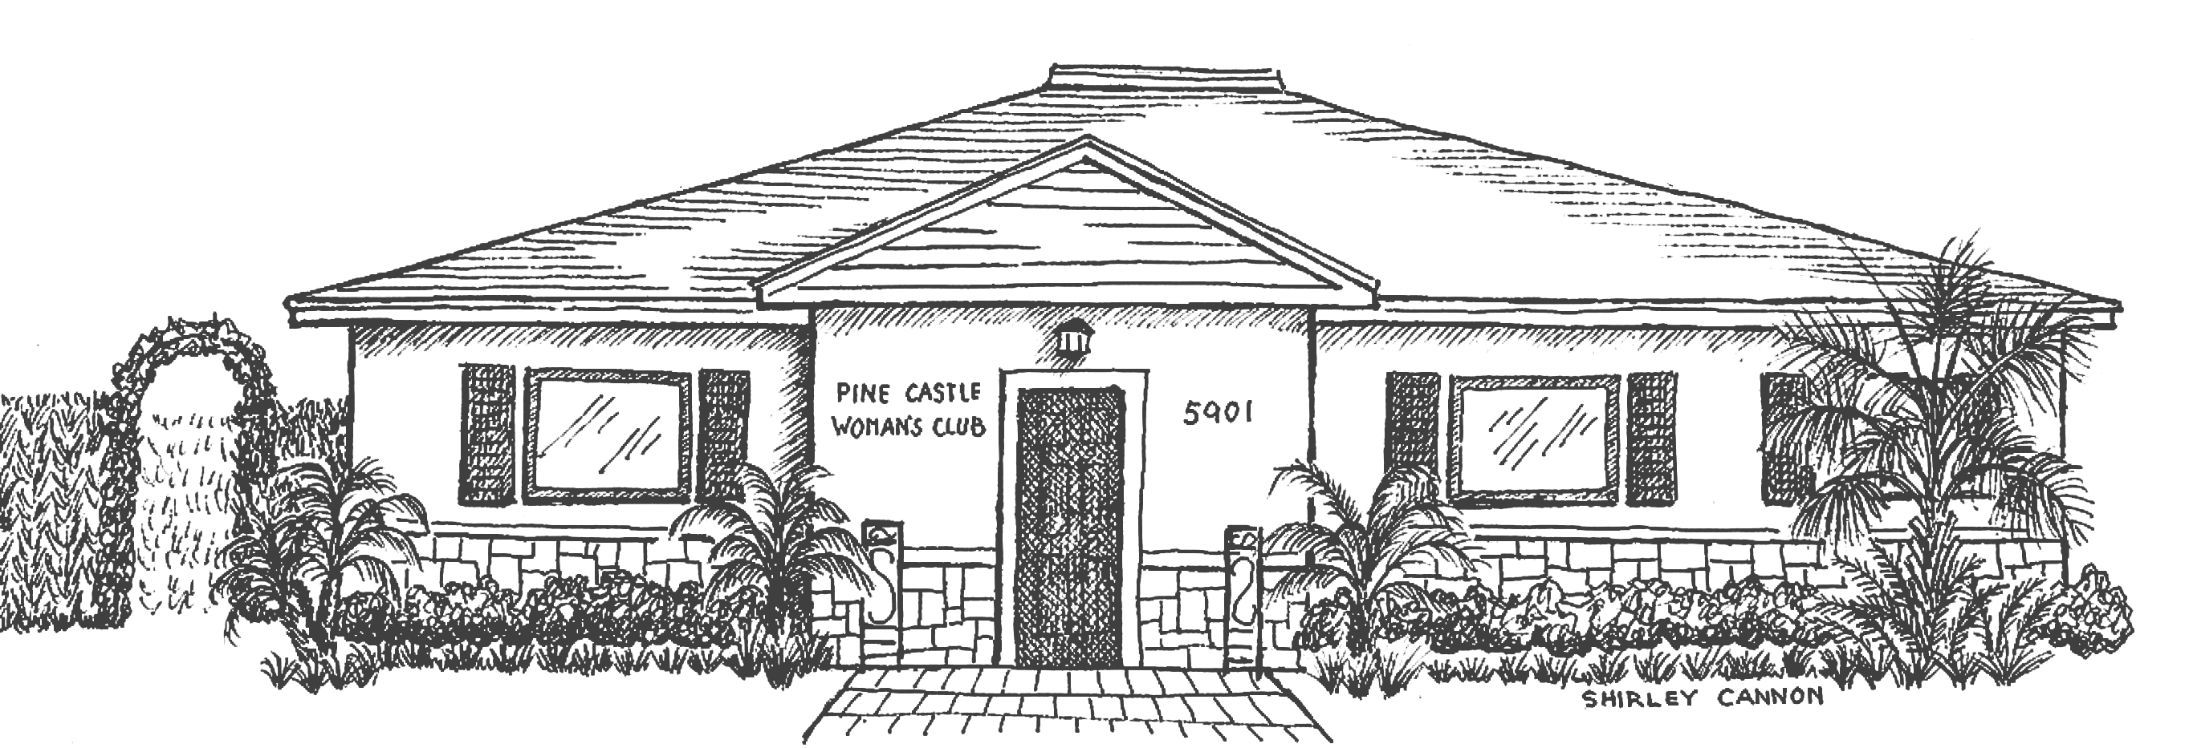
T1he Pine Castle Woman’s Club
5901 S. Orange Avenue, Orlando FL 32809
www.pinecastlewomansclub.com • pcwc1940@gmail.com
407-494-9118

Pine Castle Woman’s Club
Rental Check Off Sheet

_____ Remove all decorations
_____ Turn off all inside lights
_____ Turn off A/C in kitchen if used
_____ Leave main A/C set at 79º
_____ Empty all trash cans (including bathrooms)
_____ Sweep all floors
_____ Wipe up any spills on the floors
_____ Wipe down all counters (if used)
_____ Wipe down microwave (if used)
_____ Take all leftover food out of kitchen
_____ Wipe up any spills on front of kitchen cabinets
_____ Wipe off all tables before putting them away
_____ Return chairs to original location
_____ Check chairs for spills and wipe down as needed
_____ Pick up any trash/food from patio area and area around
building (including parking lot) if applicable
_____ Lock all doors (south side kitchen door, north side patio doors
and front door)

