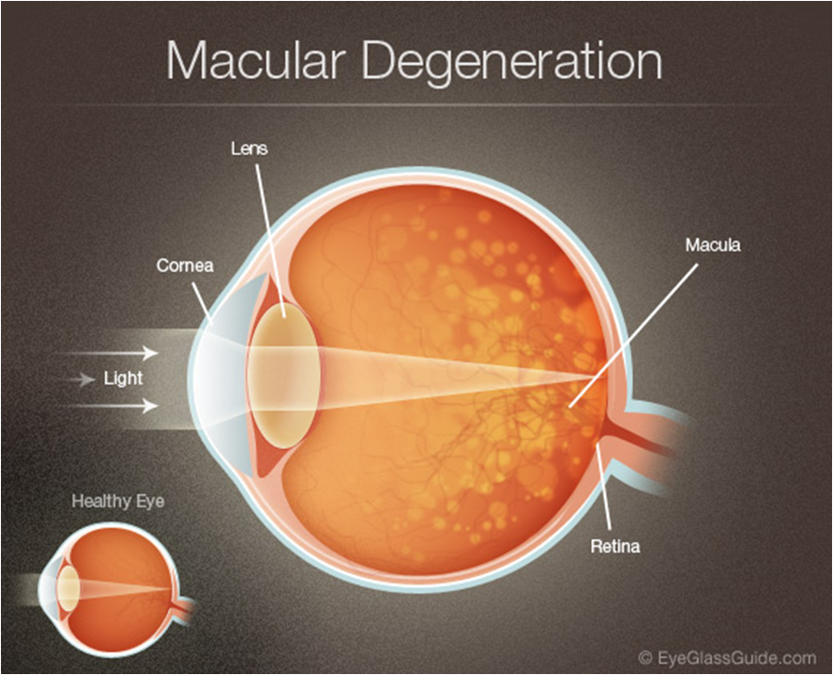
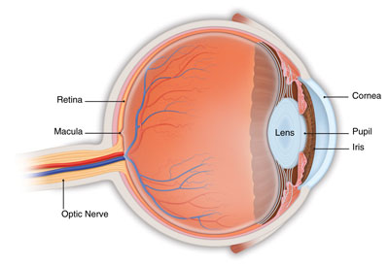

MACULAR DEGENERATION

Behind the eye lens is a jellylike substance called the vitreous body which is 99 percent water. At the back of the eye, there is a thin layer of light-sensitive nerve cells and fibres called the retina. We see things because light entering the eye strikes the retina and is turned into an electric impulse that the brain understands as an image. Near the centre of the retina, directly lined up with the pupil in front of the eye, is a tiny pit. This area and the area surrounding it, is called the macular area. It is about the size of a pea. It processes the details in the central part of the picture image that is sent to the brain. The macula needs good light to work efficiently and works best in daylight. The rest of the retina is responsible for side, or peripheral vision.

If the macula deteriorates, the retina becomes like a camera with a spot on the film. The center of the field of vision blurs, and all detail is lost. This condition is called macular degeneration. It occurs most commonly in people over 55 years of age.

Macular degeneration is the leading cause of blindness in North America, accounting for one-third of all cases of vision loss. Although macular degeneration is usually associated with aging, children, adolescent and adults under 55 may be affected.

Two Types of Macular Degeneration:
- Dry type (atrophic) – there is a gradual degeneration of the tissue cells that make up the macula and the loss of vision progresses slowly, usually developing over many months or years.
- Wet type (exudative) – this is much more serious because degeneration of the macula is accompanied by hemorrhaging or leaking of fluid from a network of tiny blood vessels under the retina. This results in scarring and loss of vision which can develop over a relatively short period.

Causes:
Macular degeneration is the result of free radical damage. Factors that predispose a person to developing macular degeneration include:
* nutritional deficiencies * chemicals & fumes from cleaners
* aging * atherosclerosis & arteriosclerosis
* high blood pressure * diabetes
* infections * environmental toxins
* excessive light * eye injuries leading to retinal detachment
Symptoms:
- Difficulty in seeing at a distance
- Difficulty in doing detailed work
- Blurred vision (distortion or curvy lines accompany or precede the blurred vision)
- Becomes harder to distinguish colour

Healthy Eye Lifestyle
- Get adequate rest
- Make sure that eyes are not strained by intense close reading or inadequate light
- Avoid bright lights
- Avoid cleaners that contain harmful chemicals, even the fumes from cleaners can damage fragile eye tissue. (Shaklee Cleaners are recommended)
- Avoid chlorine and bleaches. They are very destructive to eye tissue. Use only non-toxic germicides, disinfectants and laundry brighteners. (Shaklee Cleaners are recommended).
- Don’t smoke, and avoid cigarette smoke.

Healthy Eye Diet
- Choose foods from the “Healthy Body Diet”
- Daily intake should include plenty of FRESH fruits and vegetables, including carrots, yams & cantaloupe.
- Provide RAW nuts & seeds in your diet daily (example: 2 to 3 tablespoons of milled raw flaxseed or 3 1000 mg capsules of flaxseed oil capsules)
- 50% of your protein food should be raw. Soy protein is especially beneficial (Shaklee Soy Protein is recommended)
- Avoid alcohol, sugar, and white flour
- Avoid fats & oils that have been subject to heat and/or exposed to the air such as fried foods, hamburgers, luncheon meats, and roasted nuts. Vegetable oils should not be heated over 49°C during the refining process (the temperature will be stated on the label of good oils).

ESSENTIAL Supplements and Herbs:
- CarotoMax
  - Contains 5 mg lutein; 200 mcg zeaxanthin; 5 mg lycopene; 1.5 mg alpha carotene; 3 mg (5000 I.U.) beta carotene; 20 mg grapeseed extract; 20 mg quercetin; 30 mg sulforaphane IN EACH CAPSULE!!
  - Absolutely essential for healthy eyes
  - protects the eye from free radical damage
- Shaklee Vitalizer
- Raw Protein … protein is the building clock of the eye tissue. Raw, complete, soy protein powder is recommended
- Shaklee VIVIX

Other Nutrients of Benefit:
- Shaklee Mental Acuity … an herbal formula containing Ginkgo Biloba, Bilberry, Hawthorn, Gotu kola & Rosemary
    - Ginkgo Biloba – a powerful antioxidant herb with anti-aging properties, enhances circulation to the eye and lowers pressure in the eye
    - Bilberry-a strong antioxidant with anti-aging properties, helps maintain strong flexible capillary walls (strengthens collagen structures), may help halt or prevent macular degeneration
    - Hawthorn-increases circulation to eye, increases intracellular vitamin C levels, thus strengthening capillary walls
    - Gotu Kola-helpful for circulatory problems, strengthens connective tissue
    - rosemary-improves circulation to the brain & eyes, helps regulate blood pressure, helps prevent toxicity
- DTX … an herbal formula containing milk thistle seed extract, schizandra, reishi mushroom, turmeric, dandelion, artichoke – a powerful detoxifier which enhances the reduction of free radical damage
- Alfalfa
  - the leaves of alfalfa are the world’s richest known source of minerals
  - alkalizes and detoxifies the body
- Zinc - deficiency has been linked to retinal detachment & other eye disorders
