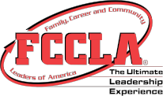
FCCLA Planning Process

IDENTIFY CONCERNS

SET A GOAL

FORM A PLAN (WHO, WHAT, WHEN, WHERE, HOW, COST, RESOURCES, AND EVALUATION)

ACT

FOLLOW UP

