Shaklee Background
From a small family business, Shaklee Corporation has grown to become the finest manufacturer of nutritional, household, and personal care products in the world.
- Shaklee was founded by Dr. Forrest C. Shaklee, the research scientist who created the first known multivitamin-mineral in the world in 1915.
- Shaklee became a corporation in 1956 and has led the Natural Health industry in nutritional research, technology, and product innovation since its founding on that date.
- Shaklee pioneered the environmental “GREEN” movement when it developed the first known non-toxic biodegradable cleaner in 1960.
- Shaklee became the first company in the world to obtain Climate Neutral certification and totally offset its carbon emissions resulting in a net-zero impact on the environment.
- Roger Barnett is the chairman and CEO of Shaklee Corporation. He is a visionary leader with many proven successes, a multi-billionaire, and is committed to the company’s future.
- Shaklee’s Global World Headquarters are in Pleasanton, California ... Canadian Head Office is in Burlington, Ontario. Shaklee is in eight countries around the world, and continuing to expand.
- Shaklee products have been used by 130+ medal winners in world class sport events.

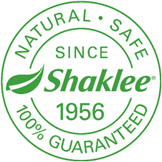
Shaklee Science
Millions of people worldwide are looking for natural, wholesome ways to optimize their health and well-being. They have come to rely on Shaklee products, because it is the #1 Natural Nutrition Company in America.
- Shaklee leads the world in natural health scientific research with over 75 full-time scientists.
- Shaklee has invested over $300 million in clinical testing, research and development.
- Shaklee tests their nutritional supplement raw materials for more than 350 contaminants, including 320 pesticides (while government standards require only 80).
- Shaklee conducts more than 100,000 tests a year to ensure the greatest purity and potency possible.
- Shaklee’s scientific standards are the toughest purity standards in the nutritional industry ... therefore, they guarantee that every Shaklee product is 100% SAFE.
- Shaklee provides the proof that their products work, with over 100 scientific
publications in peer-reviewed journals that confirm their efficacy.

Shaklee Opportunity
Shaklee offers a person-to-person, home-based entrepreneurial marketing plan that provides unlimited earning potential, and rewards you for helping others.
- Shaklee has paid out over $6 billion to people just like you
- A Shaklee business could mean:
√ being your own boss √ earning what you’re worth
√ working with a proven system √ a bonus car
√ annual expense-paid trips √ creating unlimited, on-going income
√ home business tax advantages √ ownership with minimal investment
√ work part-time or full-time √ work when, where, and with whom you choose

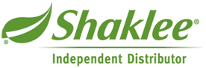
Let Shaklee Change YOUR Future!
Ivan & Martha Willmore ... 905-871-4281 ... hoop@interpc.ca ... www.imwillmore.myshaklee.com

