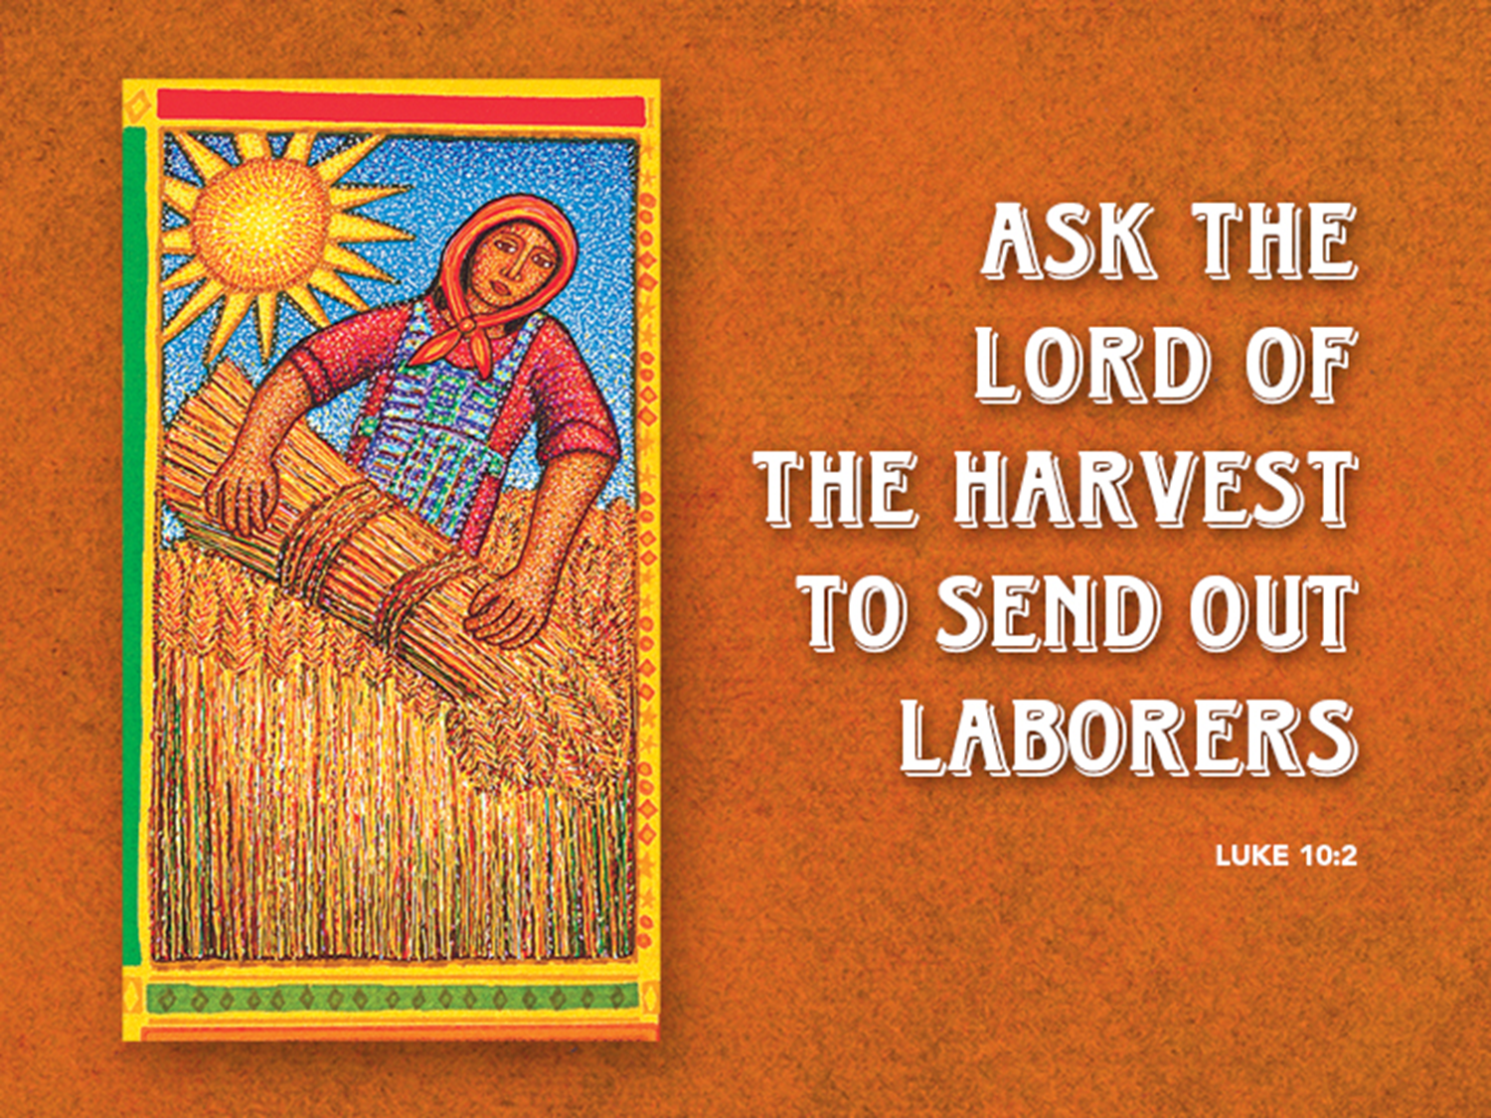

A Word from God
July 3rd, 2016
Luke 10:1-11, 16-20

As we prepare our hearts for God’s Word this morning, would you pray with me?... God of grace, we pray that you would guide us today as we consider your word. Open our hearts to understand. Show us what you mean for us to hear so that we can become more like you…
Wait a minute, wait a minute… Is that you God? Oh, well… no really it is great to hear your voice… O.K. go ahead. We’re listening. Oh, seriously, people would rather hear from you than me… Yes, I’m sure!
O.K. So…about this morning’s text, what you’re saying is that, just as those seventy were sent out as a sign that your ministry was for all people (is that what the number seventy symbolized? The 70 known nations at that time? O.K. great. Sorry…go ahead.) So just as those seventy were appointed to go out you are appointing us? You want us to go out and be laborers in your harvest?
Wow, God. That is quite an honor, but the whole "labor" thing…it’s not something were really "into" if you know what I mean.
Trust you…of course…trust you. Silly of me…but this whole "lambs in the midst of wolves" sounds dangerous. You say it IS dangerous? Lord, you are not exactly reassuring me here.
Yes, I was wondering about that whole lack of preparation and planning. "No purse, no bag, no extra sandals". It doesn’t seem like a very wise way to begin an outreach.
What do mean "just pay attention and trust you"? …Well, if there are opportunities all around us, how are we supposed to see them?...Right, just trust you. If we ask, you will make it clear.
Oh and God, about "going"? We Lutherans are much more comfortable staying where we are and working with the things that we know we do well. I’m sure you’ve noticed how welcoming we are to those who are not members…What do I mean by a member? Well, it’s someone who has been through the classes and has decided to join our congregation... O.K. True…fair enough. This isn’t about becoming a member of anything.
Now, I know this is going to sound kind of slow, but if it’s not about getting people to join our church, then what is it about?
Oh, yeah, I guess it is right there in the text, Bring your peace to places and people, cure their sicknesses, cast out their demons, and tell them about who you really are.
Now, God? I know this is going to sound like a lack of faith on my part, but we Lutherans don’t generally go in for the whole "faith healing" kind of thing. You know… we believe in doctors and science and all that. We’ll bring ‘em a casserole or something, but curing people? What if it doesn’t work?
How did I know you were going to say that? O.K. O.K. I’ll tell them. "Just be my light and my love for people and let you do the healing in your own way". Got it.
So let me see if I have this straight. What you are saying is, you are appointing us to go from this place, completely trusting in you, not in our plans and our methods, and we are to live our lives for the purpose of bringing your peace, healing, and good news to everyone we meet. Does that sound about right?
Listen God, I don’t want to be a skeptic, but I’ve gotta tell you, I’m not real confident that people are going to buy into this message… Well, I’ve been laboring in your kingdom for quite some time now and, we have our moments, but most people pretty much just want to live their lives, do the things they enjoy, get their weekly dose of church, and end up in heaven. We’ve never been much good at change, let alone changing our lives for the sake of your mission. I don’t mean to be pessimistic, but I just don’t see it happening.
What about the mission? Well, yes, we all know Jesus told us to go out and make disciples… Yes, we know we are sent out into the world…well I guess we just don’t get all "literal" about it. It’s more of a goal really.
… Alright, I’ll pass along the message…And I will let them know that our place in heaven is secure either way…alright…thank you for the quick answer… … …
…People of God, your Lord has a message for you. From this day forward you have a new reason for being on earth. For some of you it may be the same, but for many of us it will be brand new.
Here it is: God has appointed you to bring the peace of Christ everywhere you go. You are to bring the power of God’s love and healing to the sick. You are to confront and cast out the demons that plague God’s people. You are to confront and cast out all that opposes God’s will in the world. You are to take every opportunity to live and to tell the good news of what God is really like. You are not to allow yourself to be limited by your own resources and plans and gifts, but you are to trust God with this mission. God promises that Christ will be with you and that your names are written in heaven.
O.K. God, I told them. I guess we’ll just have to see what happens... Time will tell.
Time will tell for sure… This summer we have a tremendous opportunity to join in a mission almost exactly like the one Jesus sent his 70 disciples on 2000 years ago. This summer it’s called Revive Ohio. The Revive folks aren’t following Jesus’ instructions exactly to the letter though. For one thing instead of going out two by two they go out in teams of four. Two experienced apostles and two newbies. The revive teams plan to cover every inch of Darke County, praying for every church, business, and home along the way. The Revive teams will be going into the marketplaces and into the streets of our county with the primary goal of making a harvest for the Kingdom of God. The primary tool the teams use is the universal wrench, the saws all of saws, the large adjustment hammer of faith. The tool the revive teams use is prayer.
Do you think you could be a team member and simply go out and find people to pray for? I do believe the first action item in our mission statement is that in Christ’s love we will seek. This summer the Revive Ohio team offers us a tried and true process that the vast majority of people not only accept, but are hungry for. They are willing to train us on how to get outside the walls of this Church and meet people who are hungry for a word of prayer and to hear some good news for a change. Do you think you might be called by Jesus to join such an effort, maybe even appointed? Revive Ohio is being offered to us on a silver platter. It’s not hard physical labor, it’s not expensive, but it does require your love and your compassion and your commitment to the mission. I said it isn’t hard physically, but it does require your labor. I’ll be attending the worship and equipping session on July 19th at the First Assembly of God Church in Greenville. Yes, I did say I would be attending an “Assembly of God” worship service. I believe this is such an important mission I’m willing to put aside the differences in our theologies in order to pray people into a relationship with Jesus. After all, a hurting person doesn’t much care about your theology. What they want to know is that someone loves and cares about them. That’s what these Revive teams demonstrate every time they meet someone. If you would like to see for yourself what this Revive Darke County is all about, I invite you to stick around for a 9-minute video that I’ll show on the screen immediately after worship today. So, if you decide to join me on one of these revival teams or not, remember the words God “spoke” to us this morning, …”your name is already written in Heaven.” This isn’t about your salvation, but it just might be about your neighbor’s…
May we begin to act more like the disciples of Jesus. May we never shy away from sharing His peace even when it passes all human understanding. May we live confidently in full knowledge that our ultimate fate is, and always has been, in God’s hands. Finally, may we live lives of honor in Jesus name, Amen.

