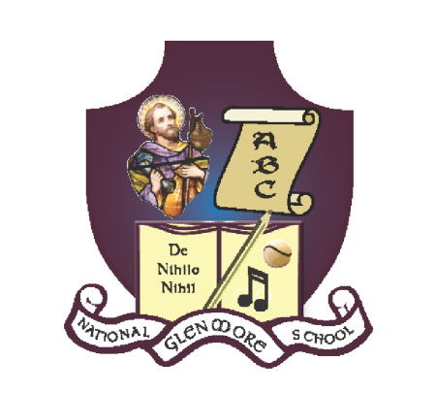
GLENMORE NATIONAL SCHOOL
S.N. SEAMUS NAOFA
GLENMORE, CO. KILKENNY

Return to Educational Facility Parental Declaration Form

This form is to be used when children are returning to the Glenmore National School after any absence for the school year 2020-2021.

Child’s Name: ________________________ Class: _________________
Date(s) of Absence(s): _______________________
Reason for Absence: ___________________________________________
Parent/Guardian’s Name: __________________________

Declaration:
I have no reason to believe that my child has an infectious disease and I have followed all medical and public health guidance with respect to exclusion of my child from educational facilities.

Signed: ______________________________Date:_______________________

