THE CANINE COURIER
Newsletter of the Sioux Empire Kennel Club
VOL 08-14 October/November Issue


Club Calendar
November
4 Election Day
4 SEKC board meeting TBA
11 SEKC general membership meeting 7pm Clubhouse
27 Thanksgiving

December
2 SEKC Board meeting TBA
SEKC Christmas party
25 Christmas
31 New Year’s Eve

January
1 New Year’s Day
6 SEKC Board Meeting
13 SEKC General Membership meeting 7pm clubhouse
Classes begin

TREATS
Nov Brian & Grace

Dec Christmas party

Jan open

Show Calendar

For more information go to http://www.akc.org/events/search/index.cfm

Message from the President
LETTER FROM THE PRESIDENT

Summer is gone and fall is going fast. By the time you see this we will be finished with the Fall Show and getting ready for the holidays. I don’t know about you, but my summer flew and I don’t know where it went.
I know that many of you volunteered your time to making the Fall Show a success and I want to thank you for your help. It is a big undertaking each year and without the support of all the volunteers, it would be possible.
The board is working hard to finish up the year so that everything is organized and ready for the New Year. We are working to make our classes more competitive and to attract the family dog. All of the instructors deserve a gold medal for the hours that they spend working with other people’s dogs so we

are trying to find a way that makes it easier for them and also gives them time to work their own dogs. As
soon as we have everything together we will be having a meeting with the instructors.
It is still going to be busy as we will be having an agility seminar hosted by Kathy DeSchepper and Karen Kelling. I know it will be of interest to members and possibly others outside the club. This is exciting and I hope that more members come up with ideas like this.
We have our slate for the board from the Committee and if there are any nominations from the floor they have to be made in November.
We will be having one more meeting this year in November and then in December – no meeting, just a Christmas Party. Kristine is working on it now and I know that it will be a great time.
Again, thanks to everyone for your help and work.
Paula Spielman, President

Brags & Wags
Please send me all of your dog and Family brags
And litter announcements.

Attended the Border Collie National Specialty at Purina Farms in September.

Borderpatrols Lindy Lou Who (Lindy) finished her Rally Novice B title

CH AbfabBorderpatrols Bye a Nose RN BN CGC (Jonesy) finished second in a very competitive Working Dog Sweepstakes and showed well for BOB. He also earned a couple of qualifying scores in agility.

On October 11, Jonesy passed his TDI certification and passed the CGCA. He will be primarily working with the SDSU Student Organization Lost and Found in Brookings which focuses on suicide awareness and prevention for college students.
Jonesy & Lindy are owned and loved by Liz Droke

Springmist Victorian Angel BN, NAP, OJP, NFP, CGC, THDN (Tory), earned her AKC Therapy Dog Novice title on September 9, 2014. Tory enjoys the Tail Waggin Tutors program with Ruth at St. Katharine Drexel School during the school year and with Denise at the Prairie West Library in the summer. Tory is loved and handled by Denise and Ruth Erger.

Hirdler Hill’s Life in the Fast Lane CDX RN BN CGC earned his first novice JWW leg at the TCVESSA agility trial in Ham Lake MN on October 17/19th. Rev had a perfect 100 with a time of 27.48 which was good enough for 1st place

Rev earned his CDX title at the SEKC obedience trial held Oct 24-26th with a score of 190 and first place

I have had a very busy month with my Rhodesian Ridgebacks. First Neo earned is AFSA Field Champion Title in Lure Coursing in just 5 months, winning 5 BOB”s in 6 starts. Then he went on to win his Grand Champion Title two weeks later finishing with a 5 point major. He also earned his CGCA this month and got his Beginner Novice Obedience Title at the Dog Show! So in the last five weeks he has earned a field champion title, a grand champion title and an obedience title! Go Neo!

Trinity, my female, earned her TDI, CGC and CGCA titles and at the dog show got her Beginners Novice Title and Rally Novice Title, taking first place in Rally Novice A all three days! It was so fun for me as a new obedience show person to watch all the amazing dogs and trainers we have at the Kennel Club. Thanks for all the help and support you give me :-) All dogs loved and handled by Janet Boyum

Chimera’s Talk of the Town, Gabby, passed the AKC S.T.A.R. puppy test on October 16, 2014 at the Sioux Empire Kennel Club. Gabby is trained and loved by Denise Erger.

Piper, CH Swags Dance To the Music passed her TDI testing and got her first leg if BN obedience title :) Piper is loved and handled by Tammie Smart

Sadie completed her Rally Novice title on Saturday (with a "leg to spare" on Sunday). Gem started and achieved her Novice title with legs on all 3 days. Sadie is loved and handled by Sally Marum

Our first home bred girl CH Dakota Fields Holi Cannoli received her CH title this weekend in Sioux Falls:) Loved by Megan & Josh Fields

PACH2 WESTMARCH KING OF THE WILD FRONTIER (Davy) earned 3 UDX legs and 3 OTCH pts placing in Open B 198 pts (2nd), 196.5 pts (4th), 194 pts; placing in Utility B 196 pts (2nd), 193.5 (4th), 194 pts; earning 66 Obedience Master pts to finish OM2 title! All “Q” weekend for Davy who turned 7 yrs on Oct 13 and had surgery on Oct 10. Loved by Dan & Carol Everetts, Dandy & Dino.

NEW AGILITY TITLES

PACH 49ERGOLD SKYEFIRE GOOD VIBRATIONS (Dino) finished MXJ and MX agility titles at Bellevue Dog Obed Club on Sept. 14 and KCKC on Oct. 4; Open FAST title at BDOC on Sept 13 running with Carol. Dino has 4 QQs toward MACH title starting at Open level on May 9!

PACH2 WESTMARCH KING OF THE WILD FRONTIER (Davy) finished MX and MXJ titles at Indianhead KC agility trials on Sept 6-7; Open FAST title at Bellevue Dog Obed Club on Sept 13 running with Carol. Davy has 13 QQs toward MACH after starting at Novice level on May 9!!
**Davy earned 6 Agility titles with 18 consecutive clean runs at Std level this summer**! Our hero, Davy, adored by Carol & Dan Everetts.

Member Profile
Dave Nielsen

1Family we have four kids Brian the oldest he was two grandkids Riley and Klyer our oldest daughter Mindy Jo gave us two grandkids Sierra and Chase are second oldest boy Jonathan just got done with pharmacy school and our youngest daughter Alyse is in college at Augustana my occupation for the last 40plus-years has been working with my hands fixing and repairing equipment in hospital settings-my hobby for those 40 years has been working with different breeds of dogs more towards the hunting retriever breeds I've had Weimaraner, Britney's Labradors, golden retrievers ,and now a Chesapeake Bay. Throughout the years of going to many dog seminars and try to learn as much as I could on the different breeds and how to get the dogs to be the best that they could be. The recent seminar I took was on the Internet it was Susan Garrett’s say yes dog training recall 5.0 program and I'm thinking of getting a puppy to go towards agility training to give that a try. so my dog goals for 2015 would be to take mocha my Chesapeake Bay through season and finished tests in HRC UKC and maybe run in AKC senor test and title in those hunt test. Keep running mocha in Rally and try to title her if I quit messing up as a handler we couldn't get a rally title on her. Plus start a new puppy in doing agility and keep on learning about dogs and going to seminars. 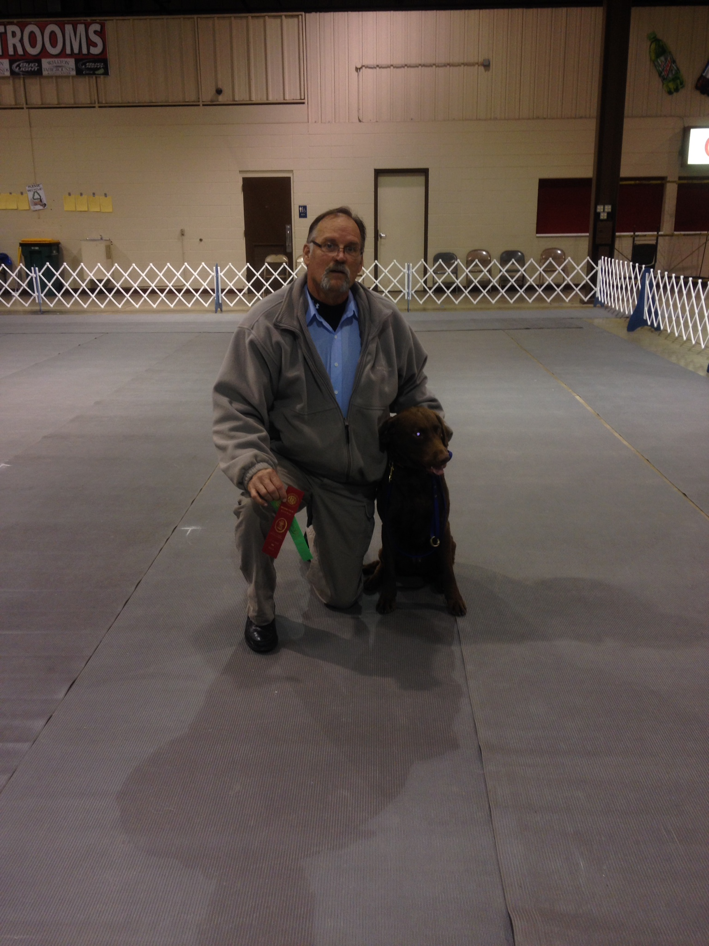Also in 2015 my goal is to reach 100 judging assignments in HRC that I have been doing during the summer weekends. I have belong to three different dogs clubs here in the Sioux Falls area one of the clubs Dakota hunting retriever club I've been officer president for six years on and off other officers positions too. I’ve been on training committees and I've been on PR committee's I've done demos in Sioux Falls, Harrisburg, Mitchell was the last one at Cabela's out on their lawn just before opening weekend of pheasant hunting as far is other hobbies we like camping hiking and fishing and doing crafts as a family as far as a bucket list it is getting pretty deep I will be probably retiring in 2016 and I will be able to start dipping into the bucket and pulling out something and going and doing it question asked to me about a dream vacation it would be making it to age 65 with good health and lots of energy to do anything that I wanted, and being around family and watching the grandkids grow up.
Norwegian Dave

Suze & Brian Frentz

- Family:
We have seven children combined. Brian’s children are Kayleigh, Rebekka, Patrick, Clark and Madelyn. Suze’s children are Alex and Kristin (last kid at home). We also have seven grandchildren ages five months – six years old.

- Dogs: Koti, Samoyed, almost 9 years old. Jessi, Belgian Malinois rescue, approx.. 3 years old.

- Other pets: Two quarter horse mares, Rope and Mysty, and we have four chickens.

- Occupation: Brian is a Facilities Coordinator for Home Federal Bank. Suze is Sales Director with Mary Kay.

- What are your goals for your canine partners in 2014? Get Jessi started in obedience at some point. Our goal with Koti is to stay on top of the hair!

- Why did you choose your breed? The Samoyed is such a loving, happy go-lucky personality and loves our grandkids. The Malinois’ brains and beauty are a wonderful combination, and provides a sense of security when Suze works at home alone.

- Is there anything that you will absolutely not eat? Brian is not fond of peppers. Suze absolutely will not eat asparagus or Brussel sprouts.

- If money was no object what would be your dream vacation? Europe – Italy for the wine, Germany for the beer.

- Do you have any other hobbies? Brian enjoys woodworking, growing grapes and turning them into delicious wine, working around on the acreage, and gardening. We both love spending time with our kids and grandkids.
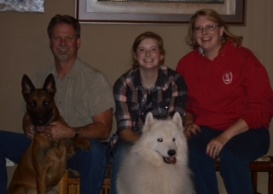
- What is the wildest thing on your bucket list? Brian would love to go on a hot air balloon ride and Suze would love to have a herd of quarter horses and a Friesian running around the place.

- Anything else you would like to add. We are both very active with our church, Zion Lutheran Church. We also love Big Bang Theory!!!!!

Tip of the Month

Holiday Safeguards

The winter season brings lots of fun holiday festivities, but pet-owners should keep in mind the following special precautions:
- The holidays are not ideal for introducing a pet into your family. New puppies and dogs require extra attention and a stable environment, which the holiday season doesn't permit. Also, a puppy is not a toy or gift that can be returned. Instead, the AKC suggests giving a gift representative of the dog to come, such as a toy, a leash, or a bed.
- Holly, mistletoe and poinsettia plants are pet poisons! Make sure they are kept in places your dog cannot reach.
- Review holiday gifts for dogs to make sure they are safe. Items such as plastic toys and small rawhide sticks may be dangerous.
- Remove holiday lights from lower branches of your tree. They may get very hot and burn dogs.
- Watch out for electrical cords. Pets often try to chew them and may get badly shocked or electrocuted. Place wires out of reach.
- Avoid using glass ornaments. They break easily and may cut a dog's feet and mouth.
- Refrain from using edible ornaments. Your dog may knock the tree over in an attempt to eat them. Also, commercial ornaments may contain paint or toxins in the preservatives.
- Whether your tree is live or artificial, both kinds of needles are sharp and indigestible. Don't leave your dog unattended in the room with the tree.
- Tinsel is dangerous for dogs. It may obstruct circulation and, if swallowed, block the intestines.
Alcohol and chocolate are toxic for dogs, even in small amounts. Keep unhealthy, sweet treats and seasonal goodies out of reach.
The holiday season is a stressful time for dogs. Try to keep a normal schedule during all the excitement.

Fall show wrap up
From the show chairman
Reprinted from an email that was sent out to the club

It is hard to believe the Fall Show is over for another year. It seemed to go very well and I am delighted to turn this over to Tracy next year. There are so many people to thank for making this year possible. I do want to thank the Board for all the support and work that they did. Tracy and Melanie, we would not have had ring judges assigned if the two of you had not jumped in to bail me out. Cindy and Jo, once again you managed to feed everyone and the food was great. I also have to say how lucky we are as a club to have two people, Megan and Cheryl, with beautiful voices so that we could have the National Anthem live each day. Karen, once again you did a great job with the Stewards and training Tamie for next year. I would love to thank all of you but honestly don't know who all helped out in that area. Brain, thanks for holding down the Information Table again. It looked good and you supplied good information. Kristine, great job on the clinic and Mike thanks for the work on obedience and rally. Tanner, thank you for the Halloween Parade and the judging. By the way, if you missed the Halloween Parade the costumes were great. Thanks to Kathy, Angelee, Warren and Pete - all of the catalogs are gone and you also make some money on spectators. Kim, thanks for once again handling the reserved grooming. Sylvia, you managed to get the judges where they were going and entertained them too which they really needed after the hotel problem.

I know I have forgotten names and if yours is not here I still appreciate everything you did. This club really pulled together and put on a great show and there are not enough thank you's to cover it.

See you all at the November meeting.

Paula

. Dues are due by December 31,2014
Please fill out and return this form with your check so the board knows what your interests are and know who to go to with each of the areas listed
Thanks
Brian Schaffer
Membership chairman

Sioux Empire Kennel Club
Member American Kennel Club
2015 MEMBERSHIP RENEWAL &
MEMBER INFORMATION UPDATE FORM
Name: _______________________________________________________________________________________
Address: _________________________________________City/State/Zip: ________________________________
Home Phone: ______________________________________cell:_________________________________________
Email: ________________________________________________________________________________________
What are the breed(s) of dog(s) you currently own or are interested in? ___________________________________
_____________________________________________________________________________________________
What are the areas of interest for your dog(s)? Check all that apply.
Conformation____Agility____Obedience____Therapy____Family Dog Training____Other____________________
Please indicate any committee(s) you would be interested in working on:
____Training Classes ____Public Education Events
____Hospitality at Meetings ____Fundraising
____Breeder Referral ____Building and Equipment Maintenance
____Summer Obedience Trial ____Agility Trial
____Fall Show ____Other________________________________________
Annual dues are $20 for single member, $25 for family and $15 for junior member (under 18 yr old). The annual building code dues of $10 are due with your renewal if you choose to have accesses to the building for training.
Dues are payable by December 31, 2014.
Amount Enclosed: ____$20 single____$25 family____$15 junior
____$10 building code
____$12.50 Newsletter Subscription ONLY
____TOTAL ____________Check Number______________Date

Please submit this SEKC Membership ‘renewal Form with a check payable to SEKC to:
Sioux Empire Kennel Club, PO Box 719, Sioux Falls, SD 57101

SEKC
PO BOX 719
Sioux Falls SD
57107

Send info to be published to
sekceditor@q.com
Type written Microsoft word format preferred
Deadline is the 3rd Tuesday of the month

