Prostate Cancer and Soy Protein
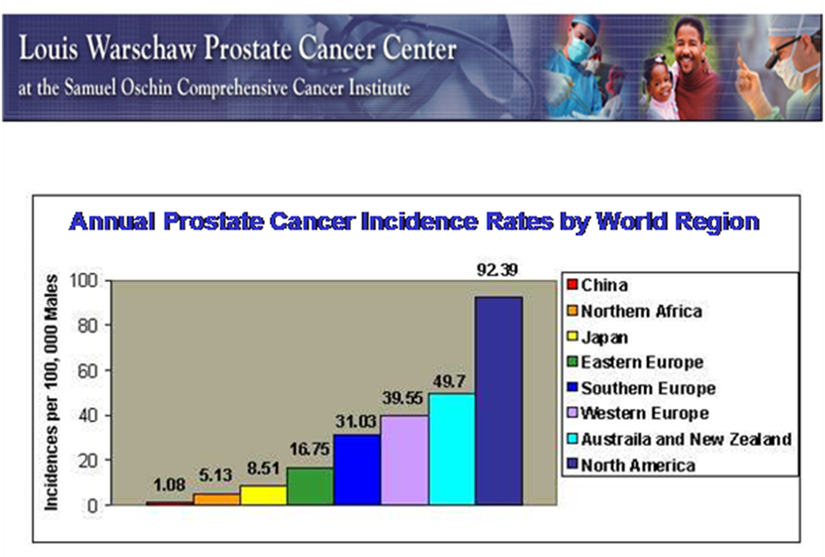
In China, where they eat 10x more soy than North Americans, men have the least amount of prostate cancer. See chart below.

Many studies support the role of soy in the prevention and possible treatment of prostate cancer:
- http://www.ncbi.nlm.nih.gov/pubmed/19211820
- http://www.jacn.org/content/24/2/146S.full
- http://www.webmd.com/prostate-cancer/news/20040924/soy-improves-prostate-cancer-outlook
- http://www.isoflavones.info/isoflavones-abstracts.php?article=prostate-cancer
- http://www.webmd.com/prostate-cancer/news/20080314/genistein-traps-mouse-prostate-cancer
- http://www.clinicaltrials.gov/ct2/show/NCT00031746
- http://www.umm.edu/altmed/articles/soy-000326.htm
- http://www.umm.edu/altmed/articles/prostate-cancer-000028.htm
- http://www.cfs.purdue.edu/fn/bot/downloads/publications/Messina_J_Nutr.pdf
- http://www.bioportfolio.com/resources/trial/123095/Soy-Protein-Supplement-In-Preventing-Prostate-Cancer-In-Patients-With-Elevated-Prostate.html
During the late 80s, researchers found that Japanese men in Hawaii who had soy at least 5 times per week had 65% less chance of developing prostate cancer than those who had soy only once a week or less.
In a study published in Urology in September 2004, Australian researchers found that men consuming a soy-enriched diet had a statistically significant drop of 12.7% in prostate-specific antigen (PSA) levels, compared to the control group whose PSA levels rose 40%.
SOY is great for prostate health!
Isoflavones are plant compounds found in soy products. Isoflavones act as hormones in the human body and can actually have great effects on several bodily functions.
For example, they can help lower your cholesterol, maintain good blood glucose levels, and even help build healthy bones. But for men, they can also act as inhibitors for prostate cancer.
It is for this reason that many studies have asked why? Why is it that Asian men are more prone to avoiding prostate cancer? Why is it that the American male tends to have larger prostates in their later years their Asian counterparts?
The best found answer to this question has been diet. It is no secret that the Asian population has been eating soy for over one thousand years. Most infants and children in the Asian population will find themselves eating the 80 to 100 mg of soy per day. After a number of years, the isoflavones in their bodies will build and their chances for prostate cancer will be reduced with each bite.
One recently conducted study focused on a group of 41 patients who were diagnosed with prostate cancer. These patients were given 100 mg of an isoflavone supplement twice a day for 6 months.
Results showed a lowering of the prostate-specific antigen (PSA) levels and ultimately a slowing of the prostate cancer growth. PSA is a protein produced by the cells of the prostate gland. The higher the PSA level, the more likely there is cancer present.
Isoflavones are found in all soy foods. One need only drink one 8 ounce glass of soymilk per day to receive 40 mg of isoflavones. Currently there is no recommended dosage of isoflavones to help lower prostate cancer risks.
However, the FDA has recommended that a person needs approximately 25 grams of soy protein per day in order to lower cholesterol levels.
Although more studies are underway to further investigate the relationship between soy isoflavones and prostate health, preliminary studies contain a hopeful future for the male population. When it comes to lowering the risks and avoiding prostate cancer, it seems that diets high in soy have been labeled a promising ally.

Have 25 to 35 g of Soy Protein Every Day

Have 25 – 35 g of soy protein every day. Study after study seems to show that diet is one of the major factors in relation with prostate problems. And research suggests that one reason for this may be the high soy content in the Asian diet. A study published in October of 2004 by the Urological Sciences Research Foundation stated that when Japanese men move to the United States and adopt a Western lifestyle, their health problems sky-rocket! According to many published journals, including the International Journal of Health, regular consumption of soy-protein-containing foods and beverages may reduce the risk of prostate problems in men by as much as 30 percent.

Bottom line: soy is great for your prostate, eat it daily!

