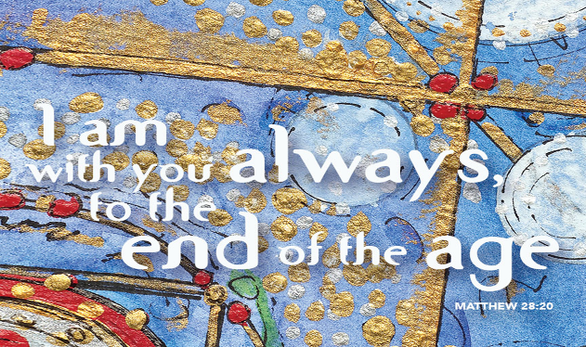
Living the Great Commission
June 11, 2017
Matthew 28:16-20
Holy Trinity Sunday
Grace and Peace to you in the Name of God, Our Father, God the Son, and God the Holy Spirit, Three in One, the Holy Trinity, amen.
Every year we get to declare a celebration of the name of God, Holy Trinity. Isn’t it nice the Church made a special Sunday named after us! Over the years I’m certain you all have heard all about the name Trinity and so, I’m not going to dwell on it this morning. Instead I want to talk about this great Gospel text from the very end of Matthew’s Book.
I have to start by saying that when I’ve been down and depressed in my life and there’s been too many of those times, no matter what stuff the world, or Satan, or my own stupidity landed me into, during those times when I felt I was all alone, I’ve found so much comfort in knowing Jesus was with me no matter what. You never have to face the world, Satan, or the consequences of your own choices by yourself. You’ve got a Lord and a Savior who is right there beside you and as close as a prayer away.
In today’s Gospel story, the Risen Christ is about to become the Ascended Christ where he will sit on the right hand of the throne of God forever. In these last precious moments, the disciples worshipped Him even though some doubted. They may not have had everything fully lined up into a complete systematic theology, but they knew enough that they worshipped this risen Jesus. Those who doubted were not rejected by Jesus, but accepted and included with all the rest. And to this faithful few, Jesus imparts his final instructions and his last testament to them. Jesus gives them a mission and a purpose. Jesus bids his followers to go and make more disciples. He said they were to baptize in the name of the Father, and of the Son, and of the Holy Spirit, but the work doesn’t stop there. You can’t baptize a person, making them a brand new Christian without teaching and discipling them so they can learn everything Jesus taught.
I’m not sure everyone knows what it means to be a disciple. The Greek term μαθητής (mathētēs) refers generally to any “student,” “pupil,” “apprentice,” or “adherent,” as opposed to a “teacher.” In the ancient world, it was most often associated, with people who were devoted followers of a great religious leader or teacher such as a Rabbi. The students learn at the feet of their master and over time become like their leader. That’s what Jesus had in mind for the Church. Peter and the others were to find other people, as the Holy Spirit led them and tell them about all Jesus had done. They, and we, are to Baptize and then continue to teach them until the Word of God and the Holy Spirit causes them to become more and more like Jesus.
Unless any of you think this commission will be an easy one, Matthew has already laid out the context into which the disciples will go. In Matthew’s Gospel Jesus has warned the disciples about persecution, saying he’s sending them out as sheep among the wolves, but He also told them that as His Church, even the gates of hell would not prevail against them. This sounds to me like a pretty aggressive Church on the move. It also sounds to me like a body of people who are committed to their cause and purpose. First off, you can’t make disciples if you haven’t been a disciple first. You can’t teach “everything” Jesus has taught, unless you’ve first learned it yourself. Those of you who are faithfully here week after week are setting the example and I applaud you good and faithful servants. Because of you Trinity Lutheran Church isn’t your typical small rural congregation. We’re an active group who take this Great Commission of Jesus seriously. A couple of weeks ago I said the average Lutheran invites someone to Church once every 23 years. Perhaps some of you thought I was putting you or Trinity down when I quoted that statistic. Nothing could be farther from the truth! You all and Trinity as a whole have far outstripped those statistics. Many of you do invite people to attend worship on a regular basis. We have many outreach ministries here that allow us to use the words “my Church” or “Our Church” regularly and often. In my humble opinion, I confess I may be a little bit biased, but In my humble opinion when God led me to this place it was like finding a buried treasure. Trinity does live out our mission statement of Seeking, Welcoming, and Serving all.
Friends, we’re doing what Jesus has tasked us to do. We’re supposed to be a Church on the move, on the offensive. The minute we forget that we risk going from being a Church that the very gates of hell cannot prevail against to becoming just one more mighty fortress. As much as I love Martin Luther and my Lutheran heritage, when the Church becomes a mighty fortress it makes it pretty hard to be a Church on the move going into the nations baptizing and making disciples. I pray every one of us will never let that happen here at Trinity.
It’s too easy to fall back into the old ways of being Church. We have a really tough message in today’s culture. Most people today, if they come to worship at all, just want to come to worship and be fed with the sweet Word of God. Most Christians don’t want to hear they have a mission and a purpose. I mean we’re already pretty busy people and along comes the Church and we add to that burden by telling people you also have yet another job to do. Here’s one more thing to add to your plate this week. Not only do you have your regular full time job, you also cook and clean the house, get the kids to their appointed places on time and as it is you have precious little me time. Now, here comes the Church, adding to all of that… Telling people they should also become inviting and bring folks to the Church and after that be responsible to teach them everything about Jesus as well… It’s no wonder every denomination and Church in the northern hemisphere is in decline…
That is one way to look at this Great Commission Jesus lays on the Church today, but that isn’t the only way to see it. The way I look at it is Jesus isn’t telling the disciples to do anything new or different than what he’s been doing and modeling for them all throughout his earthly ministry. Our translation says go and make disciples, but the real sense in the Greek is more like “as you’re going,” make disciples and Baptize them. This Great Commission is more descriptive than proscriptive. Jesus is describing what he’s been up to and he’s extending what he’s been doing to now include his own disciples. So, to Peter… As you go from Jerusalem to Rome, by your life and the way you live, be an example to those you encounter. Share the Gospel with people along the way and let them know about all the things I’ve said and done. If we do that much, then God, the Holy Spirit will take over and stir the person’s soul and grow in them. It’s more like, as you are working, playing, studying, living your life out there, that you show others the Father and His Son Jesus. You are letting your light shine before others so, they can see your good works and glorify God in heaven. When I went through my Via de Cristo weekend (some of you know it as the Walk to Emmaus Weekend) we had a saying. “You may be the only Bible your friend will ever read.” The way you react to more work and the same or less pay shows your co-workers what difference Jesus has made, or not, in your life. The way you react when a friend or co-worker offends you does the same. Everything you do is being watched by someone who is judging you based on your claim to be a Christian. Now, none of us is perfect, but there should be some evidence of transformation others can see in the way you live and react to the stuff life throws your way.
Having said that, I actually believe this Great Commission invites us to a more active role in the Church of Jesus Christ. Jesus invites us to speak words of life and healing to those we encounter, but also to invite them into the same kind of relationship you have with the Lord Jesus Christ. Setting the example and perhaps even making others jealous for what you have is step one, but as any salesperson will tell you at some point you have to close the deal. You have to make the invitation. As you know, we’ve been practicing using the words My Church or Our Church in conversation with outsiders. From what I can tell that first baby step is going pretty well. Just as a way of introducing the next baby step, starting next week the challenge gets a bit more specific. I’ll tell you more next week…
Until then, may God, Father, Son, and Holy Spirit fill you with God’s love. May you live your life as an example, but never be afraid or ashamed to also use your words to invite and encourage others to come and join the fellowship you’ve enjoyed all these years. Remember, and never forget that as you’re going and making disciples for Jesus, he is always with you even until the earth is no more. Amen.

