ACROSS: 1, Credit. 4, Tackle. 7, Cain. 8, Kenaniah. 9, Strength. 13, Beg. 16, Salvation Army. 17, ARC. 19, Every day. 24, Admonish. 25, Dire. 26, Sneeze. 27, Bronze.
DOWN: 1, Cock. 2, Epistolic. 3, Taken. 4, Tenet. 5, Cane. 6, Leave. 10, Erase. 11, Guide. 12, Honey. 13, Barbarian. 14, Guys. 15, Asia. 18, Rod in. 20, Voice. 21, Rahab. 22, Hope. 23, Mene.
___________________________________________________________________

Lent Services
Full details of the Wednesday 7pm Services at Churches in Stockport Town Centre will be announced at the beginning of Lent, as will the programme of Lenten Addresses to be given in the Tuesday 12.15 Service at St Mary’s. Please ask in St Mary’s for details or go on-line.

___________________________________________________________

DIOCESE OF CHESTER : CONFIRMATIONS 2013 - Stockport Deanery
Tuesday, 11th June 19:30 Norbury Parish Church (St Thomas)
Bishop of Stockport
___________________________________________________________________
Readers contributions to the magazine are always welcome. Hard copy (hand written if easier) to the Rectory address or by email: to : st.marysstockport@gmail.com
Editorial discretion with regard to content and space available will apply.
St Mary’s in the Marketplace
St Mary’s Rectory, 24 Gorsey Mount Street,
Stockport, SK1 4DU.
0161 429 6564 www.stmarysinthemarketplace.com
St Mary’s in the Marketplace
“SECURING THE FUTURE FOR THE NEXT 100 YEARS” 50p
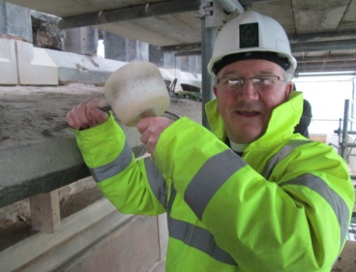

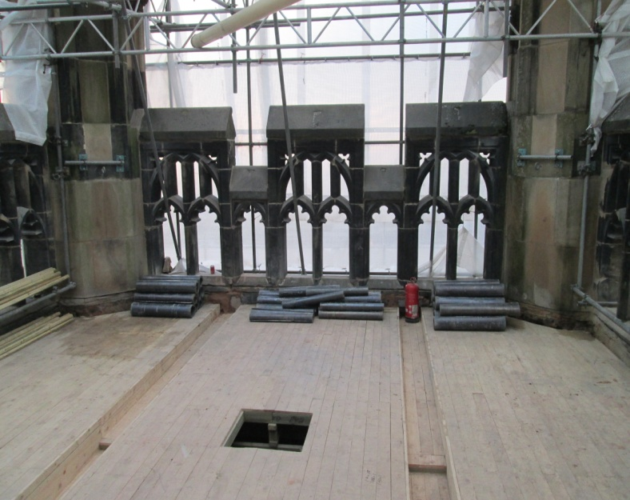

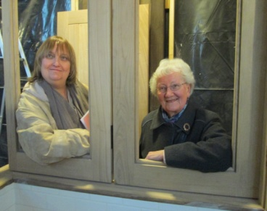

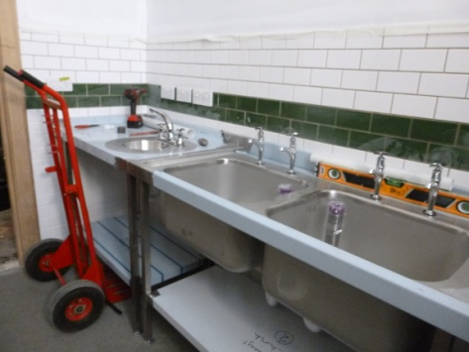

From the Rector’s Desk
Dear Reader .
.
In the months leading up to the commencement of the project in hand, the re-ordering of the interior of St Mary’s, it was suggested that the Church might have to close for the duration of the work. This was unimaginable to myself and others, and I’m so glad that we decided to carry on and remain open as “normal” as possible since last July. It has been an extraordinary time of cheerful acceptance of dust and noise, of interruptions and inconveniences. The outside “convenience” itself has proved that we were able to find a way of staying open not only for services, but also and most especially for our numerous concerts and other activities, at the weekend and during the week days. Our hospitality team of volunteers has done a great job, and thanks go to them, and to all who have helped us through this most challenging time. When others thought we might close, we stayed open and it worked.

But now we have had to accept that a temporary closure of the church is essential in order for the work on the floor surfaces and for the electrics to be completed; as well as for a substantial re-ordering of the chapel. We must close the doors to the public, and to the worshipping community in order to allow our contractors access as and when they need it, to all areas of the church.

We owe it to Lambert Walker, our splendid contractors, the stonemasons and joiners, together with all the related trades and craftsmen, to give them a clear run to finish the great job in hand.

In the late 1880’s the church was obviously “closed” for nigh on 18 months while the major re-ordering was undertaken. I am very pleased that we have managed to remain open, for services, for refreshments, for prayers, for candles to be lit, for folk to visit us, and throughout Advent, Christmas and New Year.
We have yet to post a “blog” or “podcast” - well we have thought about it but not on our site, there just isn’t the time at present to keep either up-to-date. But surely, we must embrace technology.

Our online presence will not automatically be viewed by lots of people (unfortunately) it will need to be made know (constantly) using traditional media as well as by word of mouth. The Secretary Bird is constantly seeking appropriate links on which to publish our events and make known the work being undertaken at St Mary’s. Areas of “joint working” where we can work with others for the benefit of all of us – and of course other organisations are doing the same.

Are you aware that Stockport Deanery has its own web-site? Well for those of you with a computer and internet connection it can be found on www.stockportdeanery.org.uk – and yes we have a page which links to our own web-site on www.stmarysinthemarketplace.com. Did you know that Stockport Market has it’s own site – well it’s new and can be found on www.stockportmarket.net – very informative and well worth looking at - and if you were reading this magazine electronically you would be able to click the link and instantly enter the site!

Yes, we must embrace technology, we can’t afford to be left behind…

PS. Our pews are presently being advertised on the “world wide web” – via Gumtree. If you are interested in one (or more) just ask – available at £100 each (for the standard 10’4” pews). You will need to pay for transportation but we may be able to help to arrange the shared use of a rental vehicle or removal van. Your opportunity to take a little bit of St Mary’s home! This offer will not be available much longer if we don’t sell privately relatively quickly we will be selling off to a dealer or demolition/reclamation company.

Technology (new and old)
The Secretary Bird hasn’t spoken for awhile but has been here working away frantically, at times virtually round the clock – well maybe not quite that, but lots of late nights! My life seems to mainly consist of 171,596 files taking some 149,643 mega bits of space – 26,660 photo files (some are duplicated granted and many are Roger’s), 92 video files (which I didn’t know I had), 112 email files (odd considering both email accounts are held externally), 1185 document files, 117 spreadsheets, 25 presentations (well yes I can believe that), and 366 illustrations (which I could probably get rid of). The screen of my laptop flashed uncontrollably on and off the other day and it felt as if my life was ending….. well my electronic life that is . How many of us have their lives filed on a laptop, notepad, ipad or other such device! It’s a bit worrying don’t you think – if not a bit “sad”…. I dashed home after this attack of uncontrollable “flashing” and backed up everything to an external disk drive (which is where the data came from) – and feel so much better now.

Can we move forward without embracing technology? Can St Mary’s move forward without the computer and access to the internet? Technology (not all that many years ago) would have incorporated such things as the printing press, the piano and the organ. Then came microphones, video projectors and now with the internet we can incorporate websites and social networking. Let’s not forget texting on cell phones!

St Mary’s does not (as yet) have a Facebook account or a Twitter feed (although we have thought about it) but we do have a web-site (which granted needs some dedicated time and further development) and we do have an e:mail address (which is extremely well used). We have available to us the technology to use “power-point” (presentations on screen) and to keep most of our day to day records electronically – but fear not the baptism and marriage registers remain safely locked away and used as required in good old pen and ink!
We could have used St Andrew’s, but the building is now in regular use and isn’t available on a Sunday morning or on certain Tuesday lunch-times. It therefore became more appropriate for us to look at alternatives – a little “partnership working” with neighbouring churches that have offered to open their doors to us and to make us welcome, as we do to everyone who visits us. The decision was made to “disperse” for Sunday worship to other churches, either within the town centre or nearer to where members of the congregation live; but to hold our normal Tuesday services at St Peters. I am most grateful to the Churchwardens of St Peter’s for agreeing to this arrangement.

I hope that following the weekend of the handover, we shall all be able to return to St Mary’s and see what has been done so far. There may well be work still to be done, so I am not rejoicing just yet. God has been good to us in providing for us in such an extraordinary way, financially. But he given us some testing times and some quite substantial hurdles to jump over in practical terms before we can finally say - “it is done”.

It is timely for me personally to thank God for the great work which has been done at St Mary’s in these past seven months, and to thank you our patient, understanding, thoughtful and generous-hearted congregation and community of Stockport.

The Bible tells us that “With God NOTHING is impossible”, and if you are looking for evidence of that, come to St Mary’s and look around you. You will be amazed!

Yours very sincerely
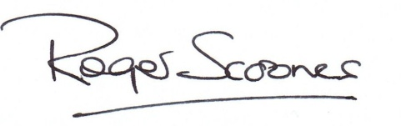

1 ‘If you love those who love you, what — is that to you?’ (Luke 6:32) (6)
4 ‘They threw the ship’s — overboard’ (Acts 27:19) (6)
7 The first murderer (Genesis 4:8) (4)
8 He was the head Levite in charge of the singing when the ark of God was brought back to Jerusalem (1 Chronicles 15:22) (8)
9 Samson was noted for this (Judges 16:6) (8)
13 Solicit money or food from passers by (Acts 3:2) (3)
16 What William Booth’s Christian Mission became in 1878 (9,4)
17 Alliance of Religions and Conservation (1,1,1)
19 ‘I will praise your name for ever and ever. — — I will praise you’ (Psalm 145:1–2) (5,3)
24 Simon had (anag.) (8)
25 Desperate (Deuteronomy 28:48) (4)
26 Elisha witnessed the boy he was seeking to resuscitate do this seven times before opening his eyes (2 Kings 4:35) (6)
27 The belly and thighs of the statue in Nebuchadnezzar’s dream were made of this (Daniel 2:32) (6)
Down
1 ‘Before the — crows, you will disown me three times’ (Matthew 26:75) (4)
2 Relating to the books of the Bible between Acts and Revelation (9)
3 ‘They have — the Lord out of the tomb, and we don’t know where they have put him!’ (John 20:2) (5)
4 Belief (5)
5 ‘Take the following fine spices: ... 250 shekels of fragrant — ’ (Exodus 30:23) (4)
6 ‘Do not — Jerusalem, but wait for the gift’ (Acts 1:4) (5)
10 A seer (anag.) (5)
11 ‘Even there your hand will — me’ (Psalm 139:10) (5)
12 The wild variety was part of John the Baptist’s diet (Mark 1:6) (5)
13 A non-Greek speaker who was looked down on by civilized people (Colossians 3:11) (9)
14 Famous 1950s musical whose characters included members of
16 Across, — and Dolls (4)
15 The province from which Paul wrote to the Corinthians (1 Corinthians 16:19) (4)
18 ‘He was standing in the gateway with a linen cord and a measuring — — his hand’ (Ezekiel 40:3) (3,2)
20 ‘Today, if you hear his — , do not harden your hearts as you did in the rebellion’ (Hebrews 3:15) (5)
21 The Jericho prostitute who hid two Israelite spies on the roof of her house (Hebrews 11:31) (5)
22 ‘And now these three remain: faith, — and love. But the greatest of these is love’ (1 Corinthians 13:13) (4)
23 ‘God has numbered the days of your reign and brought it to an end’ (Daniel 5:26) (4)

Sunday Services
Following discussion with many of our neighbouring churches the hand of welcome and friendship has been offered to us to join them for Sunday services whilst St Mary’s is closed on the 3rd, 10th & 17th February.
To help you decide where you would like to attend – here are a few of the alternatives:-
Tiviot Dale Methodist Church [10.45am]
St George’s, Heaviley [8.00am Holy Communion; 10.15am Sung Eucharist]
St Matthew’s, Edgeley [3rd Feb: 10.30am Holy Communion/10th&17^{t h} 9.30am & 11.15am ]
St Luke’s, Brinnington [10.00am Holy Communion]
St Alban’s, Offerton [8.00am Holy Communion; 10.00 Sung Eucharist]
St Mary’s, Cheadle [8.00am Holy Communion; 9.30am/11.15am Morning Worship]
St Andrew’s, Cheadle Hulme [Services at 10.45am – 3rd Feb Holy Communion 9.30am]
St Saviour’s, Great Moor [8.30am Holy Communion; 10.45am Sung Eucharist]
Stockport Evangelical Church
(Independent, Bible-believing church – services at St Andrews, Hall Street) [10.30am]

Tuesday Services
Not too far to travel from St Mary’s – our 10.00am Holy Communion & 12.15pm Lunch-time services will move to St Peter’s. This covers the 29th January, 5th & 12th February. We look forward to your return to St Mary’s on Tuesday, 19th February when we open our doors for the first time after the present works to the interior are completed.

A heavenly Valentine
For God so loVed the world
That he gAve
His onLy
begottEn
SoN
That whosoever
Believeth In him
Should Not perish
But have Everlasting life.
John 3:15

Prayer for the Duke and Duchess of Cambridge
God our creator, we thank you for the wonder of new life and for the mystery of human love. .
We pray for William, Duke of Cambridge and Catherine, Duchess of Cambridge as they prepare to receive the gift of their child. .
We thank you that we are known to you by name and loved by you from all eternity, through Jesus Christ our Lord. Amen
Issued by the Church of England

Shrove Tuesday is the day before lent starts on Ash Wednesday. The name Shrove comes from the old middle English word 'Shriven' meaning to go to confession to say sorry for the wrong things you've done. Lent always starts on a Wednesday, so people went to confessions on the day before. This became known as Shriven Tuesday and then Shrove Tuesday.

Come and join us for our Pancake Party
Tuesday, 12th February 2013
6pm – 8pm
St Mary’s Rectory
This is a social event and an opportunity for us to meet-up whilst St Mary’s is closed – we hope that you can come and join us – everyone welcome.
The other name for this day, Pancake Day, comes from the old English custom of using up all the fattening ingredients in the house before Lent, so that people were ready to fast during Lent. The fattening ingredients that most people had in their houses in those days were eggs and milk. A very simple recipe to use up these ingredients was to combine them with some flour and make pancakes!
Early notification would be appreciated if you wish us to order Easter Eggs for you. Eggs will need to be ordered in packs of SIX and if ordered after the 11th February will incur a delivery charge.
The cost is £3.99 per egg (plus postage and packing as charged).
However - no order will be placed unless we have sufficient demand to meet the criteria for ordering, as clearly these items have to be paid for in advance and are non-returnable if unsold.

Coming Soon
Arrangements will be made shortly for a meeting/introductory session to be held explaining the changes of working practices planned for St Mary’s. Our hopes and expectations, now that the major building works are behind us and we are ready to prepare for a new ere…

Look out for details of our celebratory events as well as the launch of the Nave Café and other promotional activities

Stockport Heritage Trust
We are delighted to have held our first “management” meeting with the Stockport Heritage Trust who are preparing to return to St Mary’s during March 2013. We are looking forward to their return into the north aisle area and joint-working with us on various projects, as well as running the church shop.

www.stockportheritagetrust.co.uk
E-mail: stockportheritage@gmail.co

13th February ASH WEDNESDAY
Lent begins with Ash Wednesday. But why 'Ash' Wednesday? The reason has to do with getting things right between you and God, and the tradition goes right back to the Old Testament.
In the Old Testament, the Israelites often sinned. When they finally came to their senses, and saw their evil ways as God saw them, they could do nothing but repent in sorrow. They mourned for the damage and evil they had done. As part of this repentance, they covered their heads with ashes. For the Israelites, putting ashes on your head, and even rending your clothes, was an outward sign of their heart-felt repentance and acknowledgement of sin. (See Genesis 18:27; 2 Samuel 13:19; Job 2:8, 30:19; Isaiah 58:5; Jeremiah 6:26; Jonah 3:6)
In the very early Christian Church, the yearly 'class' of penitents had ashes sprinkled over them at the beginning of Lent. They were turning to God for the first time, and mourning their sins. But soon many other Christians wanted to take part in the custom, and to do so at the very start of Lent. They heeded Joel's call to 'rend your hearts and not your garments' (Joel 2:12-19). Ash Wednesday became known as either the 'beginning of the fast' or ‘the day of the ashes’.
The medieval custom was to burn the branches used on Palm Sunday in the previous year in order to create the ashes for Ash Wednesday. The actual custom of 'ashing' was abolished at the Reformation, though the old name for the day remained. Today, throughout the Church of England, receiving the mark of ashes on one’s forehead is optional. Certainly the mark of ashes on the forehead reminds people of their mortality: "Remember that you are dust and to dust you will return..." (Genesis 3:19)

New Electoral Roll

Once every six years it is necessary to prepare a completely new Electoral Roll. This was last done in 2007, so a new Electoral Roll must be prepared this year.

Formal notice will be posted on Sunday 10th February that a new roll is being prepared. Personal contact will be made to everyone on the current Electoral Roll.
Everyone who wishes to be on the new roll must apply in writing using the appropriate form – these will be available in Church, from the Electoral Roll Officer (Margaret Forster) or at the Rectory Office, St Mary’s Rectory, 24 Gorsey Mount Street, Stockport, SK1 4DU. Telephone: (0161 429 6564). Email: st.marysstockport@gmail.com.

Qualification for inclusion:
Generally speaking, a lay person is entitled to have hi/her name entered on the roll of a parish if he/she is baptised, of sixteen years or upwards, and has signed an application form for enrolment declaring himself/herself either - (a) to be a member of the Church of England or of a Church in communion therewith resident in the parish; or (b) to be such a member and, not being resident in the parish, to have habitually attended public worship in the parish during a period of six months prior to enrolment; or (c) to be a member in good standing of a Church which subscribes to the doctrine of the Holy Trinity (not being a Church in communion with the Church of England) and also prepared to declare himself/herself to be a member of the Church of England having habitually attended public worship in the parish during a period of six months prior to enrolment.
Full details available on request.

PRAYER FOR BUILDING PROJECT
Lord and heavenly Father,
You have called us to witness to your Son Jesus Christ by word and deed;
- We thank you for the life and witness of this church in the Market Place over the centuries, and for all who have served you faithfully here.
- Please help us in our day to be faithful and forward-looking, bearing witness in the present and leaving an inheritance for those who will follow in years to come.
- Be with us at this special time in which we are seeking to repair and refurbish our building to your glory. Keep in safety those who work at high level in repair work.
- Please protect our life together and provide for all our needs. Give us boldness and wisdom in all our planning, and deepen our faith and love.
Please hear this prayer which we offer for your glory, through Jesus Christ our Lord, AMEN.

Building News
See copies of our weekly publication “Building News” to keep up-to-date with the work being undertaken “inside” and “outside” St Mary’s

The collect for Ash Wednesday goes back to the Prayer Book, and stresses the penitential character of the day. It encourages us with the reminder of the readiness of God to forgive us and to renew us. The Bible readings are often Joel 2:1-2, 12 – 18, Matthew 6: 1-6,16 – 21 and Paul’s moving catalogue of suffering, "as having nothing and yet possessing everything." (2 Corinthians 5:20b - 6:10)
The Collect for Ash Wednesday:
Almighty and everlasting God,
You hate nothing that you have made
And forgive the sins of all those who are penitent:
Create and make in us new and contrite hearts
That we, worthily lamenting our sins
And acknowledging our wretchedness,
May receive from you, the God of all mercy,
Perfect remission and forgiveness;
Through Jesus Christ your Son our Lord,
Who is alive and reigns with you,
In the unity of the Holy Spirit,
One God, now and for ever.
Ash Wednesday: a good time to admit you are sorry
Have you done something which haunts you? Which makes you feel restless and defensive, every time you think of it? Why not deal with it this month, and put it behind you? Whatever your mistake has been, consider what the Bible has to say to you:
‘I have not come to call the virtuous but sinners to repentance’ (said Jesus). (Luke 5.32) ‘Let the wicked forsake his way, and the unrighteous man his thoughts: and let him return unto the Lord, and he will have mercy upon him; and to our God, for he will abundantly pardon. (Isaiah 55.7) ‘Yet even now, says the Lord, return to me with all your heart, with fasting, with weeping, and with mourning; rend your hearts and not your clothing. Return to the Lord, your God, for he is gracious and merciful, slow to anger, and abounding in steadfast love, and relents from punishing.’ (Joel 2:12-13)
God is inviting you to come to him this Ash Wednesday. What a wonderful offer! Make the most of it, and remember how the prodigal son was welcomed back by his compassionate father.

