Little Lanes

Illness and Accidents

At Little Lanes we will deal promptly and effectively with any illnesses or injuries that occur while children are in our care. We take all practical steps to keep staff and children safe from communicable diseases.

All parents or carers must complete the Medical Form when their child joins the Club, requesting permission for emergency medical treatment for their child in the event of a serious accident or illness.

We will record any accidents or illnesses, together with any treatment given, on an Incident Record or Accident Record sheet as appropriate, which the parent or carer will be asked to sign when they collect the child.

Little. Lanes cannot accept children who are ill. If any children are ill when they first arrive at the Club we will immediately notify their parents or carers to come and collect them. Any children who have been ill should not return to the Club until they have fully recovered, or until after the minimum exclusion period has expired (see table at the end of this policy).

First aid
The Club’s designated First Aider is Clare Greenham & Megan Garratt. The designated First Aider has a current first aid certificate and has attended a 12 hour paediatric first aid course, which complies with the requirements of Annex A of the EYFS. First aid training will be renewed every three years. To ensure that there is a qualified first aider present and available at all times when the Club is running, other members of staff will also receive first aid training. We will take into account the number of children and layout of the premises to ensure that first aiders are able to respond quickly to any incident.

The location of the first aid box and a list of qualified first aiders are clearly displayed at the Club. The designated First Aider regularly checks the contents of the first aid box to ensure that they are up to date, appropriate for children and comply with the Health and Safety (First Aid) Regulations 1981.

The manager will ensure that a first aid kit is taken on all outings and that at least one member of staff on the outing holds a current paediatric first aid certificate.

Procedure for a minor injury or illness
The first aider at the session will decide upon the appropriate action to take if a child becomes ill or suffers a minor injury.
- If a child becomes ill during a session, the parent or carer will be asked to collect the child as soon as possible. The child will be kept comfortable and will be closely supervised while awaiting collection.
- If a child complains of illness which does not impair their overall wellbeing, the child will be monitored for the rest of the session and the parent or carer will be notified when the child is collected.
- If a child suffers a minor injury, first aid will be administered and the child will be monitored for the remainder of the session. If necessary, the child’s parent will be asked to collect the child as soon as possible.

Procedure for a major injury or serious illness
In the event of a child becoming seriously ill or suffering a major injury, the first aider at the session will decide whether the child needs to go straight to hospital or whether it is safe to wait for their parent or carer to arrive.
- If the child needs to go straight to hospital, we will call an ambulance and a member of staff will go to the hospital with the child. The staff member will take the child’s Medical Form with them and will consent to any necessary treatment (as approved by the parents on the Medical Form).
- We will contact the child’s parents or carers with all urgency, and if they are unavailable we will call the other emergency contacts that we have on file for the child.
- After a major incident the manager and staff will review the events and consider whether any changes need to be made to the Club’s policies or procedures.
- We will notify Ofsted and child protection agencies in the event of any serious accident or injury to a child in our care as soon as reasonably possible and within 14 days at the latest.
- We will notify HSE under RIDDOR in the case of a death or major injury on the premises (eg broken limb, amputation, dislocation, etc – see the HSE website for a full list of reportable injuries).

Communicable diseases and conditions
If a case of head lice is found at the Club, the child’s parents or carers will be discreetly informed when they collect the child. Other parents will be warned to check their own children for head lice, but care will be taken not to identify the child affected.

If an infectious or communicable disease is detected on the Club’s premises, we will inform parents and carers as soon as possible.

If there is an incident of food poisoning affecting two or more children looked after at the Club the Manager will inform Ofsted as soon as possible and within 14 days at the latest.

If there is an outbreak of a notifiable disease at the Club, we will inform the local health protection unit, HSE under RIDDOR (if appropriate), and Ofsted.

Useful contacts
Health Protection Unit: 0300 303 8537
Ofsted: 0300 123 1231
RIDDOR Incident Contact Unit: 0845 300 99 23

This policy was adopted by: Cheri Garratt | Date: February 2022
To be reviewed: February 2023 | Signed:  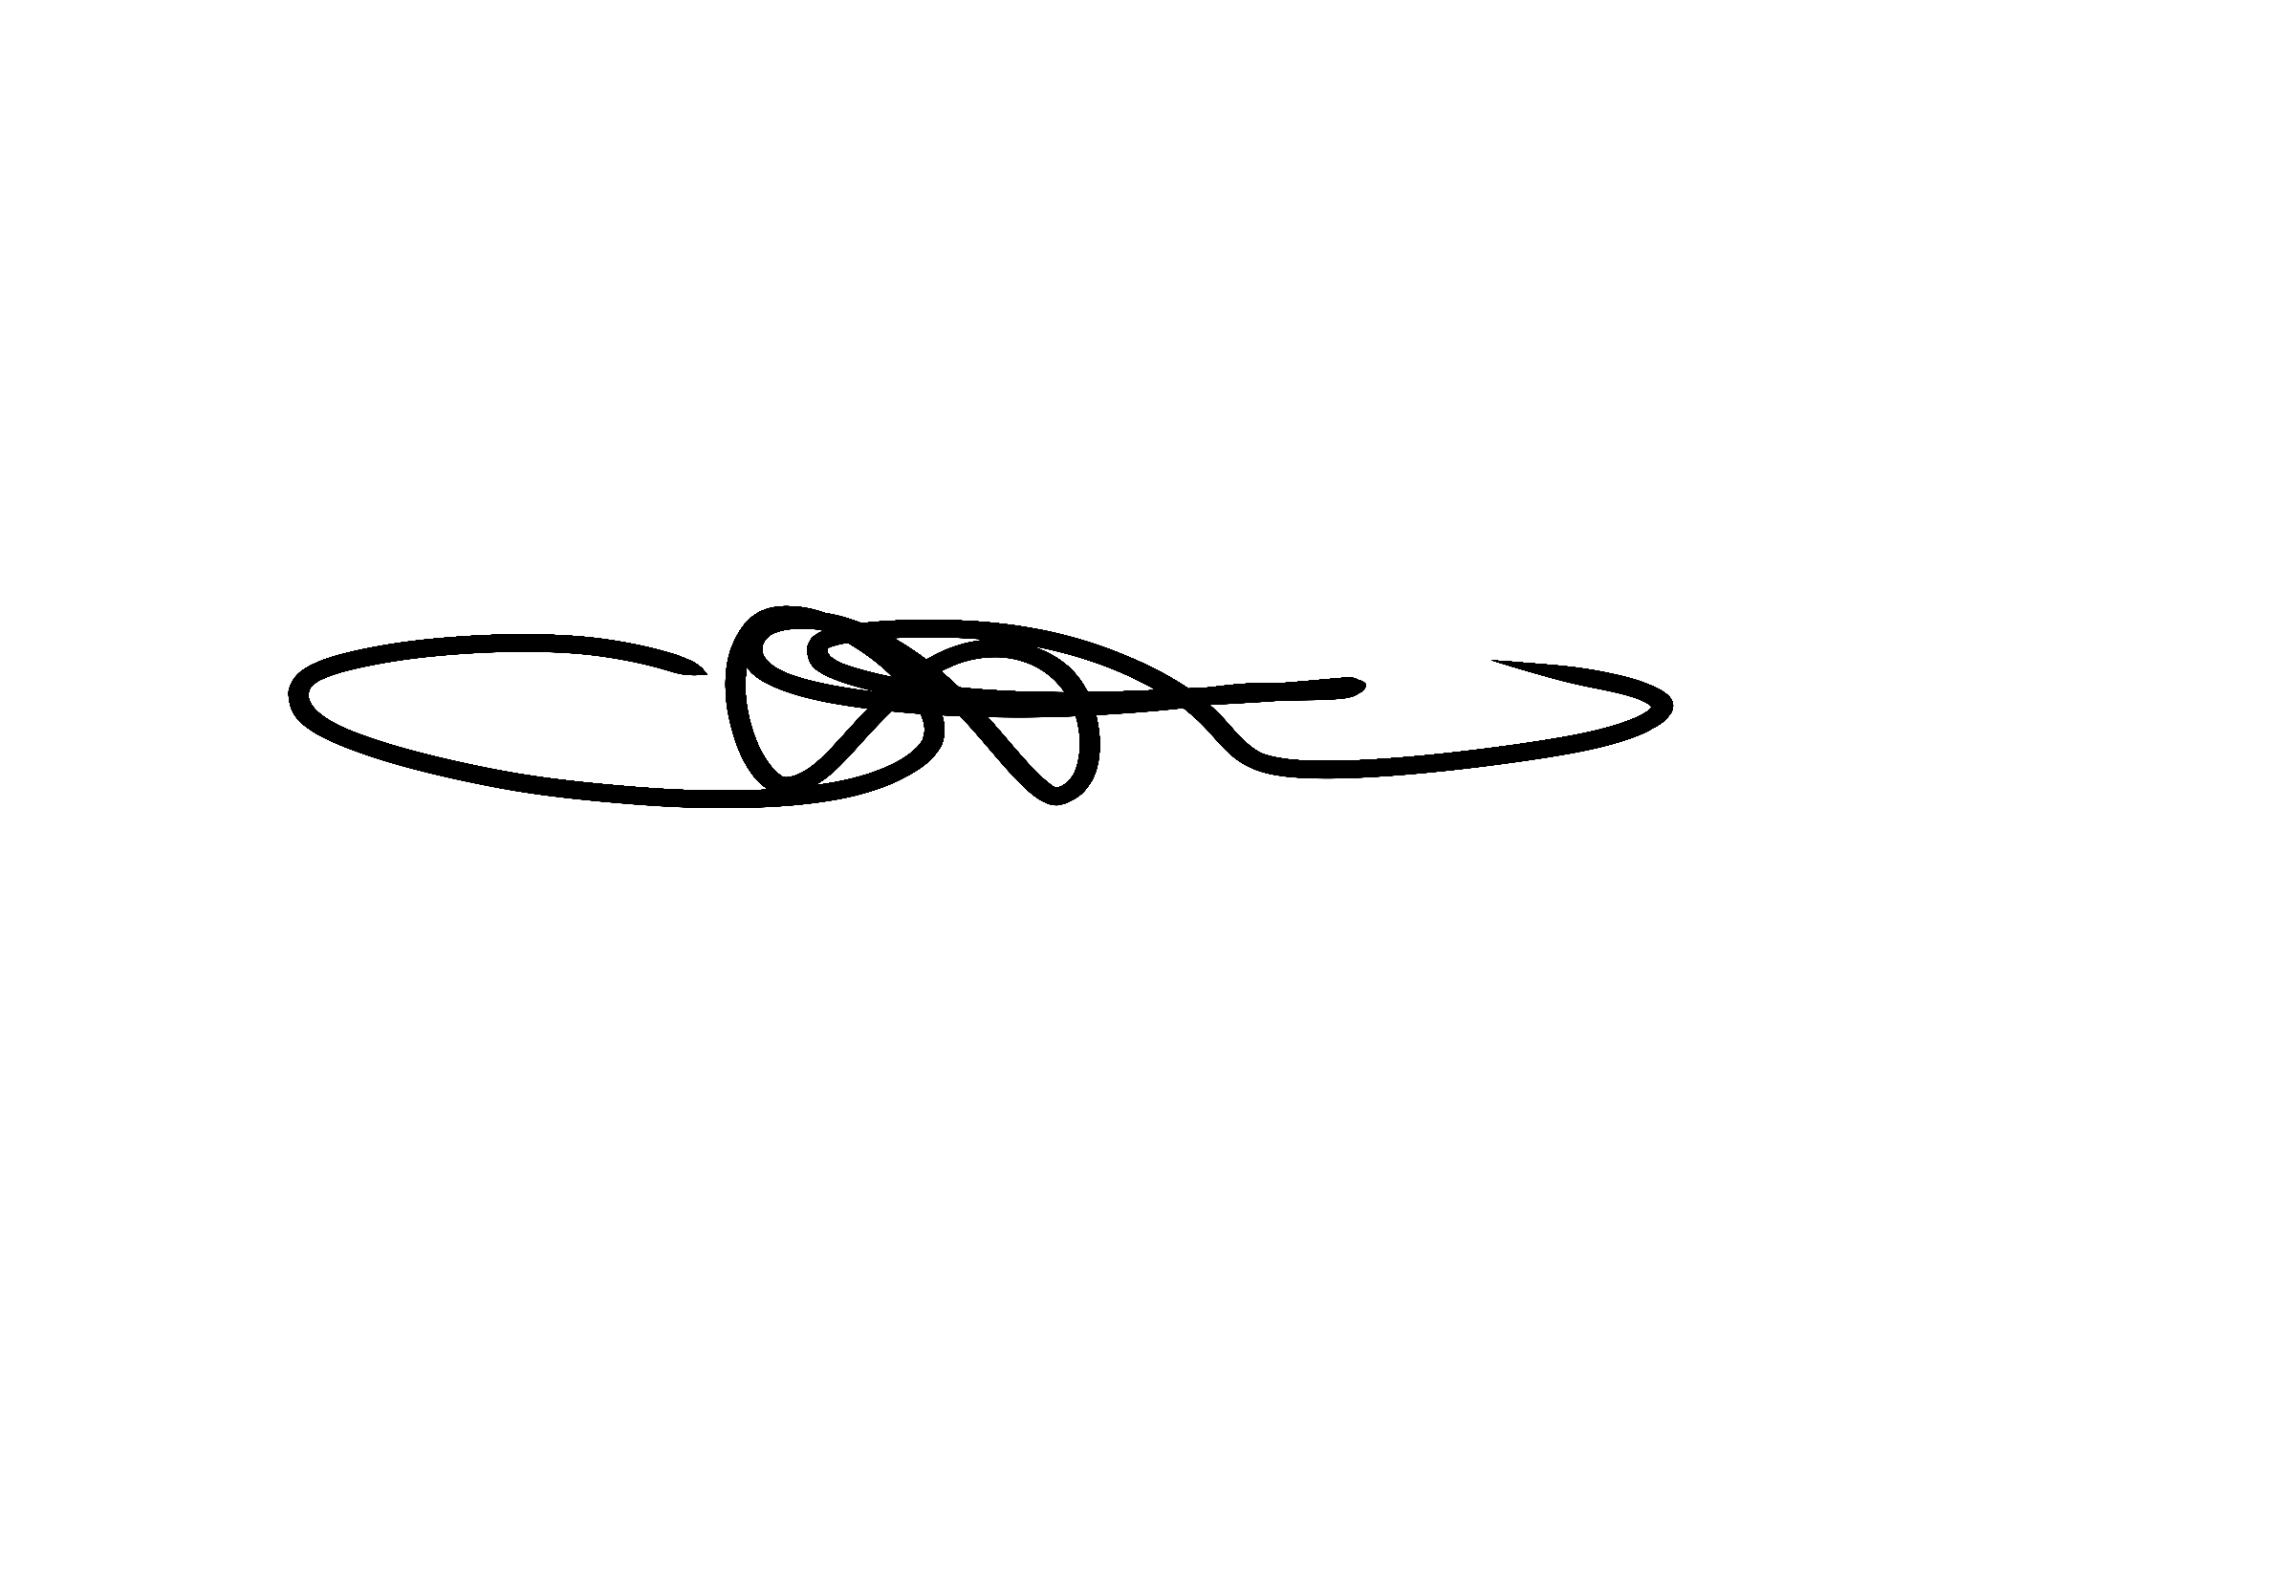

Written in accordance with the Statutory Framework for the Early Years Foundation Stage (2021): Safeguarding and Welfare Requirements: Staff Qualifications, Training, Support and Skills [3.25], Accident or injury [3.51-3.52], Food and drink [3.50]

Minimum exclusion periods for infectious conditions and diseases
Disease/Condition | Exclusion period
Chicken Pox | Until all vesicles (spots) have crusted over
Cold Sores | None. Avoid contact with sores
Conjunctivitis | None
Diphtheria* | Exclusion always necessary, consult local Health Protection Team
Diarrhoea and Vomiting | 48 hours after last episode of diarrhoea or vomiting
Glandular Fever | None
Gastro-enteritis, E. Coli, Food Poisoning, Salmonella and Dysentery | 48 hours after last episode of diarrhoea – further exclusion may be required for some children
Hand, Foot and Mouth disease | WNone
Hepatitis A* | Until 7 days after onset of jaundice
Hepatitis B* and C* | None
High temperature | 24 hours
HIV/AIDS | None
Impetigo | Until lesions are crusted and healed, or 48 hours after starting antibiotic treatment
Influenza | Until recovered
Measles* | 4 days from onset of rash
Meningitis* | Until recovered
Molluscum Contagiosum | None
Mumps* | 5 days from onset of swollen glands
Pediculosis (lice) | None
Pertussis* (Whooping cough) | 5 days from commencing antibiotic treatment or 21 days from the onset if antibiotics not given
Ringworm | Exclusion not usually required
Rubella* (German Measles) | 4 days from onset of rash
Scabies | Until first treatment has been given
Scarlet fever* | 24 hours after starting antibiotic treatment
Slapped Check, Fifth Disease | None (once rash has developed)
Threadworms | None
Tonsillitis | None
Tuberculosis* | Consult local Health Protection Team
Typhoid*, Paratyphoid* | 48 hours after last episode of diarrhoea – further exclusion may be required for some children
Warts (including Verruca) | None. Verruca sufferers should keep feet covered

* Denotes a notifiable disease.
If in any doubt contact local health services for further information.

