Amelia-Nottoway Technical Center News 10/23/2020
ANTC STUDENT SPOTLIGHT!
LaKaia Stith, NHS Senior
Cosmetology II
What brought you to ANTC? A career day at NHS
What is your dream job? My dream job is being a Makeup Artist
What is your favorite class that you have taken so far? Why? Cosmetology is my favorite class. I promise I’m not being biased. It’s my favorite because I can actually be me in there and I can ask questions and not feel embarrassed for not understanding. Also, Mrs. Rajah is very welcoming and funny.
What is the best advice you have been given by your instructor at ANTC? To not live life in fear and to always remain teachable
What is your favorite memory at ANTC? My favorite memory would be making Dream Boards; that was fun, but we also got to look towards the future.
What was the first feeling you had when you attended ANTC? Nervous; In my head, I was like what if I made the wrong choice or what if I can’t do this!
What words of wisdom do you have for other students? Just be yourself in whatever you do, and never doubt yourself. Always encourage yourself!

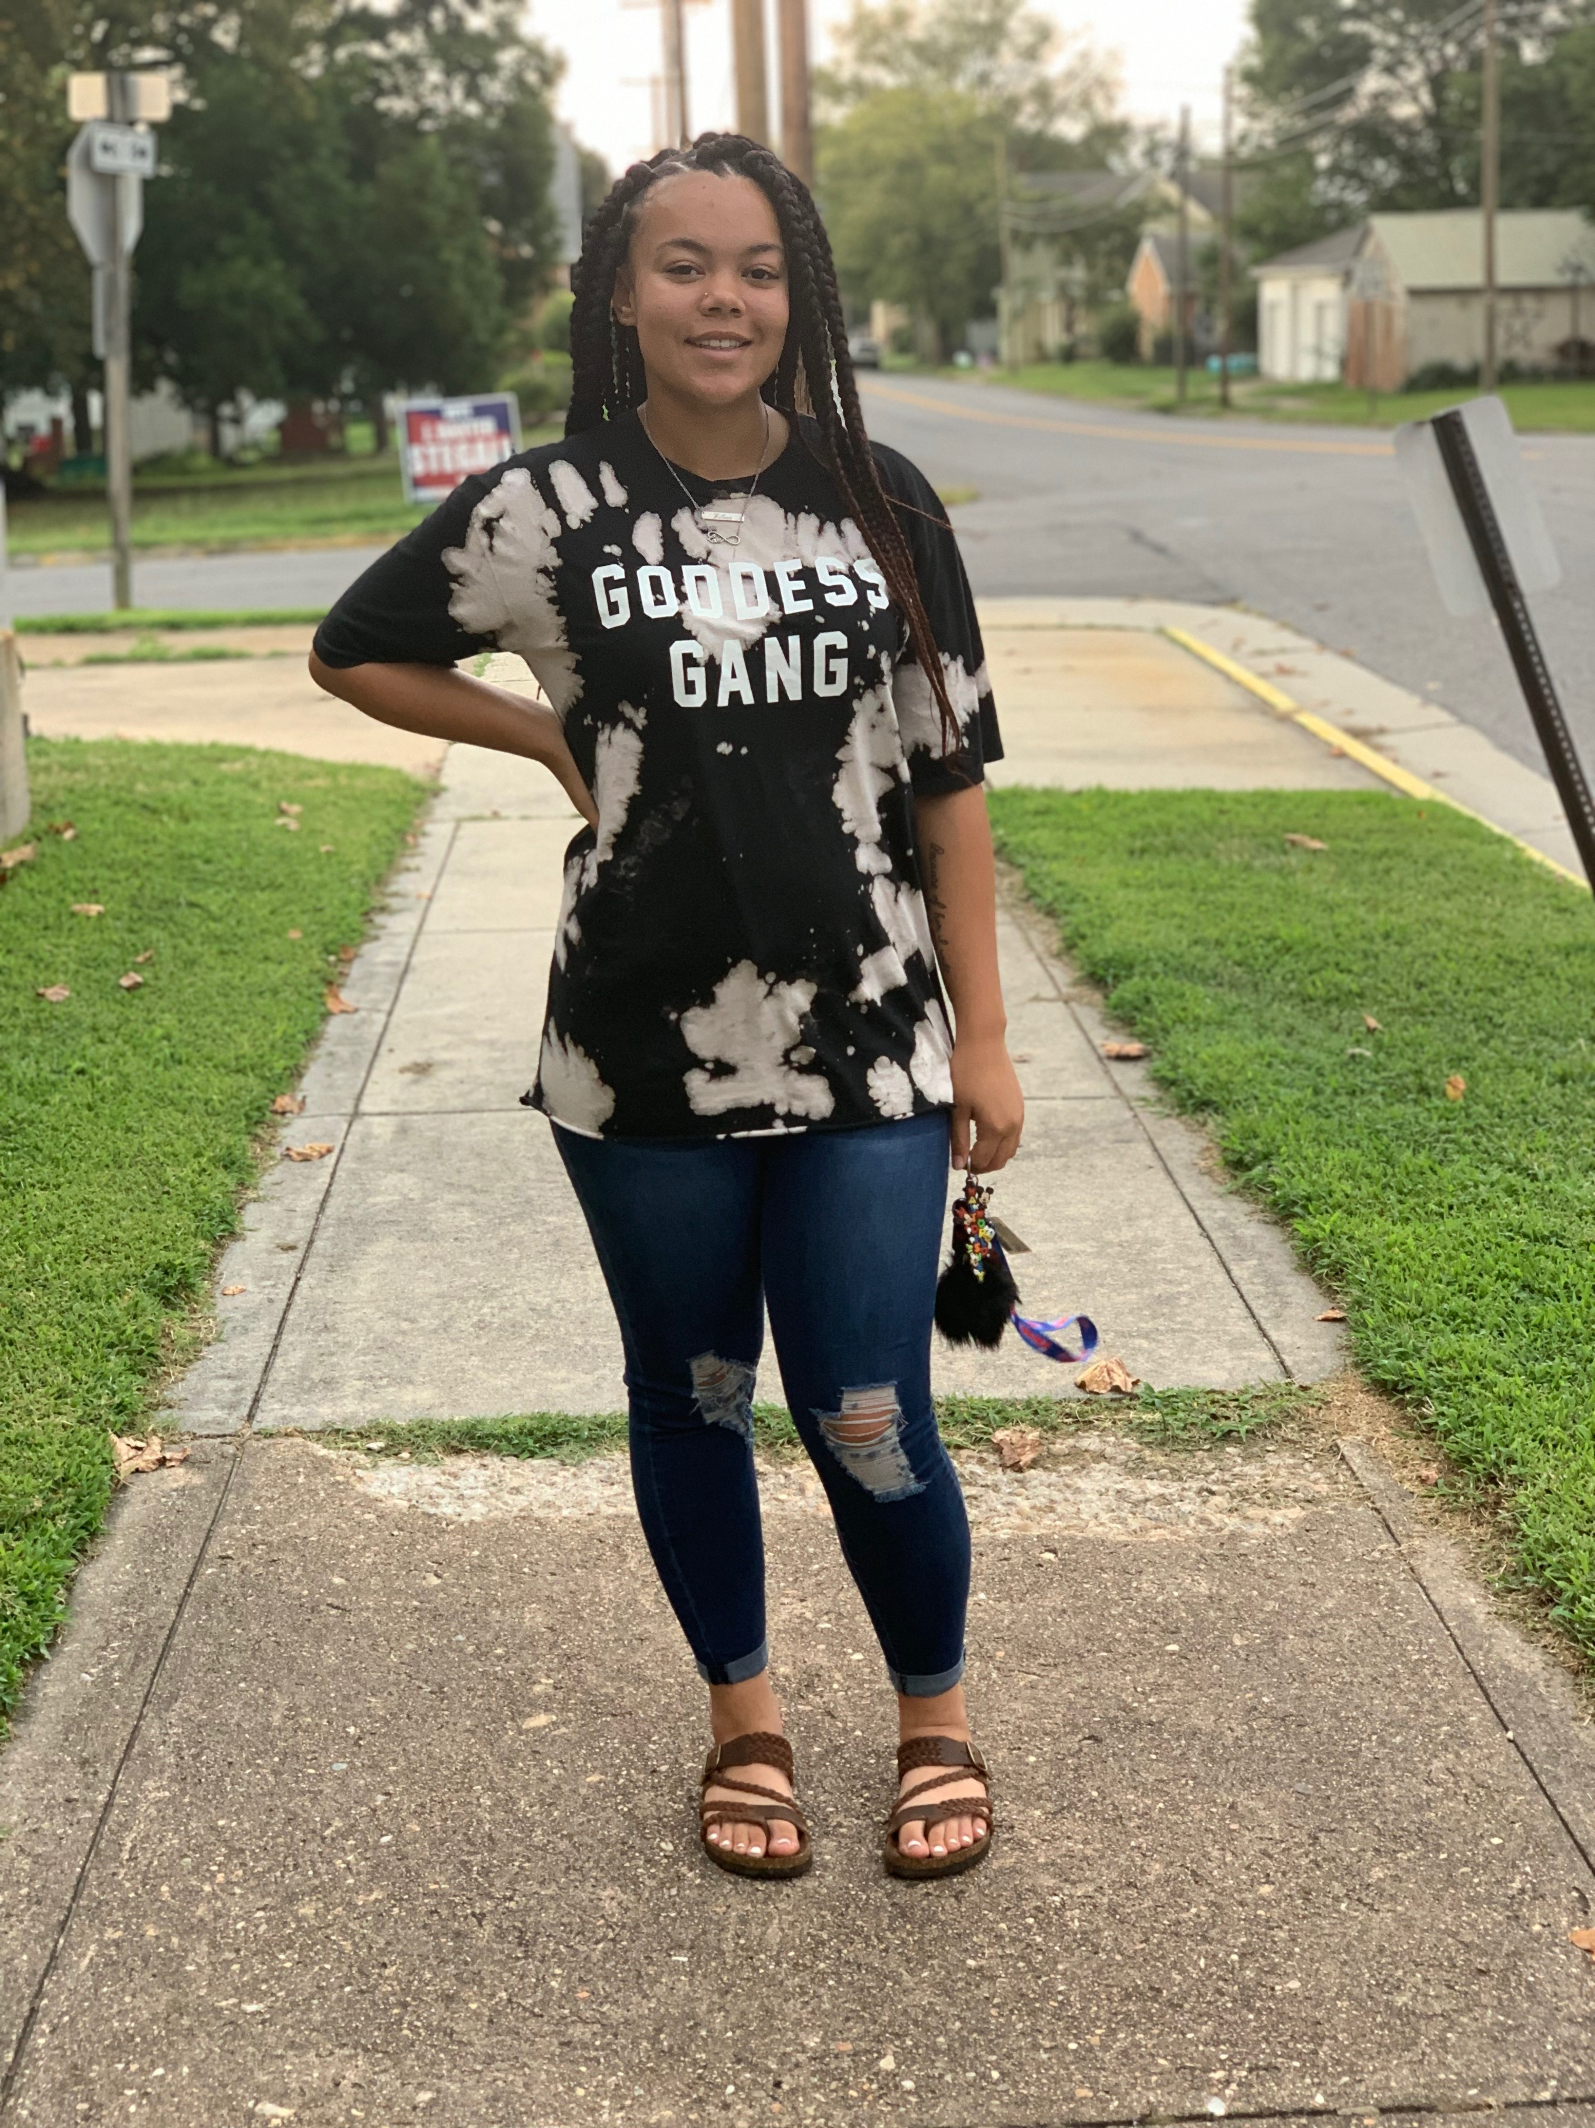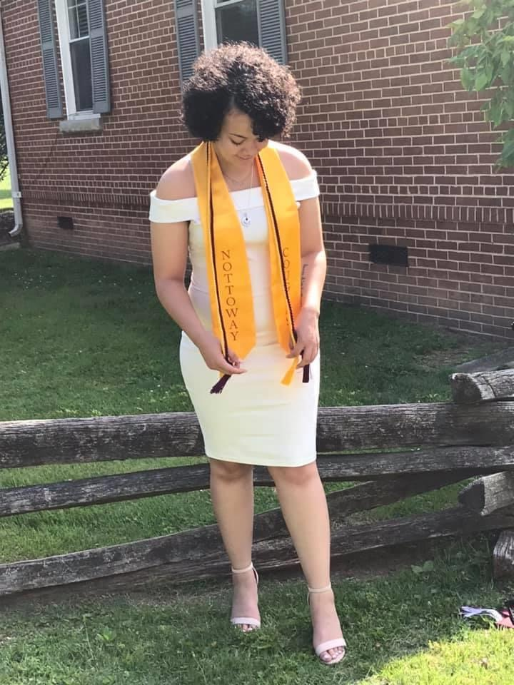
ANTC ALUMNI HIGHLIGHT!
Nicole Yates
High School: Nottoway High School 2020
ANTC Program: Cosmetology
Current Career: Nicole will take her
State Board exams this fall.
Future Plans: Barber
DID YOU KNOW?
ANTC Joint Board Members
Amelia Members
Jim Ferrara, Chairman Glen Wilkerson Catherine Wilkinson
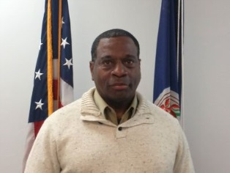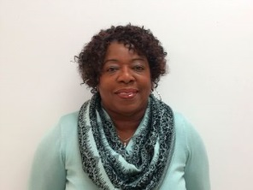

Nottoway Members
Bill Outlaw, Vice Chairman James Fowlkes Jamie Higgins

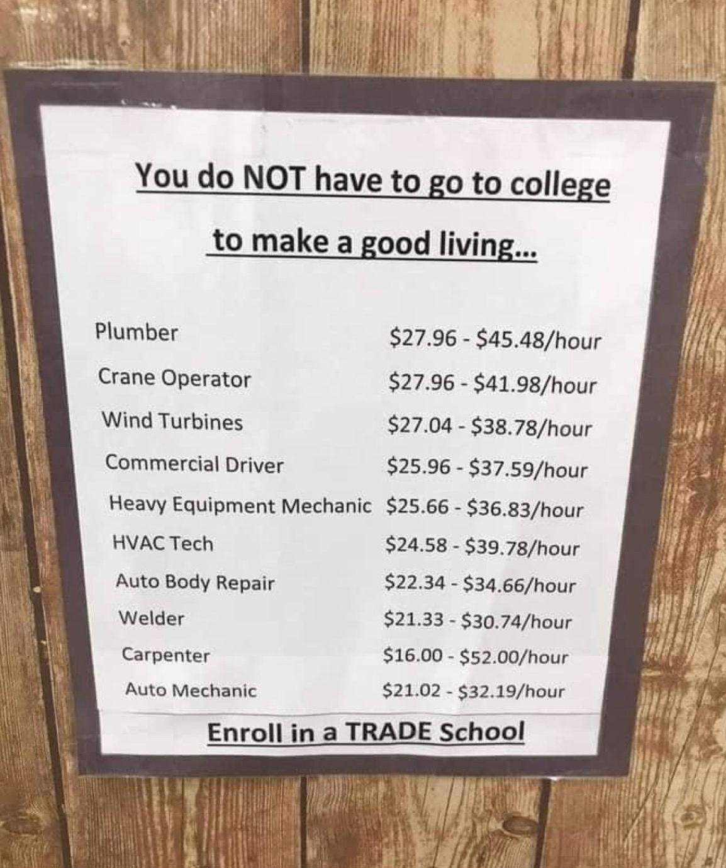
College Is Not For Every Student
It is safe to say that not every student will go to college, and there is nothing wrong with students choosing not to attend college. While college might not be for everyone, CTE provides another avenue to success. A college degree is not necessary for many jobs and there is a market for high-skilled non-college educated labor. In 2017, fifty-five percent of the best-paying jobs were in manufacturing, transportation, and construction. According to the US Bureau of Labor Statistics, a construction supervisor or mechanic can both make a median annual wage of $60,000.00. Not bad!
What would happen if educators embraced the mantra “college isn’t for everybody”? As educators, we need to realize that we do not get to choose which students will and will not go to college, and we cannot direct them to a path that they have no desire to follow. However, it is our charge to educate every student and meet their various needs. You may have a different opinion, but please consider this list of successful individuals who do not possess a college degree!
Steve Jobs Rachael Ray Dave Thomas
Richard Branson Albert Einstein Oprah Winfrey Ford

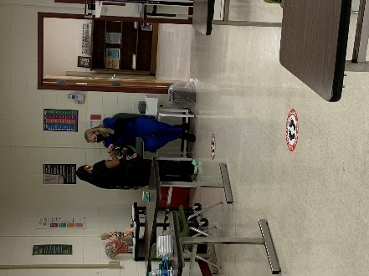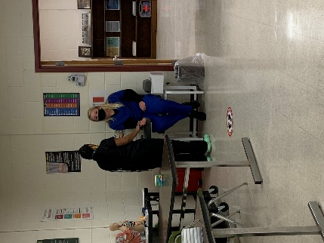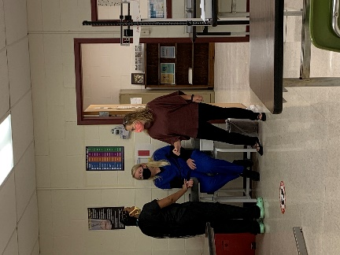
Current Program Feature: Medical Assistant I, Nottoway High School

Skill: Conducting Patient Triage

Tasks/Competencies: Identify patient, date, time, and purpose of visit; Assess vital signs and record findings; Report subjective/objective patient data to the physician.

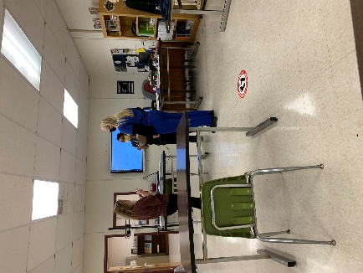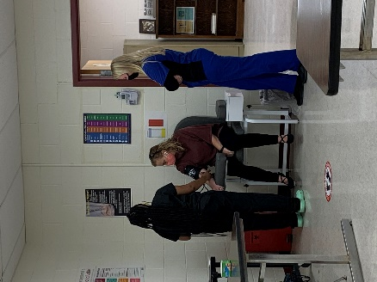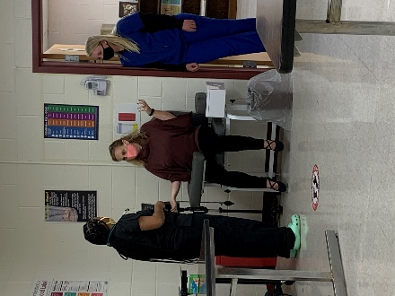
Want to know more about ANTC? Visit our website at https://www.amelianottowaytechcenter.org/
There are great things happening with students engaged in hands-on learning!
Celebration
Congratulations to Mrs. Vronek on being selected to help rewrite the CMAC (Clinical Medical Assistant) exam. We are so very proud!
AMERICAN MEDICAL CERTIFICATION ASSOCIATION
AMCA’s Mission
The AMCA’s mission is to improve the quality of patient care while helping individuals become marketable in today’s ever-changing workforce. The AMCA is committed to working together with schools and organizations to develop quality allied healthcare professionals.

