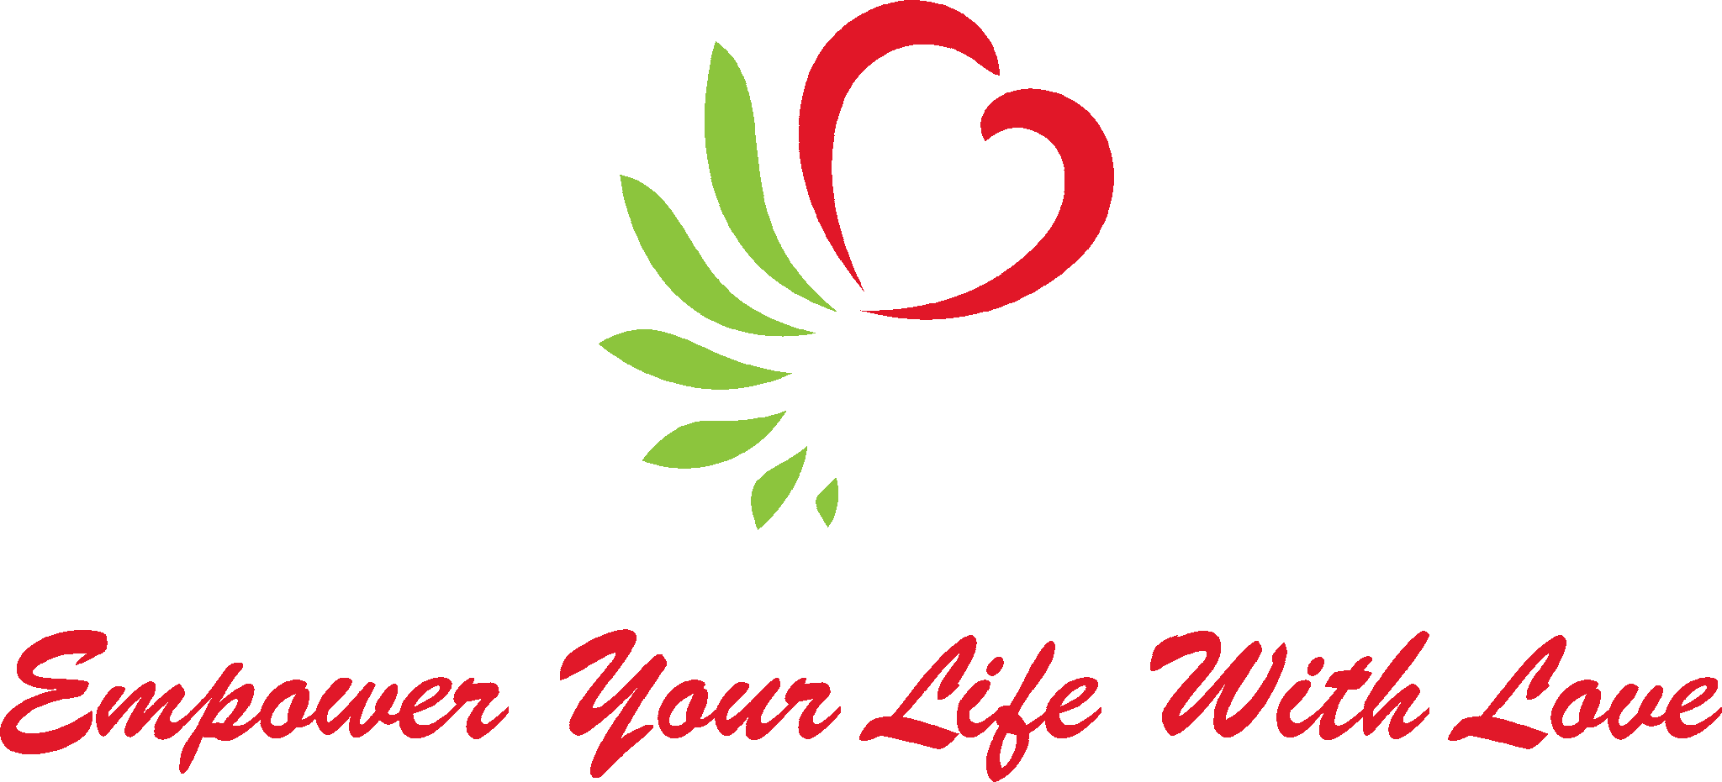
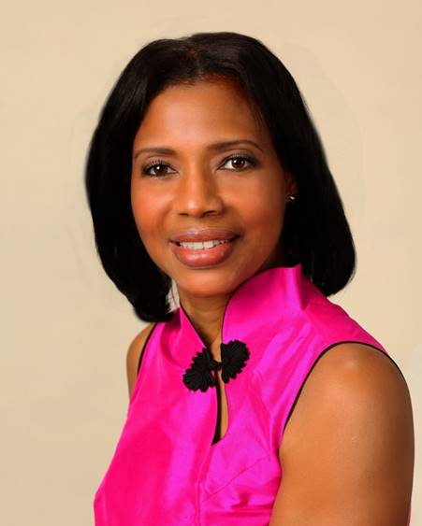
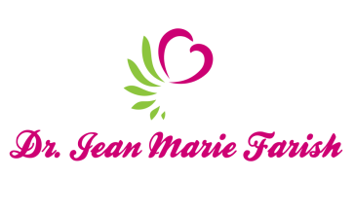

LOVE LIGHT NewsLetter

I am excited to host my VoiceAmerica Empowerment Show-LOVE LIGHT with amazing Guests to cultivate a lifestyle of love and wholehearted connections through worthiness. My show is aligned with my mission to live an altruistic and heart centered life.

MEET LOVE LIGHT GUEST

Dede Lyons
Empowerment Coach, Author, Motivational Speaker, Angel Guide
Founder of Feel Good Express

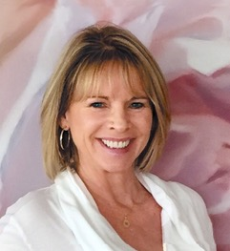

“CONNECTING TO YOUR ANGELS AND UNSEEN HELPERS”

JUNE 12, 2020

ABOUT Dede Lyons

Empowerment coach, author and motivational speaker, Dede Lyons, Founder of Feel Good Express lifestyle program, guides clients with the tools to attract a joy-filled life. Lyons long passion for feeling good coupled with her success at guiding others to feel energized, inspired her to create the FGE methodology for all of life’s challenges. Whether clients are working toward self-love, attracting a soulmate, opening their spiritual connection, or revamping a business plan, the effortless FGE express practices will catapult you towards achieving your personal and professional goals.Lyon’s self-empowerment journey began at age 40 in 1990, when she was in the throws of her NYC Broadcast Television career and running out of steam. She witnessed herself and many colleagues close to burnout from the high demands of their jobs. She was determined to find ways to feel more energized and invigorate herself and her sales team.Thus, she embarked on her spiritual journey, alongside her career in Broadcast Marketing, to experience many different modalities to refresh her mindset and raise her vibration. Utilizing mind/body/spirits tools including self-healing books, juice fasting, aromatherapy, journaling, and the power of positive thinking, Lyons attracted the pearls of wisdom that would eventually become the foundation of FGE.As a result of a career setback, a pivotal and tremendous shift occurred in the spring of 1995 when she received an angel reading from Trudy Griswold, the author of “Angel Speake”. Soon after, Dede was journaling and connecting to her Angelic team on a regular basis. This higher connection not only raised her vibration and opened a direct channel to her Angels, it gave her access to one of her dormant gifts: the gift of claircognizance. This crystal clear knowing enables Lyon to give concrete, customized advice, birthing the term she later phrased “Corporate Spirituality”.

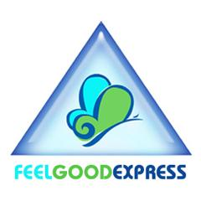
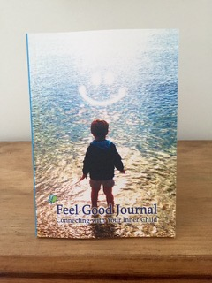
https://www.facebook.com/feelgoodexpressdede/

“An empowered self is a loving self and keep your love light shining”

