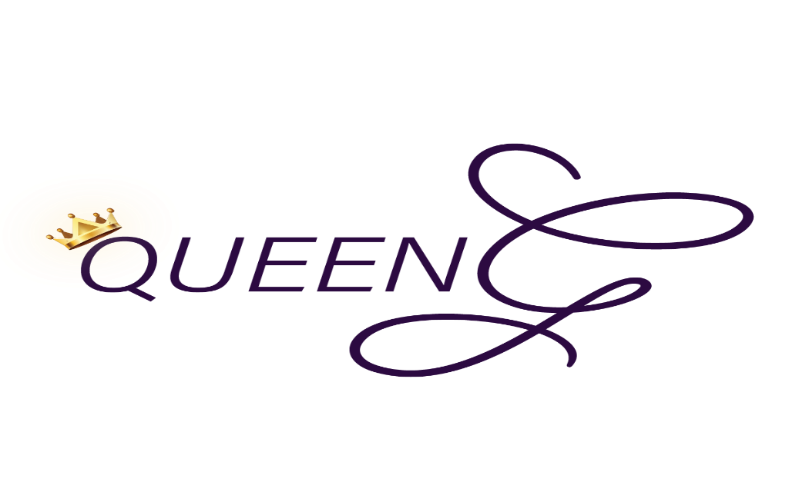
Contract Inquiry Request Form
Queen G Creative Professional Services
Gabrielle Gibson ● 401-484-7285 ● QueenGCreative@GMail.com ● Providence, RI
This is the initial inquiry form that must be completed and returned prior to any consultation or formal agreement. Once this form has been completed and submitted, it will be reviewed. Following the review, you will be contacted for a preliminary consultation. After we have reached mutual terms of agreement, we will modify the contract accordingly. Signature of this document constitutes a legally binding contract. Parties who enter into this agreement do so under their own free will and without coercion. Thank you for your interest in Queen G Poetry services. It will be an honor to serve you.

Purchaser Information
Name:
Address:
Phone Number:
Fax Number:
E-mail:

Type of Service Requested
Initial service request/inquiry must be submitted at least 21 days prior to date of service. Any requests beyond that time frame will be reviewed on a case by case basis.

Please select the service/s you are interested in:
 | Spoken Word/Poetry Performance
 | Workshop Facilitation/Teaching
 | Speaking Engagement/Panel
 | Writing (Professional or Creative)
x | Creative Copy Package (see descriptions on pages 3-4) /Consultation
 | Songwriting
 | Voice Over Work/Vocals
 | Host/Master of Ceremony
 | Other
Please give a brief description of the type of service you are interested in:
______________________________________________________________________________________________________________________________________________________________________________________________________________________________________________________________________________________________________________________________________________________________________________________________________________________________

Performance Information
● If you would like a spoken word/poetry performance, is there a specific topic? Y or N
● Are you requesting a new piece written specifically for your event? Y or N
● Are you requesting one poem or multiple poems? If multiple poems, please specify the number of poems and/or the performance time expectation: _________________________

● Will I be a featured performer or the primary performer? _____________________

● How many sets for this event?___________

● What time will I be performing/presenting? ________ to ________
*Please note that all promotional materials need to be approved prior to publicizing advertisements*

Venue/Event Information

Event (Include title of event and type of event):________________________________________________________
Date/s:__________________________
Venue Location (**If accessing venue requires 5 miles or more of travel, there will be a transportation fee unless client provides transportation. Client provided transportation is negotiable on a contract by contract basis.**):______________________________________________________________________________
Will there be easily accessible parking? Y or N
(All parking expenses, if any, must be compensated by client)
Will there be valet? Y or N
Set-up Date and Time:_____________________________
Will there be a dress rehearsal or sound check? Y or N (If yes, please indicate expected start time)
Will there be a cordless mic and stand? Y or N
Will there be a stool/seat and stand/podium? Y or N
Will there be a projector? (for workshops/teaching services) Y or N
Will there be audio/visual equipment set up?__________________________________________________
Will there be a photographer and/or videographer? Y or N
If requested for more than 2 hours, appropriate amenities must be provided.
(Note: This includes food, lodging, and water. If not available, there will be a small fee so that said amenities can be provided for myself and/or my team. This will be discussed during consultation.)
Will there be available wi-fi connection? Y or N
Am I permitted to sell my merchandise? Y or N
Will there be facilities (such as tables) set up for me to sell my merchandise? Y or N
Note: Any request of service that requires more than one day of work consecutively and/or requires significant travel will merit provision of lodging and transportation by the client, independent of the service fee.

Payment
**Rates vary depending on the services provided. Prices are negotiable depending on the offer.**

Rates | Services
$1,000+ | Spoken Word/Poetry Performance
$1,500+ | Workshop/Speaking Engagement
$850+ | Host/Master of Ceremony
Contract/project specific rate, in addition to writing credits, copyright, and % of revenue from song * | Songwriting
Contract/project specific rate* | Voice Over Work
Contract specific rate | Consultation
Contract/project specific rate* | Other
*=Negotiable after consultation
Creative Copy and Consultation Packages
Package | Cost | Benefits Included
Basic | $235  (one-time payment; save $15) | Consultations (2) +  - Vison casting for your business/goals  - Customized script for EPK promo video
Or $50 deposit
and 4 payments of $50
Bonus | $500  (one-time payment; save $25) | Consultations (2-3) +  - Vison casting for your business/goals  - Customized script for EPK promo video  - Customized copy (limited) for websites and social media platform
 | Or $125 deposit and 4 payments of $100
Advanced | $700  (one-time payment; save $25) | Consultations (4)+  - Vison casting for your business/goals  - Customized script for EPK promo video  - Customized copy for websites and social media platform  - 1-2 customized edited photos for portfolio/branding/promo (samples available)
 | Or $225 deposit and 4 payments of $125
Ultimate | $950  (one-time payment; save $40) | Consultations (6)+  - Coaching  - Vison casting for your business/goals  - Customized scripts for EPK promo video (2)  - Customized copy for all websites and social media platform  - 3 customized edited photos for portfolio/branding/promo (samples available)  - Brand promotion  - 1-on-1 support on contract development
 | Or $250 deposit and 4 payments of $185

Once the legally binding contract for service is signed, there is a non-refundable security deposit of 50% of the total service cost due (deposits for Creative Copy Consultation is specific to package price and payment plan). If there is any part of the contract that is not upheld by the client, there will be an accrued fee of 10% for breach of contract. If the service is cancelled with less than 2 weeks prior to service date/event, there will be a cancellation fee of 30% total service cost. Payment is expected within two weeks of services rendered; late payment will incur a 10% late fee. Upon completion of services, client agrees to refer Queen G Creative to 3 other organizations (personal written referral) without disclosure of compensation.

If any information on this form needs to be altered, please re-submit the form with updated information as soon as possible. It is always my goal to serve you with professionalism, excellence, honesty, integrity, and passion for each and every service. I am committed to providing you with quality service.

Thank you for considering Queen G Creative!
I have read, understand, and agree to the terms of service as presented in this document.
Client Name: _________________________________________________ Date:_____________________

Queen G Poetry: _______________________________________________ Date:_____________________

