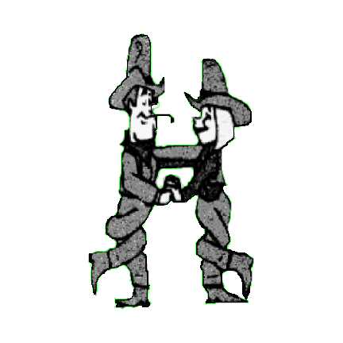 COUNTRY CHOICE PARTNER DANCERS

A LITTLE DAYLIGHT

Choreographed by Chris & Andy Malpass. Qualified Instructors 01606883862 email - chrisandy-partners@hotmail.co.uk

Description 64 count partner dance starting in Closed Western Position. Gent facing L.O.D Lady facing R.L.O.D

Opposite feet throughout. Gents steps given except where stated

Music A Little Daylight (Lovin' You) by Steve Wariner

01- 08 GENT- WALK, WALK, SHUFFLE, WALK, WALK, SHUFFLE LADY – WALK, WALK, SHUFFLE, TURN INTO WRAP, SHUFFLE

01- 04 Walk forward on left, right, shuffle forward on left, right, left

05- 06 Walk forward on right, left, turning the lady 1/2 turn left under gent's left arm into wrap, (Lady on gent's right side)

07- 08 Shuffle forward on right, left, right Both F.L.O.D

*(on counts 5 & 6 lady turns under gent's left arm into wrap)*

09- 16 GENT – WALK, WALK, TRIPLE IN PLACE, PINWHEEL 1/2 TURN, TOUCH

LADY – TURN OUT OF WRAP, TRIPLE IN PLACE, PINWHEEL 1/2 TURN, TOUCH

09- 12 Walk forward on left, right, triple in place left, right, left. Lady 1/2 turn right out of wrap, triple in place on gent's right side

13- 16 Pinwheel 1/2 turn right walking on right, left right, touch left Gent F.R.L.O.D Lady F.L.O.D

*(on count 9 lady turns under gent's left arm out of wrap into Double Open Hand Hold. Lady on gent's right side)*

17- 24 GENT – BEHIND, SIDE, 1/4 TURN, TOUCH, LADY – SIDE, BEHIND, 1/4 TURN, TOUCH, BOTH – STEP 1/2 TURN, SIDE SHUFFLE

17- 18 Cross left behind right, step right to right side. Lady step right to right side, cross left behind right

19- 20 1/4 turn right stepping onto left, touch right next to left. Lady turns 1/4 right stepping onto right, touch left

21- 24 Gent step forward on right, pivot 1/2 turn left stepping onto left, side shuffle to right on right, left, right Gent F.O.L.O.D

Lady step forward on left, pivot 1/2 turn right stepping onto right, side shuffle left on left, right, left Lady F.I.L.O.D

*(on count 19 release hands. On count 22 rejoin in Double Open Hand Hold)*

25 – 32 BOTH - CROSS ROCK, SIDE SHUFFLE, CROSS ROCK, SHUFFLE 1/4 TURN

25- 28 Cross rock left in front of right, recover onto right, side shuffle to left on left, right, left (Lady crosses behind)

29- 32 Cross rock right in front of left, recover onto left, shuffle 1/4 right on right, left, right Both F.R.L.O.D (Lady crosses behind)

*(on count 31 release gent's right hand, lady's left, now holding inside hands)*

33 – 40 BOTH- STEP 1/2 TURN, SHUFFLE FORWARD GENT- WALK, WALK, WALK, TOUCH LADY- 1/2 TURN RIGHT, TOUCH

33- 36 Step forward on left, pivot 1/2 turn right stepping onto right, shuffle forward on left, right, left Gent F.L.O.D Lady F.R.L.O.D

37- 40 Walk forward on right, left, right, touch left. Lady turns 1/2 right under joined hands on left, right, left, touch right

*(on count 34 release hands, join inside hands. On count 37 lady turns under gent's right arm into Double Open Hand Hold)*

41 – 48 BOTH- ROCK BACK, RECOVER, SHUFFLE 1/2 TURN, ROCK BACK, RECOVER, GENT SHUFFLE 1/4 TURN. LADY SHUFFLE 3/4

41- 44 Rock back on left, recover onto right, shuffle 1/2 right on left, right, left. Lady shuffle 1/2 left Gent F.R.L.O.D Lady F.L.O.D

45- 48 Rock back on right, recover onto left, shuffle 1/4 turn left. Lady shuffle 3/4 right Gent F.O.L.O.D Lady F.I.L.O.D

*(on counts 43 & 44 release gent's left, lady's right hands. Lady turns under gent's right arm)*

*(on counts 47 & 48 lady turns under gent's right arm, rejoining in Double Open Hand Hold)*

49 – 56 BOTH - SIDE, TOGETHER, SHUFFLE 1/4 TURN, 1/2 TURN, SHUFFLE BACK

49- 52 Step side left on left foot, step right next to left, shuffle 1/4 turn left on left, right, left BOTH F.L.O.D

53- 56 1/2 turn left on right, left, shuffle back on right, left, right BOTH F.R.L.O.D

*(on count 51 release gent's left, lady's right hands. On count 53 release hands. On count 54 rejoin inside hands)*

57 – 64 BOTH-1/4 TURN, TOGETHER, SHUFFLE 1/4 TURN. GENT- WALK, WALK, SHUFFLE FORWARD LADY-1/2 TURN, SHUFFLE BACK

57- 60 On left foot 1/4 turn left, step right next to left, shuffle 1/4 turn left on left, right, left

61-64 Gent- Walk forward on right, left, shuffle forward on right, left, right Lady 1/2 turn right on L, R shuffle back left, right, left

*(on count 57 Double Open Hand Hold. On count 59 release gent's left, lady's right hands)*

*( Lady turns under joined hands to finish in Closed Western Position)*

KEEP SMILING