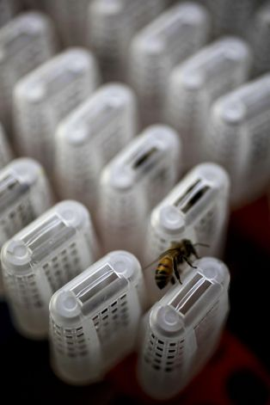 | Order Form  2021 Queen Order
Buck’s Busy Bee’s, LLC | DATE: __________________________
5254 Bellview Drive
Brainerd, MN 56401
Phone 218-330-4627
bbb@bucksbusybees.com

Billing Address  ____________________________  ____________________________  ____________________________  Phone Number____________________________  Email____________________________________ |  |  | Shipping Address  ________________________  _________________________  _________________________

qUANTITY | DESCRIPTION | uNIT pRICE | TOTAL
 |  | TOTAL

BEE DAY QUEENS  Picked Up Only  (ORDERS UNDER 50)  MAY 9TH , 2021  $38.00 Each - Website  $35.00 Each – Cash  (we only sell Queens in Quantities under 50 On Bee Day) | Nucs  (4 Frame Nucs)  $159.00 - Website  $149.00 - Cash | Notes:

Mail All Order Forms To: Buck’s Busy Bee’s, LLC 5254 Bellview Drive, Brainerd, MN 56401
www.bucksbusybees.com

