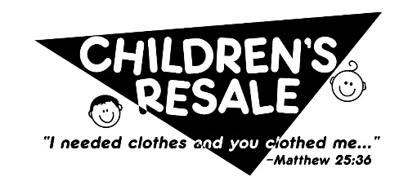
Partnership Program 2022

The Children’s Resale will be hosting our bi-annual sales and would like to invite you or your business to partner with us in serving families across the Michiana community. Our resale offers high-quality, child and maternity items for a fraction of retail prices. Your partnership will allow for a child in need to receive a monetary voucher to shop our resale.
HOW YOU CAN GET INVOLVED
WHO: Individuals, families, groups, local businesses, companies, churches, schools, & independent distributors.
WHAT: Sponsor a child or children through a monetary donation. 100% of donations will go towards providing vouchers to families in need.
WHEN: Sponsorship will be accepted anytime with 2022 Resales on March 26th/Nov 5th.
HOW: Complete the form below and submit it, along with your donation, to a Resale Committee Member, or via mail at P.O. Box 911, Wakarusa, IN 46573

Businesses, we extend an offer to:
- Include your business name to our Resale Community Partnership take home flyer & website.

YES, I would like to partner with the Children’s Resale!!
Your Name: |  |  | ______________________________________________ Phone: ____________________
Mailing Address: |  |  | _________________________________________________________________________
Email: | __________________________________________________________________________________
Business Name (if applicable): |  |  |  |  |  |  | _______________________________________________________________
Website: |  |  | _________________________________________________________________________
□ I want my donation to remain Anonymous (information above will not be publicized if this box is checked)
Enclosed is my gift of: |  |  |  |  | (every $25 sponsors one child)
 |  | □ $25 |  | □$50 |  |  |  | □$75 | □$100 | □$125 | □other $_________
- Make checks payable to ‘Children’s Resale’
May we contact you with future partnership requests? □Yes, please □No, thank you
Resale Committee contact: |  |  |  |  |  | __________________________________ |  |  |  |  |  | Phone: | _____________________

