THE OBERHASLI BREEDERS OF AMERICA
The Oberhasli Breeders of America (OBA) club was organized in 1976 in order to preserve, promote and develop the Oberhasli breed. Since the club was formed, it has been successful in raising awareness about the attributes of this breed and establishing programs and tools for Oberhasli breeders to utilize towards improving and “showing off” their animals. The OBA offers the following services and programs to its membership:
- All-American Program
- Premier Youth Competition
- Comprehensive and up-to-date website
- Newsletter
- Swiss Belle Milk Production Recognition
- A voice for the breeders!
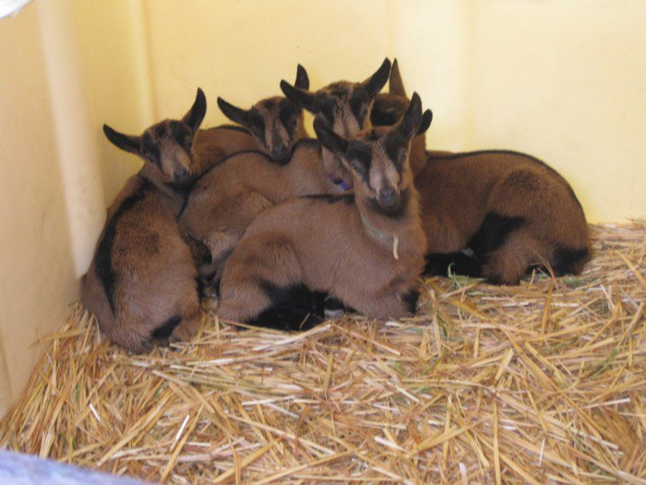

More info on the web at: www.oberhasli.net

OBERHASLI BREED RESOURCES

- Oberhasli Breeders of America:
www.oberhasli.net

- American Dairy Goat Association:
www.adga.org

- American Goat Society:
www.americangoatsociety.com

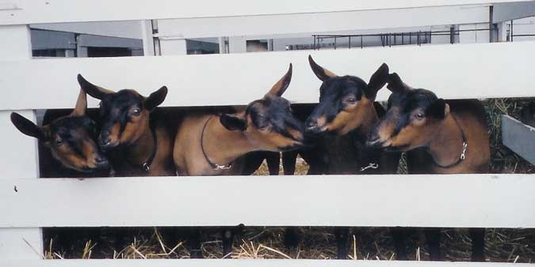

OBERHASLI


DAIRY GOATS
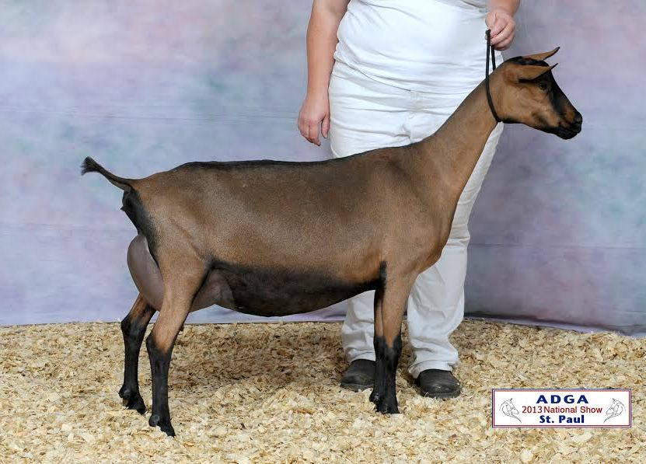

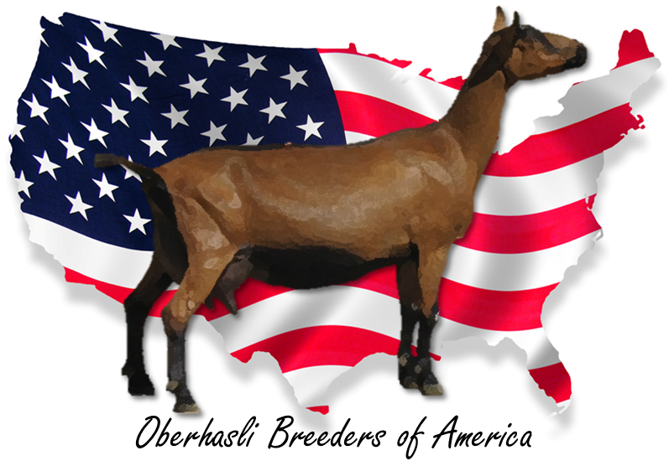
SGCH HAYCREEKS XCITED SONA
2013 ADGA Nat’l 1st pl. 2 year old
2012 OBA All-American Winner
Breeder: Morgan Allen

- History of the Oberhasli Breed
- Oberhasli Breed Description
- Oberhasli Milk Production
- Oberhasli Breeders of America
- Oberhasli Breed Resources

PRODUCED COURTESY OF THE OBERHASLI BREEDERS OF AMERICA

OBERHASLI BREED DESCRIPTION
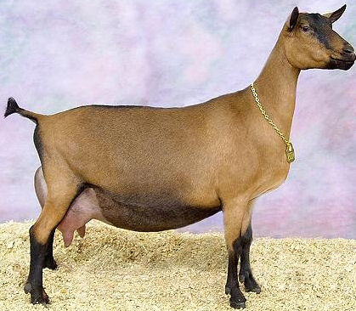
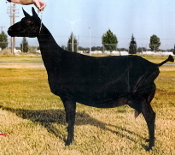

- The Oberhasli is a Swiss dairy goat.

- This breed is a medium size, vigorous and alert in appearance.

- Its color is chamoisee (red bay with black head, legs, belly, and dorsal markings). Does can be all-black in color; bucks must be the correct bay color.

- Mature Oberhasli does are generally around 28-30” tall at the withers (top of shoulders) and weigh, on average, 120-150 lbs. Mature bucks are generally 30-32” tall at the withers and weigh approximately 150-175lbs.

- The Oberhasli is among the most docile of dairy goat breeds.

OBERHASLI MILK PRODUCTION

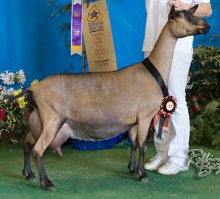
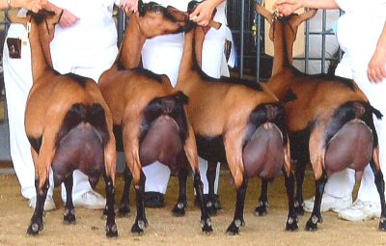
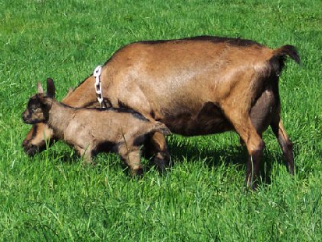

- All-Time Oberhasli Milk Production Record High:
4665 lbs. of milk in 304 days (15.35 lbs/day)

- All-Time Oberhasli Butterfat Production Record High:
234 lbs. (5%) in 304 days

- 2014 Oberhasli Breed Average (275-305 DIM):
2133 lbs Milk; 77lb/ 3.6% Butterfat; 63lb/ 3.0% Protein

HISTORY OF THE OBERHASLI BREED

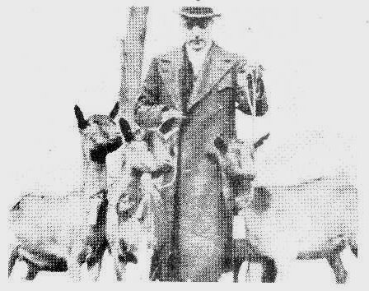
Oberhasli dairy goats were first imported to the U.S. from Switzerland in 1906 and 1920. Unfortunately, these animals were crossbred with other breeds and eventually disappeared into the general goat population. In 1936, a Dr. H.O. Pence (pic’d at right) made an additional importation. Although these animals did end up laying the foundation for the breed in America today, more obstacles were to come. Oberhasli goats were mistakenly considered a branch off of the already established Alpine breed and thus were shown and compared to them. Because of this “clumping” of the Oberhasli and Alpines breeds, they were bred with other Alpines with the resulting animal considered American Alpine; this began a trend that could have very well been the end of Oberhasli in America…again. One important note, though, is that because the Oberhasli breed was crossed with Alpines, many of the chamoisee Alpines (those with similar color patterns to the Oberhasli) today can trace their ancestry back to Oberhasli roots.
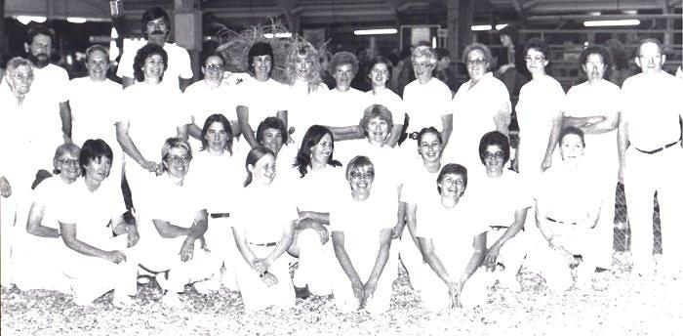
Esther Oman of Santa Rosa, CA believed in keeping her small herd of Oberhasli pure and separate from Alpine genetics. She is credited largely for preserving the Oberhasli breed in the U.S. Through hers and a few other breeders’ efforts the Oberhasli breed began to grow in numbers and popularity. In 1979, the American Dairy Goat Association (ADGA) granted the Oberhasli breed their own herdbook separate from the Alpine breed. Shortly thereafter, in 1985, the Oberhasli breed was allowed to exhibit in the ADGA National Show. Since then, the breed has grown tremendously in the areas of type and productivity. Once considered the lesser breed of the recognized dairy goat breeds, Oberhasli today can often be found winning Best in Show awards, and achieving Linear Appraisal scores and milk records comparable, and sometimes better to the other breeds.
Oberhasli exhibitors at the inaugural National Show for Oberhasli (1985)

