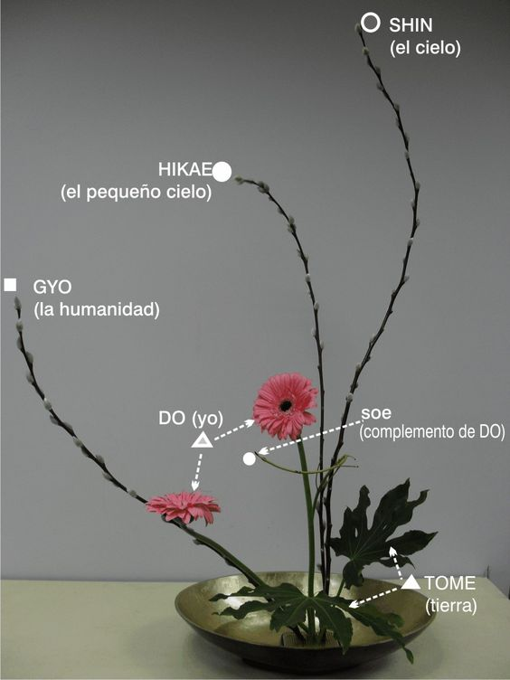
IKEBANA INSTRUCTIONS
Moribana: Meaning "piled up." These arrangements are designed in wide, shallow containers.
Nagerie: Meaning "thrown in." Nagerie arrangements are made in tall, narrow vases. Kenzan: The tool used to support stems inside the container. The pinholder tool is the most commonly used.
Shin, Soe, and Hikae: In the Sogestu School of Ikebana, the rules upon which this article is loosely based, shin, soe, and hikae are the terms for the 3 main pieces of an arrangement. Shin is the longest branch, and represents heaven; soe is the medium branch and represents man; and hikae is the shortest and represents the Earth.
Jushi: Jushi are any flowers or leaves that do not make up the 3 main placements. They are meant to complement the shin, soe, and hikae. Add as many jushi as you like, but only in odd numbers.
Give the flowers a fresh cut underwater, at an angle. Remove any damaged leaves, and any that might get tangled under the water.
Containers are secondary to the flowers, and they should complement the design without overpowering the complete image.
Before you begin your arrangement, look at the flowers for inspiration. Their form might suggest a season, a landscape, or a haiku. Finding this direction and letting the form of the blossom or stem guide you is the key to learning ikebana.
Complete your arrangement by adding water to the container and, if you like, covering the frog with leaves, more flowers, or mosses.
Bristolgardenclub.org

