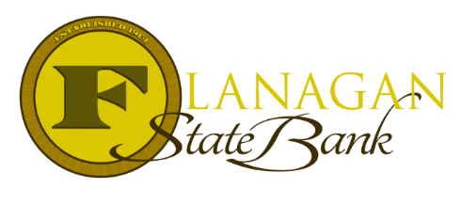
Mortgage Tidbits

Keeping you informed and in the know….

Investment Properties…dun, dun, DUN!

Just kidding! They’re not that scary once you get to know the rules surrounding them. Let’s take a look!

Fannie Mae & Freddie Mac Financing:
- For purchase & limited cash out refinance’s transactions, the max LTV/CLTV/HCLTV for a 2-4-unit property is 75%.
- For a cash out refinance transaction, the max LTV/CLTV/HCLTV for a 1-unit property is 75%, for a 2–4-unit property it’s 70%.
- Gift funds are not allowed for use as a down payment. Down payment must be the borrower’s own funds.
- All borrowers must not be obligated on more than 10 financed real properties in total, this includes the subject property and the borrower’s primary residence.
- Minimum credit score of 620 required and the AUS must give an Approve/Eligible or Accept
Freddie Mac Financing:
- For purchase & limited cash out refinance’s transactions, the max LTV/CLTV/HCLTV for a 1-unit property is 85%.
- Private Mortgage Insurance, or PMI, will stay on the loan until an LTV of 65% on a single-family residence is reached.
Fannie Mae Financing:
- For purchase & limited cash out refinance transactions, the max LTV/CLTV/HCLTV for a 1-unit property is 75%.

Now of course, you might be thinking why buy an investment property? Turns out, they can offer benefits such as a greater asset stability, increased diversification, protection from inflation, and arguably the best, tax benefits! Please confirm all tax benefits with your CPA or Tax Preparer!

Keep in mind though, a couple things matter for qualifying! Like seller contributions cannot exceed 2% and the entire down payment must come from the borrower’s own funds. Inquire with us to learn more!
Call us today for the best answers to the mortgage questions!
Insert photo here or delete box when ready to use
~ Provided to you by ~
Name: Phone:
Title: Email:
Address: City, State, Zip
Apply Now Link:

