Amelia-Nottoway Technical Center News 5/6/2021

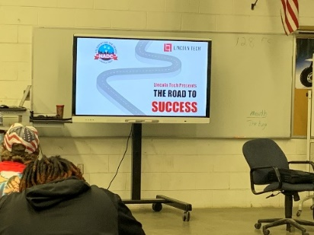

**Program:** Auto Body l & II; Amelia and Nottoway

**Skills:** Post Graduate Planning

Collision Repair

**The Road to Success**

**Presentation by**

**Lincoln Tech**

**Nashville Auto-Diesel College (NADC)**

**QuinnNash**

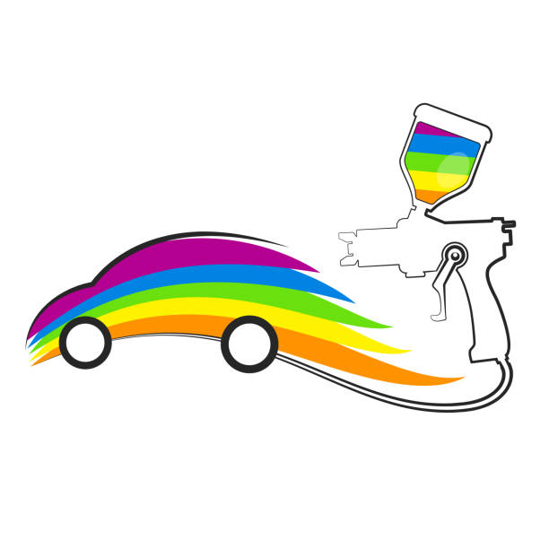

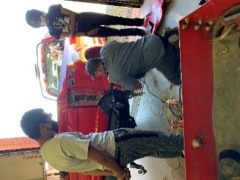 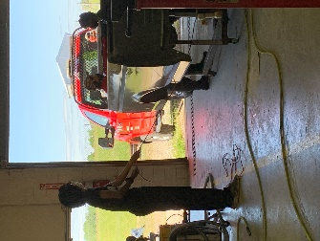 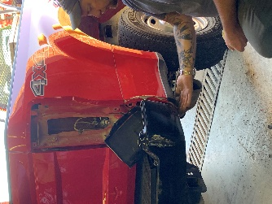



**Program:** Cosmetology l

**Skills:** Cutting and Styling

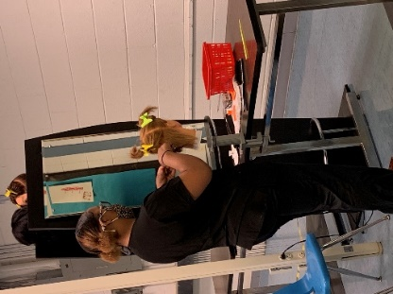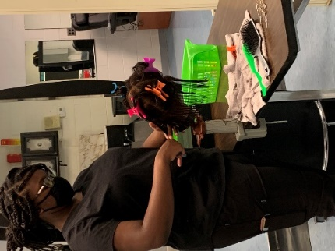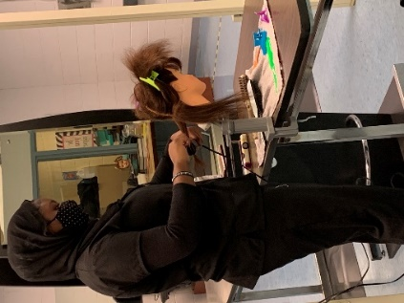

**Webinar with Southside College of Health Sciences**

**Quinn**

**Program:** Medical Assistant I & II

**Skills:** Post Graduate Planning

CPR – Adult

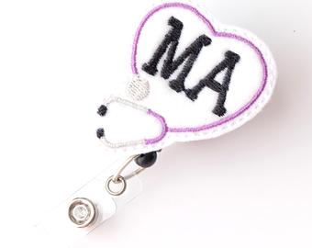

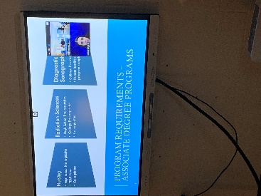 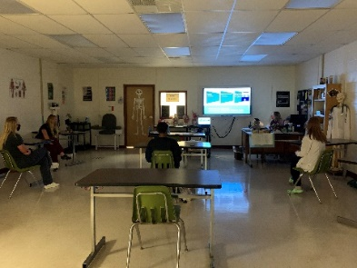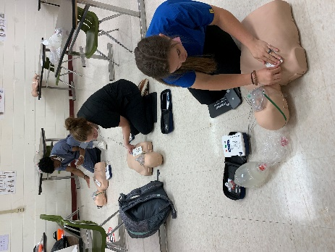 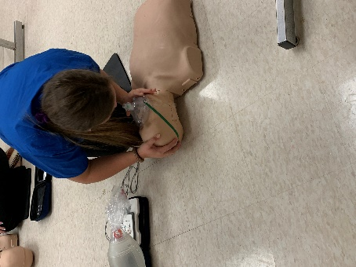 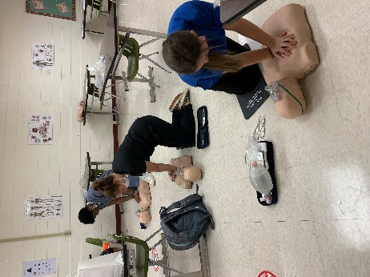

**Parent Presentation**

**Chaeli Quinn**

**Quinn**

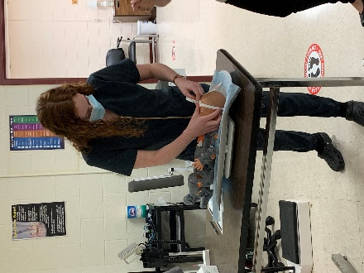 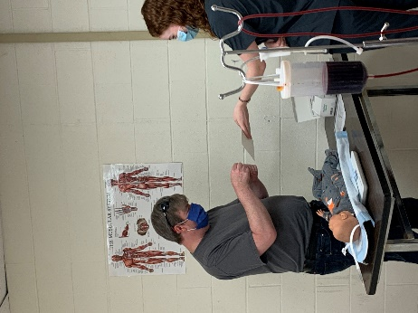 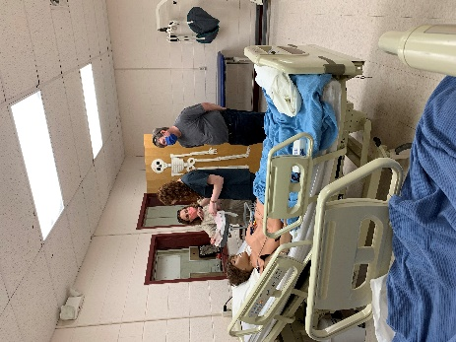

**Strep Test**

**Quinn**

**Pediatric Assessment**

**Quinn**

**EKG**

**Quinn**