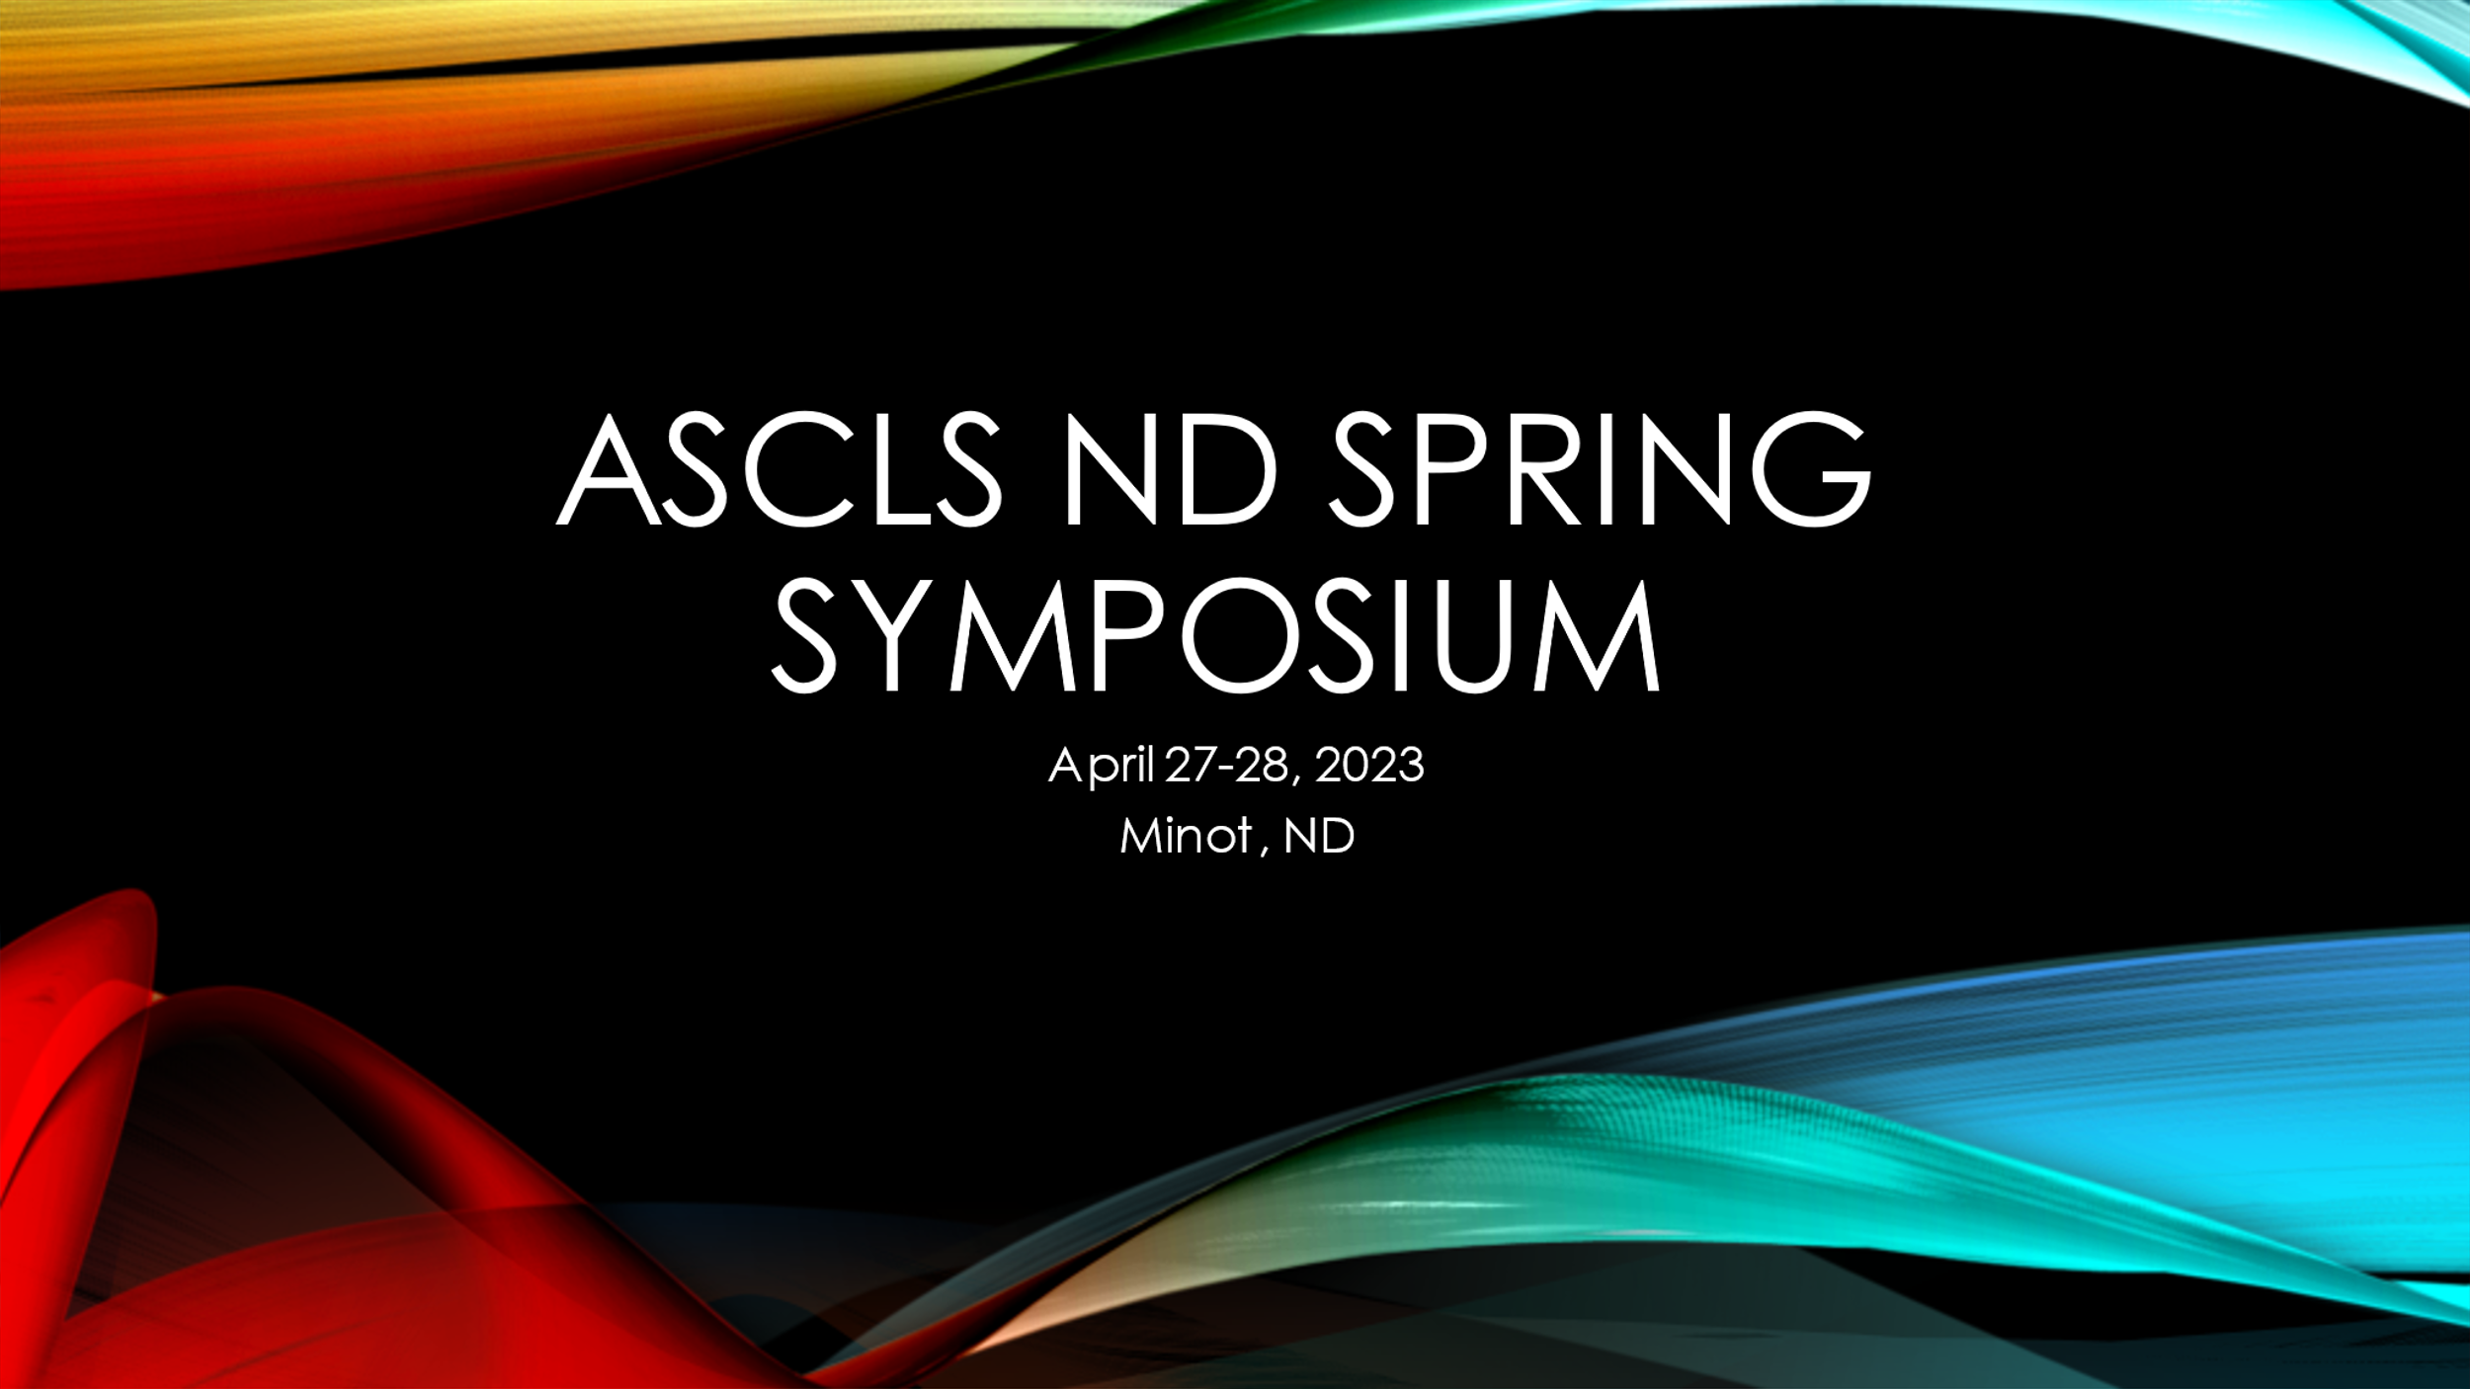
“Spring Symposium” - April 27-28, 2023
EXHIBITOR REGISTRATION FORM
American Society for Clinical Laboratory Science - North Dakota

Supporting Sponsors:
Sleep Inn & Suites
2400 10th Street SW
Minot, North Dakota 58701
(701) 502-0028

Room Special Rate*: $99.00 + tax
(traditional Double Queen or King)

*To receive special rate, guests must call and provide group ID: ASCLS
Rooms can be reserved at this rate for Wednesday, Thursday and/or Friday
Reserved room block will only be available until April 7, 2023 - make your reservations early!

SPRING SYMPOSIUM VALUE, BENEFITS & HIGHLIGHT - We look forward to the opportunity for your business to interact and display your great products, technology and recent developments with our attendees as you make contacts with our laboratorians across this area.

How to register and submit payment:
- Complete form  - Email completed form to: Sharon Reistad at sreistad@srt.com  - Payment via check (payable to ASCLS-ND) | Mail check to: Sharon Reistad  7340 37th Ave SE  Minot, ND 58701

ASCLS-ND Website: https://asclsnd.org W-9 #’s/Form: available upon request

ASCLS ND SPRING SYMPOSIUM
April 2728, 2023
Minot, ND

THANK YOU FOR YOUR CONTINUED SUPPORT!!!

REGISTRATION INFORMATION
Complete & submit registration form and payment.

Pre-registration is required.
Registrations must be postmarked by April 10, 2023
Late fee of $20 applies after April 10, 2023.

Please enter information in this typeable document:

Company Name:
Contact name:
Sales Person(s) Attending:
(list all as name badges will be required)
Address:

City, State, Zip:

E-mail:
Phone:
Fax:

Instruction: Indicate registration level (type “X”) and additional meeting support below:
REGISTRATION DEADLINE IS FRIDAY, APRIL 10, 2022

 | Single exhibit booth space (approx. area-8 x 10 ft; 6’ x 30’’ table, 2 chairs) |  |  |  | $400
 | Please checkmark if electrical connection is needed for your display
 | Double exhibit booth space (2- approx. 8 x 10 ft area + 2 tables; 4 chairs) |  |  |  | $600

(The facility has no area to park demo trucks)

Please note: the price of exhibit is for booth set up and up to 2 attendees (for food count) If more attendees are required, please add $10 per person Number of extra attendees____________ x $10

 | Additional Support: Our Company would like to provide additional support for:
 | Provide a speaker for a workshop: |  | Name:
 | Sponsor the expense of a workshop speaker: |  | $ Amount:
 | Sponsor or help sponsor a break |  | $ Amount:
 | Sponsor Other (please indicate):

Meeting Questions: | Sharon Reistad (E) sreistad@srt.com (C) 701-240-7219

EXHIBITOR FEE:
REGISTRATION AMOUNT (from above) | $
EXTRA ATTENDEE(S) AMOUNT | $
ADDITIONAL SUPPORT AMOUNT | $
$20 LATE FEE (if applicable) | $
TOTAL: | $

