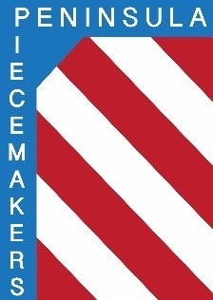
Peninsula Piecemakers Quilt Guild
P.O. Box 1295
Newport News, VA 23601

Board of Directors Meeting May 19, 2022

Attendance:
Board
President: Rhonda Gianturco (abs) Vice President: Karen Carr
Executive Treasurer: Natalie Hutchinson Executive Secretary: Lois Bates
Day Coordinator: Mark Fowler (abs) Day Treasurer: Lori Murdock
Day Secretary: Linda Tozier Night Coordinator: Calie Mowery
Night Treasurer: Debbie Martin Night Secretary: Susan Waddles

1. The meeting was called to order on Zoom by Vice President Karen Carr at 5:32 pm.
Karen welcomed Calie our new night coordinator.

2. Linda made a motion to approve the April 18 minutes. Natalie seconded. Approved.

3. Treasurer’s report: Natalie said the night block of the month monies will be updated next month. She sent a check to Hilton Baptist Church for the first six months of 2022. The insurance bill was $920. Balances: Executive: $17,612.37
Day account: $2,141.33 Night account: $1,746.47
Lois made a motion to accept the report. Lori seconded. Motion approved.

4. Old business:
a. Newsletter & website: Linda Odell would like to get more photos for the website so that the public and members would see an active and vibrant guild. It would help if the historian positions were filled. Karen will write a job description for historian to be in the newsletter and a plea will be made at meetings. Debbie Martin will work with Linda to write format requirements for website submissions.

b. Program committee members are needed. Karen should not and cannot plan programs for both chapters for the whole year.

5. New business:
a. Natalie reported Carol Pittman will conduct the audit again this year.

b. Mystery quilts will be shown at the June meetings so coordinators should add that to their agenda.

6. Meeting adjourned at 6:23 pm.

Respectfully submitted,

Lois A. Bates, Executive Secretary

.

