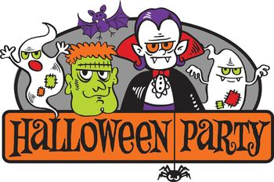
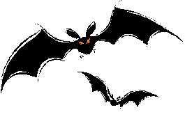
Elite Mixed Martial Arts Center
Saturday, October 31, 2020
Pumpkin games will be scheduled during normal class times
Activities
- Pumpkin Games
- Refreshments – Juice or Water
- Prizes at each game
Please let us know if you plan to attend!

