2021 – 2022
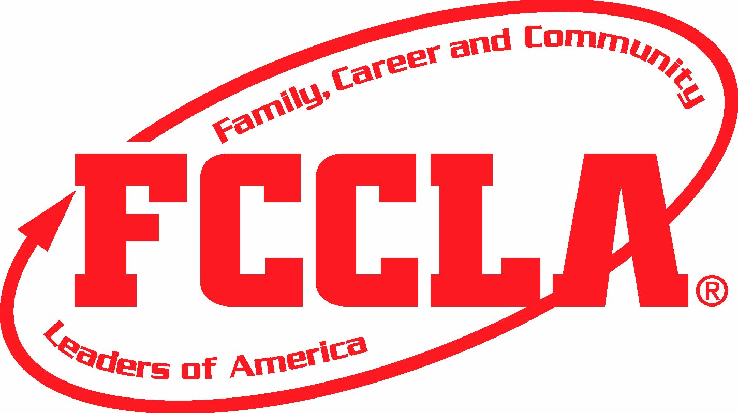
NJ FCCLA PRESENTS
RED ROSE CHAPTER AWARD
Why? This program is designed to recognize well rounded chapters who contribute to the
State Program of Work! They must take part in member development, community service,
conferences, leadership activities, national programs, and competitive events.
How? In order to be recognized with this award, chapters must complete all of the required elements as well as 20 out of 80 points of the Additional Point Options. The point values are in red next to the description below. The official application form (on the njfccla.org website) must be filled out, saved as a PDF and submitted for proof of completion.
When? Applications are due on February 15, 2022 and chapters will be recognized at the SLC during the Recognition Session where the chapter presidents receive the award.
Requirements:
- Maintain or increase Membership from 2020-2021
- Chapter participation in Fall Leadership Connection. (Minimum of 8 members)
- Participated in Virtual Fall Competitive Events (4 entries minimum.)
- Chapter attendance at Leadership Bootcamp (at least 4 members and 1 adviser)
- Compete in competitive events at the SLC (at least 5 members competing)
- Chapter participation in SLC (minimum 10 members)
- Complete Power of One (at least 3 members)
- Show participation and results of one Service Initiative
- Chapter printed the Fall and Winter Newsletters and delivered to administration
Additional Point Options: (must complete a minimum of 20 points)
Points | Options (Show proof of each item with photos, screenshots, and documents, as applicable)
1 | - Submit an application for a State or National award for recognition
1  1 | - Chapter participation in FCS Dine in Day, December 3rd (Show promotion and proof of participation)  - Celebrate NJ FCCLA’s 75th Anniversary with a celebration
2  2  2  2  2  2  2  2 | - Chapter participation in Campaign for Tobacco Free Kids Program  - Chapter participation in NJ: Say Yes to FCS or STAR Event Say Yes to FCS  - Create a Chapter Social Media Account public and follow NJ FCCLA  - Create an FCCLA bulletin board for the hallway of your school.  - Chapter attendance at the 2021 Hybrid NLC (2 members and 1 adviser)  - Invite State Officers to present and participate in a chapter meeting  - Sponsor a creative fundraiser  - Sponsor a Membership Drive show participation
3 | - Participate in a collaborative effort with another CTSO or business/industry partner
3  3  3  3  3  3 | - Make a chapter website and email the link to njfccla@gmail.com  - Compete in a STAR Event at SLC (minimum 3)  - Participate in 3 of the FCCLA Week Initiatives  - Schedule a virtual meeting with a superintendent or member of your town’s BOE  - Members competed in 2021 NLC Competitive Events  - Chapter participation in the “Safe Rides Save Lives” program
4 | - Complete in a National Program (other than Power of One) and submit the application on fcclainc.org
4  4  4  4 | - Apply for Go For the Red Membership Campaign (fcclainc.org)  - Provided an article for the New Directions Newsletter or had an article printed  - Chapter had a STAR Events project in the Top 3 in the nation at 2021 NLC  - Submitted a service Project in the Lead4Change service program
5 | - Mentor a new chapter (proof of at least 3 supportive initiatives)
5  5  5 | - Meet virtually with a member of NJ legislature to advocate for FCCLA and FCS  - Run a chapter member for State Office  - Link NJ FCCLA to a new business partner who is willing to sponsor a state scholarship

