Direct Deposit Authorization Form
Please print and complete ALL the information below.

Name: ____________________________________________________________

Address: ____________________________________________________________

City, State, Zip: ____________________________________________________________

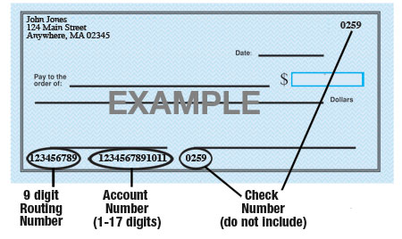

Name of Bank: ____________________________________________________________

Account #: ____________________________________________________________

9-Digit Routing #: ____________________________________________________________

Amount: ◻ $ ____________ ◻ ____________%  or ◻ Entire Paycheck

Type of Account: Checking Savings (Circle One)

Please attach a voided check for each bank account to which funds should be deposited.

Grace n’ Care LLC is hereby authorized to directly deposit my pay to the account listed above. This authorization will remain in effect until I modify or cancel it in writing.

Employee Signature: ____________________________________________________________

Date: ___________________________

