The Confident New You – Free 5 Day
Online Challenge
October 12th – 19th 1:00 PM EST

Presented By:
BY: JACQUELINE CAPATOLLA

Jacqueline’s House of Beauty Salon & Spa
310 / 330 Grant St
Lobby Suit 107
Pittsburgh, PA., 15219
(412)-281-2209
www.jacqelinessalonandspa.com

You’ll experience an ultimate make over using my wheel of confidence, so you feel self-love, confidence, have an exciting NEW image and feel beautiful
INSIDE AND OUT.

INSIDE OUT
JACQUELINE’S 360° Confident Ultimate Makeover LIVE LAUNCH

Our Daily Focus…

Session 1: Oct 12th - 1:00 pm, Inspiration: Learn the 5 areas to move from self-doubt to being fully confident.

Session 2: Oct 13th - 1:00 pm, Identify: Embracing who you are is your essence.

Session 3: Oct 14th – 1:00 pm, Mindset: Taking time to celebrate your wins. Gifts – Skills – Accomplishments

Session 4: Oct 15th – 1:00 pm, Make Up Tutorial: The 5-minute make-over so you look and feel more attractive in just 5 minutes a day.

Session 5: Oct 16th – 1:00pm, Wellness: “Tregar Therapy” learn a technique you can use to have instant stress relief when you need it, and use it over and over again.

Worksheets:
Use the worksheets to take notes – as your planner and your map to finding inner strength and beauty

Follow along with us Live each day to complete the worksheets provided.

Notes
____________________________________________________________________________________________________________________________________________________________
____________________________________________________________________________________________________________________________________________________________
____________________________________________________________________________________________________________________________________________________________
____________________________________________________________________________________________________________________________________________________________
____________________________________________________________________________________________________________________________________________________________
____________________________________________________________________________________________________________________________________________________________
____________________________________________________________________________________________________________________________________________________________
____________________________________________________________________________________________________________________________________________________________
____________________________________________________________________________________________________________________________________________________________
____________________________________________________________________________________________________________________________________________________________
____________________________________________________________________________________________________________________________________________________________
____________________________________________________________________________________________________________________________________________________________
____________________________________________________________________________________________________________________________________________________________
____________________________________________________________________________________________________________________________________________________________
The Wheel of Confidence 5 Areas You Need to Transform
- Inspiration
- Identity
- Mindset
- Physical
- Wellness
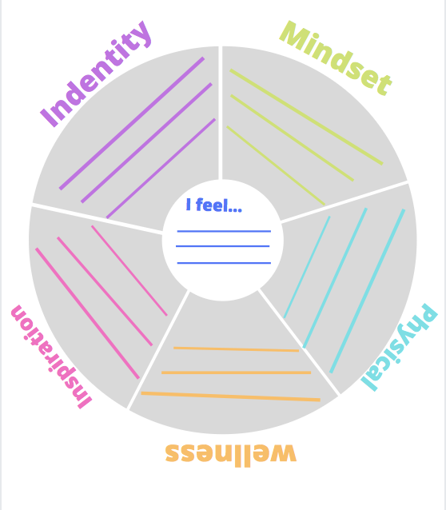

- Areas of the Confidence Wheel Confident New You
1.INSPIRATION: Learn the 5 areas to move from self-doubt o being fully confident
- Put a star next to each item you need to focus on
____________________________________________________________________________________________________________________________________________________________
____________________________________________________________________________________________________________________________________________________________
____________________________________________________________________________________________________________________________________________________________
____________________________________________________________________________________________________________________________________________________________
____________________________________________________________________________________________________________________________________________________________
____________________________________________________________________________________________________________________________________________________________
____________________________________________________________________________________________________________________________________________________________
____________________________________________________________________________________________________________________________________________________________
____________________________________________________________________________________________________________________________________________________________
____________________________________________________________________________________________________________________________________________________________
____________________________________________________________________________________________________________________________________________________________
____________________________________________________________________________________________________________________________________________________________
- Identity: Embracing who you ARE
- One area of who you are is your essence
- Define what your essence is and is not
- Exercise/action sheet

____________________________________________________________________________________________________________________________________________________________
____________________________________________________________________________________________________________________________________________________________
____________________________________________________________________________________________________________________________________________________________
____________________________________________________________________________________________________________________________________________________________
____________________________________________________________________________________________________________________________________________________________
____________________________________________________________________________________________________________________________________________________________
____________________________________________________________________________________________________________________________________________________________
____________________________________________________________________________________________________________________________________________________________
____________________________________________________________________________________________________________________________________________________________
____________________________________________________________________________________________________________________________________________________________
____________________________________________________________________________________________________________________________________________________________
____________________________________________________________________________________________________________________________________________________________

- Mindset: Taking time to celebrate your wins
- Start with a positive mindset____________________________________
- What are you good at…?
  - Skills__________________________________________________
  - Gifts__________________________________________________
  - Accomplishments
- Identify your genius zone to translate your skills and experience into confidence and self-love
_____________________________________________________________________________
____________________________________________________________________________________________________________________________________________________________
____________________________________________________________________________________________________________________________________________________________
____________________________________________________________________________________________________________________________________________________________
____________________________________________________________________________________________________________________________________________________________
____________________________________________________________________________________________________________________________________________________________
____________________________________________________________________________________________________________________________________________________________
____________________________________________________________________________________________________________________________________________________________
____________________________________________________________________________________________________________________________________________________________
____________________________________________________________________________________________________________________________________________________________

- Make Up - Tutorial
  - 5 Minute make over, so you look and feel more attractive in just 5 minutes a day
  - 5 minutes make over for an instant confidence boost
    - Skin
    - Eyes
    - Brows
    - Lips
    - Cheeks

_____________________________________________________________________________
____________________________________________________________________________________________________________________________________________________________
____________________________________________________________________________________________________________________________________________________________
____________________________________________________________________________________________________________________________________________________________
____________________________________________________________________________________________________________________________________________________________
____________________________________________________________________________________________________________________________________________________________
____________________________________________________________________________________________________________________________________________________________
____________________________________________________________________________________________________________________________________________________________
____________________________________________________________________________________________________________________________________________________________
- Wellness: Self Care Tips
- “Tregar Therapy” Learn a technique you can use to have instant stress relief when you need it, and use it over and over again
- And breathe – calm – balance – joy

_____________________________________________________________________________
____________________________________________________________________________________________________________________________________________________________
____________________________________________________________________________________________________________________________________________________________
____________________________________________________________________________________________________________________________________________________________
____________________________________________________________________________________________________________________________________________________________
____________________________________________________________________________________________________________________________________________________________
____________________________________________________________________________________________________________________________________________________________
____________________________________________________________________________________________________________________________________________________________
____________________________________________________________________________________________________________________________________________________________
____________________________________________________________________________________________________________________________________________________________
____________________________________________________________________________________________________________________________________________________________

NEXT STEPS:

- Testimonials
- Questions and Answers
- Taking Action
- Getting Results
- How we can help you
- Transformation
- Building Relationships

_____________________________________________________________________________
____________________________________________________________________________________________________________________________________________________________
____________________________________________________________________________________________________________________________________________________________
____________________________________________________________________________________________________________________________________________________________
____________________________________________________________________________________________________________________________________________________________
____________________________________________________________________________________________________________________________________________________________
____________________________________________________________________________________________________________________________________________________________
____________________________________________________________________________________________________________________________________________________________
____________________________________________________________________________________________________________________________________________________________
Join Us Today…
ADDITIONAL TOOLS AND MORE:
Visit our website:www.Jacquelinessalonandspa.com
follow us on:
Facebook: facebook.com/jacquelinessalon
Instagram:jacquelines_salon
Pinterest:Jacquelinterest
Twitter: @jacqueline’ssalon
LinkedIn: JacquelineCapatolla

CHECK OUT OUR
- Membership Program
- Signature Course Program & so much more

MEET OUR TEAM AT INSIDE OUT AND GET SET UP FOR SUCCESS
- NOTES/ KEY TAKEAWAY FROM THE LAUNCH

____________________________________________________________________________________________________________________________________________________________
____________________________________________________________________________________________________________________________________________________________
____________________________________________________________________________________________________________________________________________________________
____________________________________________________________________________________________________________________________________________________________
____________________________________________________________________________________________________________________________________________________________
____________________________________________________________________________________________________________________________________________________________
____________________________________________________________________________________________________________________________________________________________
____________________________________________________________________________________________________________________________________________________________
____________________________________________________________________________________________________________________________________________________________
____________________________________________________________________________________________________________________________________________________________
____________________________________________________________________________________________________________________________________________________________
____________________________________________________________________________________________________________________________________________________________
____________________________________________________________________________________________________________________________________________________________
______________________________________________________________________________

