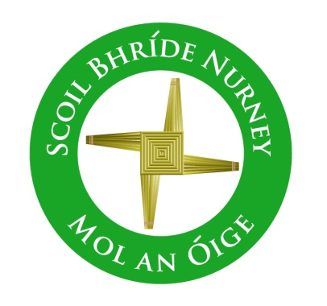
Scoil Bhríde,
Nurney,
Principal – Vinny Thorpe
Dep. Principal – Catherine Owens

County Kildare.
Tel/Fax: (045)526767
Email: sbnurney@gmail.com
www.nurneyns.com
Roll no: 16345A

August 18th
Dear Parent / Guardian

RE: Physical Distancing and Safe School Attendance

We are currently working on upgrading our procedures and routines within the school to ensure that there is as much Physical Distancing as is possible in our building. We will apply physical distancing in a practical and sensible way.

Physical Distancing will be achieved in two ways:
Increasing Separation. This will be achieved by re-configuring the classrooms to maximise physical distancing. Each class will be referred to as a bubble and we will ensure that there is as little contact as possible between children in different bubbles. Within the bubbles, children will be organised into pods. A pod is a group of children (normally 6) who will sit together and who will stay in their pod while in the bubble, or classroom.
Decreasing Interaction. This will be achieved by decreasing the potential for children from different bubbles to interact. There will be marked routes and staggered times for various bubbles to enter and exit the school and to access their classrooms. Bubbles will have different zones clearly marked to play in on the playground. We will make these routines enjoyable activities for the children, emphasising safety at all times.

While all children will be welcome back to school, we would remind parents that, where children are displaying colds, coughs or flu like symptoms, they should not be sent to school. Children who display such symptoms in school will be isolated and parents asked to collect them from the school.

If you send your child to school it is vital that you or someone from your family can be contacted at all times during the school day in the event of your child displaying colds, coughs or flu like symptoms. It is your responsibility to ensure that the school has your most up to date email and phone contact details.

Children who have travelled from countries not on the Green List should not attend school during the 14-day self-isolation period

Further information on COVID-19 symptoms in children is available at:
COVID-19 (coronavirus) - HSE.ie

Teachers will make children aware of the proper hygiene procedures regarding hand washing and etiquette related to sneezing, coughing or spitting. We would be grateful if you could also emphasise safe behaviour in this regard to your children at home as part of the preparation for returning to school.

Our aim remains to re-open the school on August 31st 2021 in an orderly safe manner, while reassuring the children and making them feel comfortable, safe and relaxed with their friends in the new school environment. This will be achieved by all of us working towards this common goal.

Thanking you in advance for your co-operation
All the team in Scoil Bhríde Nurney

