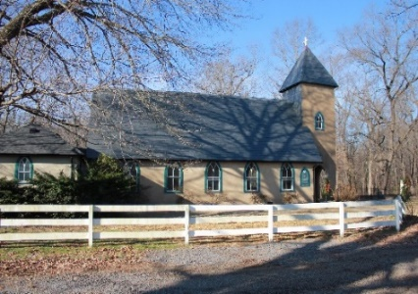**Grace Episcopal Church**



**Casanova, Virginia 20139**

**e-mail: gracechurchcasanova@gmail.com website:** [**www.gracechurchcasanova.org**](http://www.gracechurchcasanova.org)

**Regret**

“And God was sorry that he made Saul king over Israel.”

     The cycle of readings from the Hebrew Bible from First Samuel have been striking. The God depicted is not the God of Greek thought: immovable, invisible,  removed from human experience,  but rather Samuel’s God has the capacity to feel, to be frustrated from time to time and to regret. God sees Saul’s reign as a matter of regret.

     Regret is an ambiguous reality. I have never met a person who has lived a human life who does not have regrets. But, I believe that regret can either be our teacher or it can be our jailer.

     Samuel is arrested by his regret. He has not gotten over Saul. In fact, he anointed him. God on the other hand regrets allowing Saul to be king, but God is moving on. A new king who will be effective is desperately needed and God is more about the new opportunities of the NOW than the regrets of the past.

     Part of what I am learning again as I listen to the book of First Samuel three thousand years after it was composed is that my regrets must never block my embrace of the new occasion, the new moment that God is inviting me to embrace. My regrets have something to teach me but The God of the Now never will leave me a prisoner of my regrets.

 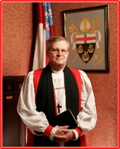

***Bishop Ted***

**AN UPDATE FROM YOUR DISCERNMENT COMMITTEE**

*(Just a reminder: “Discernment Committee” is the new name for what most of us remember as “Search Committee.”)*

A second inquiry was received in June, but unfortunately, was not successful. Keep praying; we’ll get there!

Sincere love and blessings,

**Judy Ball**, Pat Williams, **Kathlene Bilger,** Linda Winslow**, Tom Bilger,** & **Mary Neal**

Your Discernment Committee (DC) aka Search Committee

**SENIOR WARDEN’S REPORT – JUNE 2021**

Dear Grace Family,

Time seems to move faster and faster as we come to the end of the first half of 2021.😮

We joyously celebrated our return to the Church building with a “Homecoming” of sorts, complete with a country menu of fried chicken and ‘tater salad. Thank you to all who prepared and served, as well as those who attended. And a big thank you to Barbara Jacobs for the beautiful new banners!

We celebrated the Eucharist with two guest priests this month, Rev. Michael Guy and Rev. Jenks Hobson. We were blessed to have them and were most appreciative of their holy messages.

We’ve received inquiries about our cemetery of late and have fully mapped the existing graves. A record book is now maintained from an excel spreadsheet containing names, dates and locations of graves.

Since activities will be resuming, a listing of them is shown at the end of this Grace Notes issue. All are welcome!

In resuming Grace’s schedule, we are in search of servers to read, acolyte, prepare altar and/or flowers, usher (take up offering), and serve as coffee hosts. Please feel free to contact Barbara Jacobs or me if you are interested. I have tried to return the schedule of servers to what it once was; however, July will be a little tricky as folks are on vacation. Please bear with me and if I have left you out or included you in error, please let me know.

Blessings and love on behalf of the Vestry,

**Mary**

** 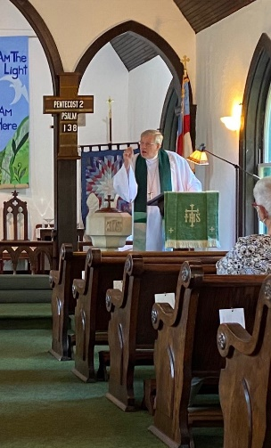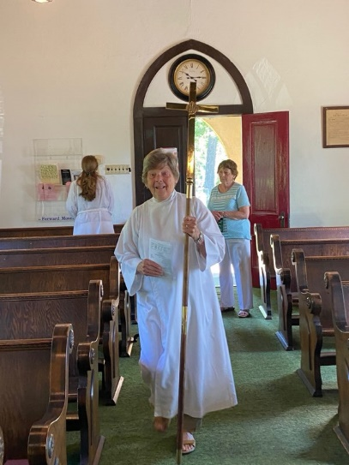 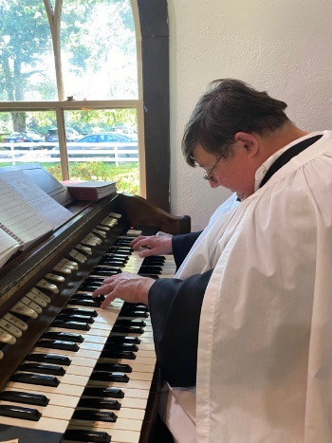 *Photos by Diane Gulick***

**Homecoming at Grace…**

**TREASURER’S REPORT – MAY 2021**

Income for the month of May was $5,808.13 (budget $6,267.00); expenditures totaled $3,635.99 (budget $4,543.00) resulting in income for the month of $2,172.14.

The book value of our endowment fund is $60,073.49; market value as of 04/30/21 - $68,389.74.

Please continue to pray for Grace Church that it will grow spiritually, financially and numerically. If you have any questions about this report or any financial matter, please contact me.

**Judy Ball**, Treasurer

**FEED MY SHEEP (FMS)**

Summertime and the livin’ Is easy.  We are all ready for a break.  Picnics, swimming , vacations. Lazy days in the sun. So many things we missed last year. One thing has stayed the same. Families are still struggling to keep their homes, find a job and provide food for their families. Let us not forget how important the Grace family donations are to FMS. Many of our suppliers have “dried up”. Not from lack of food but there are  so many organizations that need food.  Everyone is stretched thin.  May everyone have a blessed and happy summer and not forget our families that may not have the same advantages as we do.

You may send your donations to the Grace Church address - please  with this notation on checks: “FMS.”  Cash is always welcomed. You may also leave an envelope in the collection plate.

Gods Peace, Carol Grove 😇

🙚

From the Grace Archives

🙘

Can you identify these beloved Grace folks?

*(Answer in next issue of Grace Notes.)*

**JULY BIRTHDAYS & ANNIVERSARIES**

**Ricky Perreault 3-Jul**



**Jim & Dale Cirillo 7-Jul**



**Owen Fields 10-Jul**

**Pat Warren 12-Jul**

**Tommy Perreault 23-Jul**

**Greg Huddleston 26-Jul**

**Barbara Jacobs 29-Jul**

**Pat Williams 30-Jul**

**Jack Perry 31-Jul**

**JULY SERVING SCHEDULE**

|  |  |  |  |  |  |  |
| --- | --- | --- | --- | --- | --- | --- |
| **Day** | **Readings** | **Reader** | **Altar & Flowers** | **Acolyte** | **Ushers** | **Coffee Hosts** |
| **6th Sunday after Pentacost**  **July 4, 2021** | **2 Samuel 5:1-5, 9-10; Psalm 48; 2Corinthians 12:2-10; Mark 6:1-13** | **Betsy Anderson** | **Carol Cordell/ Mignonne Spellmeyer** | **Betsy Anderson** | **Marilyn Ottevaere & Mary Neal** | **Mignonne Spellmeyer & Dee Garrett** |
| **7th Sunday after Pentacost**  **July 11, 2021** | **2 Samuel 6:1-5, 12b-19**  **Psalm 24; Ephesians 1:3-14; Mark 6:14-29** | **Mary Neal** | **Betsy Anderson/ Diane Gulick** | **Mary Neal** | **Diane Gulick & Carol Cordell** | **Judy Ball & Barbara Eanes** |
| **8th Sunday after Pentacost**  **July 18, 2021** | **2 Samuel 7:1-14a; Psalm 89:20-27; Ephesians 2:11-22; Mark 6:30-34, 53-56** | **Barbara Gulick** | **Barbara Jacobs/Diane Gulick** | **Mary Neal** | **The Jacobs** | **Sue Ballentine & Carol Cordell** |
| **9th Sunday after Pentacost**  **July 25, 2021** | **2 Samuel 11:1-15; Psalm 14; Ephesians 3:14-21; John 6:1-21** | **Judy Ball** | **Carol Cordell/ Diane Gulick** | **Judy Ball** | **Marilyn Ottevaere & Sue Ballentine** | **Penny DePompa-Davis & Mary Neal** |

*https://lectionary.library.vanderbilt.edu*

**ACTIVITIES**

**Each Sunday**: Church service at Grace Church at 9AM with Coffee Hour following at the Family Center

**Wednesdays**: “The Center” potluck lunch at 12PM at the Parish Hall

**Thursdays**: Gentle Yoga at 5PM at the Parish Hall

**Fridays**: Gentle Yoga at 10AM at the Parish Hall

**2nd Saturdays**: Sewing, quilting, crocheting, knitting, embroidering, cropping, & crafting at 9:30AM, alternating between St. Luke’s and Grace’s Parish Halls

**The above activities are open to all. Please come and enjoy the fellowship.**

**☺☺☺☺☺☺☺☺**

**AMAZON SMILE**

**FOR GRACE CHURCH**

Don’t forget to sign up with Amazon Smile to have 0.5% of the purchase price of eligible items given to Grace Church at no cost to you! You can also go to the Grace Church website home page and click on the link there.

#### *******AmazonSmile Shopping App for Android Users Now Available******

You can now support Grace in the Amazon shopping app on your Android device! Simply follow these instructions to turn on AmazonSmile and start generating donations to Grace from your Android device.

* If you have the latest version of the Amazon Shopping App, open the App on your Android device.
* View Settings and select AmazonSmile.
* Follow the in-App instructions to complete the process.

AmazonSmile is not currently available for IOS users – we’ll let you know when it becomes available.

"Christ has no body now on earth but yours, no hands but yours, no feet but yours. Yours are the eyes through which Christ’s compassion is to look out to the world. Yours are the feet with which Christ is to go about doing good. Yours are the hands with which he is to bless men now” ~ Saint Teresa of Avila