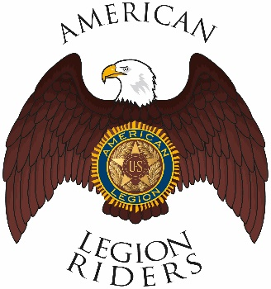

American Legion Riders Chapter 3, Hanford, CA
Minutes for December 14, 2021
Meeting called to order: The meeting was called to order @ 6:35pm. Prayer, Pledge of Allegiance and Preamble was said.
Officers Present: Director James Landolt, Vice-Director Frank Pightling, Treasurer Geni Lefler, Secretary David Darrow, Judge Advocate Pat O'Brien, Sgt-At-Arms Jack Alford. Excused. Chaplain Filly Reynolds, Road Captain Robert Stover.

Members Present: Sheri O’Brien, Gustie Compton, Jon Bailey, Scott Day, Kathleen McClary, Frank Silva, James T. McCaw
Guests Present:
Review of Minutes: Motion to accept minutes for November 9, 2021, was proposed by Pat O’Brien, and seconded by Gustie Compton and ratified by members.
Committee Reports: None
Treasurer's Report: One pending expense of $500 for the Visa Gift Cards to NAS Lemoore base chapel.
Chaplain Report: Robert “Smokey” Stover is ill, and James Landolt family is ill. Prayers for both families.
Unfinished/Old Business:
Great showing for the Christmas parade, thanks to all who attended.
Great Showing at Legion Christmas Dinner.
Convention will be held April 28th, 29th and 30th at the San Bernardino Fair Grounds. Address is 14800 Seventh St, Victorville, CA 92395, and website is https://www.sbcfair.com/.

Milage for September through October was 729 miles

Milage for October through November was 341

Motion by Frank Pightling to amend minutes from 9 November 2021 and change cash to Visa Gift cards for the donation to the chaplain’s office NAS Lemoore. 2nd by Frank Silva and ratified by the members.

New Business:
Bob Ayers will be in town on the 21st and 22nd of December for those wishing to purchase collapsing flagpole for flag line presentations. Cost is $25.

January 16th we will be escorting a new member of the United States Air Force to the recruiting depot in Visalia to give a great sendoff. Also proposed was to contact local recruiting offices in the area and make this type of escort a Riders detail.
Need help setting up for the district meeting on 8 January 2022 at 8am.
February 12th is the Sweetheart breakfasted, proposed times are 8-11am.
American Legion Riders Chapter 3 votes for ALRDOC our four votes will go to the following candidates.
Director: Mike Smith
Vice Director: Ralph Wenzinger
Sgt-at-arms: Larry Brandt
Good of the Riders:
Tickets are on sale for the ALR legacy quilt for $10 for 3 chances at winning. Proceeds go the Legacy scholarship fund.
Please visit alrhanford.com on a regular basis for updated information.
Remember to ride safe
Meeting adjourned 7:50

