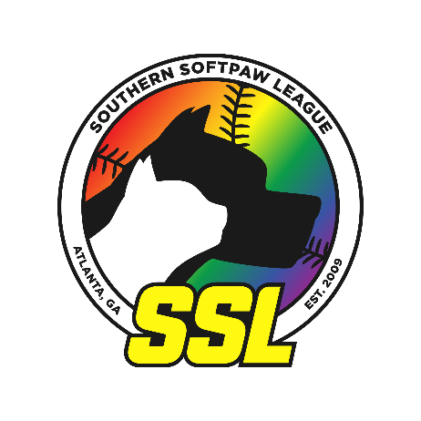

Southern Softpaw League’s Request for ADA Accommodation
(Adapted from NAGAAA’s GSWS form)

Requestor (Athlete) Information:
Name:
DOB: (DD/MM)
Division: Just Fun (JF) Competitive Fun (CF) Super Competitive (SC)
Team Name:
NAGAAA Affiliate City:
Rating:
Commissioner’s Name:

Did the Requestor (Athlete) request any accommodations from their NAGAAA Affiliate League this season? If not, why not? If yes, please describe the accommodations that were requested, and any accommodations actually provided by the League.

Explain how impairment(s) affects the Requestor’s (Athlete) ability to participate in softball play.

What specific accommodations are you requesting for the Requestor (Athlete)?

Has a physician, vocational rehabilitation specialist or other health professional recommended a specific accommodation? Yes: ________ No: ________
If so, please attach a copy of their recommendation(s).

Provide any additional information that may be helpful in reviewing the accommodation request(s).

The Southern Softpaw League reserves the right to request medical documentation to verify the existence of an ADA covered impairment or impairments, and to appropriately assess and approve a reasonable accommodation(s).

__________________________________________
Printed name of Requestor (Athlete)

__________________________________________ Date: ________________________
Signature of Requestor (Athlete)

__________________________________________
Printed name of person completing this form [if not the Requestor (Athlete)]

__________________________________________ Date: ________________________
Signature of person completing this form [if not the Requestor (Athlete)]

- Please send requests via email to the SSL Lieutenant Governor (lieutenant@southernsoftpaw.com).
- Requests and documentation will be reviewed by the Lieut. Governor and UIC (or designees).
- Approval/declination will be sent to the person completing this form

