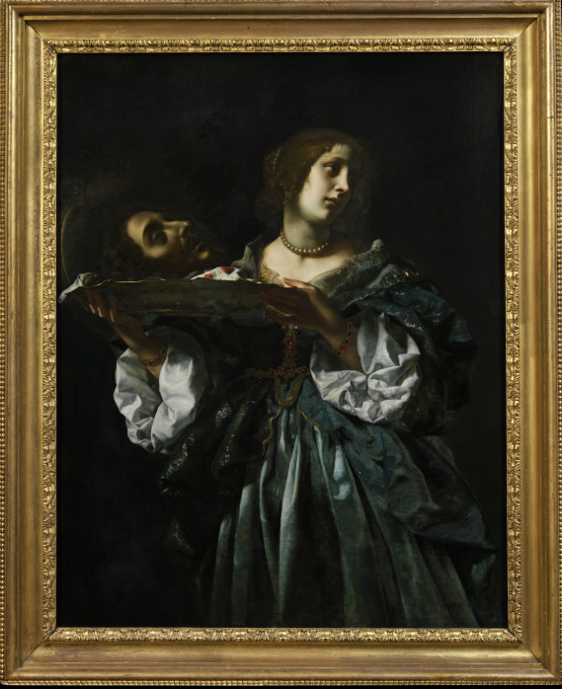
The Grudge Match Is Over
July 15, 2018
Mark 6: 14-29

Grace and peace to you from God our Father and from the one who bore our sin and opened the way of forgiveness, Jesus Christ our Lord, amen.
A Judge was interviewing a woman regarding her pending divorce. He asked, “What are the grounds for your divorce?” She replied, “About 4 acres and a nice little home in the middle of the property with a stream running by.” “No,” he said, “I mean what is the foundation of this case?” “It is made of concrete, brick and mortar,” she responded. “I mean,” he continued, “What are your relations like?” “I have an aunt and uncle living here in town but most of my family lives up north.” He said, “Do you have a real grudge?” “No, she replied. “We have a two-car carport and have never really needed one.” “Ma’am does your husband ever beat you up?” “Yes,” she responded. “About twice a week he gets up earlier than I do.” Finally, in frustration, the judge asked, “Lady, why do you want a divorce?” “Oh, I don’t want a divorce. My husband does. He says that he can’t communicate with me.” …
Today we’re going to talk about grudges and I don’t mean the kind that hold two cars and have electric door openers. The type of grudge I’m talking about is a feeling of ill will or resentment that we can’t seem to get rid of or maybe don’t want to get rid of because we feel intitled to our righteous rage due to some egregious personal injury or insult. We speak of certain sports teams having grudges because of a long-time rivalry. A grudge occurs when we simply can’t or won’t let go of what happened in the past and instead we allow the past to rule over our present. Grudges can and often do lead to some pretty bad, even evil behavior.
At some time in our lives, I believe we’ve all held onto a grudge or two. At least I know I have… In today’s Gospel Herodias held a grudge against John the Baptist because John had the audacity to point out to her and her current husband, King Herod Antipas, that their marriage was a sham. Although the family tree is convoluted, we can say with certainty Herodias, now in her second marriage had broken some law or taboo and John the Baptist, never one to be able to keep his mouth closed, pointed this out to them. Nobody likes to have their personal behavior, especially their sins, pointed out to them. So, this is what led to the grudge Herodias held against John the Baptist. I know I’m vague on details, but so is the history of these individuals. What isn’t vague is the result of withholding forgiveness and instead holding onto grievances. At some point the cloaked anger and resentment comes out and figuratively or literally we demand a price to be paid. He want someone’s head on a platter!
Sometimes I’ve heard people apologize for crying at funerals. Crying during the grief process is a healthy way of letting your feelings out and letting go. What is unhealthy is holding all those feelings inside. They will come out at some point and if you don’t let them out at appropriate times, like at the funeral, they will come out later at some point and when they do, it might be at a time and place you wish they hadn’t. In some respects, I think the same advice holds true when someone does you wrong. There are appropriate ways to let your anger or frustration out or you can keep it bottled up inside, thinking you’re taking the high road. Unfortunately, all too many times, just like our feelings of sadness and grief, those feelings of anger and frustration will emerge at the most inopportune times. There’s major differences between and grudges though. Grief is an emotion that helps us let our feelings out so we can eventually move on with our lives. Grudges on the other hand, stop us from letting our emotions out and keep us from moving beyond the wrong. Since none of us wants to literally chop the head of our enemy off, there must be a better way to deal with grudges that can lead to a, well less bloody response…
I know the quick and easy answer to the dilemma I’ve presented is, well Pastor, all you have to do is just forgive the other person and move on… I know that’s the text book answer, but how do you do that in real life, when real people inflict real hurt? How do you forgive the one who cheated on you? How do you forgive the one who lied to you or about you and ruined your reputation and cost you your job? How do you forgive all those others out there who belong to that political party and who believe all those horrible things about the candidate you like? This issue ranges all the way from the individual and personal up to the corporate and even to national politics and international affairs.
I’m not sure there’s any easy answers, but I’ve got one or two suggestions. For those of us who proclaim Christ as our Lord, the first thing we do is take our grudge to Him in prayer. Often times talking to Jesus about our huge problems helps us see them in light of eternity and in light of His plan for our lives. When I was miserable at another Church a long time ago I couldn’t see at the time how all the stuff that was happening was being allowed by a God who needed me to move on to another chapter in my life. Only as I look back on that time can I see God’s hand. Yes, it hurt, but it didn’t kill me and I’m now in a much stronger position of faith and a much closer relationship with God because of all I had to go through. Prayer made that breakthrough possible. Without it I’d still be stuck with my grudge against the folks who I blamed for all those problems back then.
I do believe the cure to holding grudges is forgiveness. Forgiveness is really hard at it’s best and humanly impossible at it’s worst. I recently watched a video of a holocaust survivor by the name of Eva Mozes Kor. She talked about how she was able to forgive one of the doctors who performed experiments on her as a child. She first wrote down every evil and vile thing she wanted to say to that person. Then she pretended to tell him she forgave him. After working through that sort of game, she was finally able to write down a letter to the man who took away so much of her life. The two actually met in 1993 and she forgave him in person. I watched the video with tears in my eyes as I thought about the comparatively minor things that have been done to me and that I’ve chosen to hold onto rather than forgive. It’s not an easy thing to do, but my dear loved ones if we can’t forgive one another, I ask you what is our alternative? Do we wait until our frustration and anger builds up to the point where we ask for the head of our adversary on a silver platter? … …
As we welcome Ruby into the family of Jesus Christ this morning let’s give thanks that God has here, in this sacrament, taken the first step in reconciling Ruby and all of us, by the gift of forgiveness we receive in the Holy Sacrament of Baptism. God loves Ruby and all of us enough not to hold any grudges against us. We’re free from the death sentence that would otherwise be ours. Thanks be to God for taking that first step! God knows better than all of us, if He hadn’t, we’d certainly go on asking for the heads of those we hate on a platter.
May we remember our Baptism and the forgiveness we received once and for all times when we were adopted into God’s family. May we learn to celebrate with great joy that forgiveness as we partake of Holy Communion regularly and often. May we take that forgiveness that we’ve received and learn to apply it as we live our lives out there in a world that knows no such forgiveness, where the law of the land still requires an eye for an eye and a tooth for a tooth. May we live under a different set of laws that says no! We’ll forgive and we will not hold grudges! Instead we’ll forgive 70 times 7 and more. Amen.

