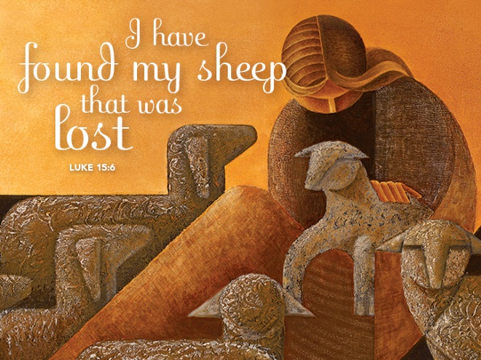

Rejoice with Heaven Over the Lost One Whom God Found
September 11, 2016
Luke 15:1-10

Grace and Peace to you from God Our Father and from the finder of lost sheep, lost coins, and lost people, Jesus Christ our Savior and Lord, amen.
I love when Jesus tells stories. Jesus was, among other things, a master story teller. When Jesus tells stories we call them parables. In confirmation class about 50 years ago my Pastor told us a Parable is an earthly story with a heavenly meaning. It’s a story about something we’re all familiar with, but it shows us something about how the Kingdom of God works. Today we get to hear Jesus tell two such stories, the lost sheep and the lost coin. Every time I read the parable of the lost sheep I can’t stop myself from laughing as I picture this “Good Shepherd leaving the 99 sheep in the wilderness to go in search of one how has left the herd and become lost. The Good Shepherd and all of heaven rejoice when that one lost sheep is found. That’s where Jesus ends his story, but in my mind the story keeps on going. The Good Shepherd returns to the place in the wilderness where he left the other 99 sheep only to find another one has wandered off to parts unknown and he now has to leave the sheep once again to search once more... It seems to me like a never ending cycle. Maybe that’s why Jesus followed up with a story about a lost coin. At least when the lady puts her other 9 coins down to search for the lost one they will stay where they were put until she comes back to pick them up again.
I’ve heard sermons about these parables since I was young and I’ve preached on these stories a few times myself. When I think about the moral of the story or the main point why Jesus told these stories it seems like we always jump straight to how our job is to seek the lost and bring them to repentance so they can be saved. I know a lot of pastors who would deliver that message with great passion and probably convince some folks to get up and out of the pews and hit the streets to go and seek the lost souls and bring them back to Jesus. That’s a pretty good message, but that’s not the point of Jesus’ story, and it’s not the reason Luke included these parables in his Gospel.
The question Jesus’ parables pose to the scribes and Pharisees, and by extension to us, is less “Go and seek those who are lost,” or even “Do you identify with the lost and found coin or sheep?”, but the more pointed, difficult question “How do you respond to the God who loses and finds?” How do we respond when God invites you to rejoice with all of heaven over the one who was lost, but is now found?” I occurred to me God is both the one who loses and the one who finds in these stories. The question for us to ponder is how do we respond when God invites us to rejoice, not just with God, but with all of heaven when God finds the one who was lost. Our response reveals whether our heart is in sync with the heart of heaven. In heaven there is much rejoicing--more over one who in found than over ninety-nine who never got lost in the first place. Please remember, being found is entirely an act of grace and mercy on God’s part. By definition mercy and grace can only be extended to the undeserving, as only the lost can be found. No one thinks a lost coin deserves to be found. And the lost sheep is the sheep who causes the shepherd problems and perhaps endangers the other ninety-nine. The living God is moved from wrath to mercy by Christ’s sacrifice not by our good works in going out and seeking the lost. The question for all of us is, does your heart rejoice with all heaven when the lost are found and when the undeserving receive mercy?
You see only God can bring a lost person to salvation. Only Jesus is the Good Shepherd. If anything, we’re the lost sheep or the lost coins ourselves. I actually don’t think that’s who we are either. Go back and look at what was happening just before Jesus told these two stories. The religious leaders were snarking at him for cavorting with sinners and tax collectors and, shame upon shame, even eating with them… Just being near one of “those people” would make a highly religious person unclean and knowingly associating with them, well, that, … that, made Jesus no better than “those people” in the eyes of the religious leaders. How dare he…
It’s against that backdrop Jesus tells these tales about the Kingdom of God. It’s to those who are carping about who Jesus chooses to associate with that he addresses these stories. It’s to those of us today who wonder about how the Church can invite people off the street into our beautiful buildings and even share food and to have a party with them that this story is addressed. This story was never intended to admonish folks to drop what you’re doing and make a beeline for the nearest IRS office in order to convert some shady IRS agent. It was intended to help us understand where God’s heart resides and how God reacts when the Holy Spirit reaches one of the lost and prompts that person to turn to God. The moral of the story is to teach us to rejoice when one who was lost has been found by God’s never ending, relentless search for those who have wandered away.
In Churches across Darke County there are some very religious people wondering what happened over the last month or so around our county. Their Pastor is hanging around other pastors who aren’t even of the same denomination. As I speak to many of the Pastors at our Pastor’s Prayer Meetings on Thursday mornings at 8 O’Clock there’s some push back from the folks asking why their Pastor wasn’t around the Church as much those last few weeks, they were complaining how exhausted they were from keeping their Church open and involved from dawn to well past dark. Then the worship was so different with so many from all those different faith backgrounds… and the many Baptisms and things were done in a way that was not the normal way people were used to things happening at the Church. It all happened so fast…
I’ve even heard there’s been push back in Churches where I would never have expected. Think about the bikers and other tattooed members of the Heavy Metal Church downtown Greenville. (Some of those people are my new best friends…) My jaw dropped when the Pastor told me they actually had people threatening to leave their church because he was involved in bringing people to know Christ through the revival. I’d rather we just rejoiced with all of heaven. I think that’s what Jesus would want us to do.
I haven’t heard any rumbling or complaining per se, but if anyone has a problem with anything we’ve done these past few weeks, and I don’t know that anyone does, and I’m not trying to go looking for problems, but if anyone has been wondering about what’s been happening and wants to let their voice be heard, please come and talk to me. I promise I’ll respect you and your opinion and I promise if you tell me what’s on your mind we’ll be even closer as brothers and sisters in Christ than ever before… When we share our hopes and concerns, in love, we demonstrate to the world how a healthy congregation behaves.
Please let me emphasize I have not heard anything directly from or about anyone in this congregation, but if it’s happening in others it may very well be happening here too. These were rumblings from folks who didn’t rejoice over “one sinner who repented.” Well, maybe they would have rejoiced over one, maybe even two or three, but when they all of a sudden had more than they knew what to do with, it became an issue.
May any Church that receives the lost who you have found O’ God, be blessed and not overwhelmed. May we be people who are here to love those you have found and returned to us to help and to nurture. May we rejoice with you and with all the host of heaven for God has indeed forgiven and redeemed the lost and the forsaken, including each of us. We pray Lord for all the Churches who have taken a step of faith to reach out to our communities in Darke County. May all your Churches who are wrestling with how to move forward find a path that is faithful to your will so that our hearts may be in tune with yours, so your name will be honored and glorified in all we do. Amen.

