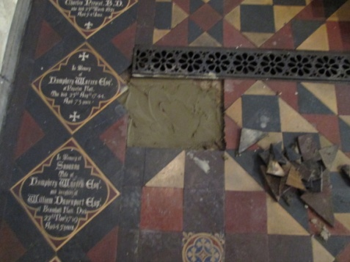
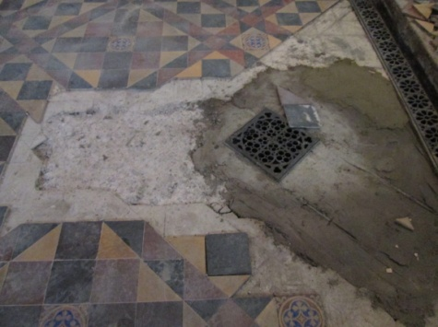
Clearly the main works inside St Mary’s continues to be the tiling, with a considerable amount of work already having been undertaken at the east-end of the church. Repair and replacement has certainly been more extensive than originally thought.

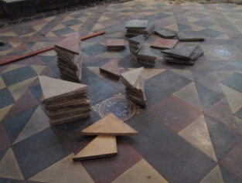
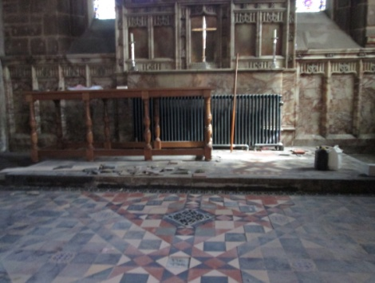

The end of the present works are however in sight and the Project Team will meet with our Architect, Structural Engineers and other interested parties again on Wednesday to discuss the final stages. We will let you know as soon as we can when normal opening times can resume (although these may be slightly modified to fit in more closely with the Stockport Heritage Trust).
Our next issue of Building News will be the last – it will mark “the end” of the work we started last Summer – Phase 5 Tower, Phase 1 Interior and the Churchyard archway/boundary walls. Well “the end” may be a little optimistic – it certainly won’t be “the end” of Phase 1 (Interior), as work still needs to be completed in the Memorial Chapel and on the second chair store. But it will be “the end” of work being undertaken high above our heads on the Tower, or otherwise “out of sight”. You will be able to see where we are up to inside the Church (and in the church-yard) and we will keep you updated as to any other issues, by “other” means.
The appeal however remains active, and we still need every penny we can get to help us not only complete the restoration stage of Phase 1 (Interior) but to help us undertake additional work – for example, to replace the induction loop system; purchase additional items of furniture, upgrade our personal address/audio facilities etc. There are also several “repairs and maintenance” issues that have arisen during the restoration/refurbishment that will need to be addressed in the very near future. Our telephone system has failed and will need to be replaced, the clock remains at mid-day/mid-night as we seek funding for the anticipated £2K repair bill. Further modifications are almost certainly going to be required to make the heating system totally efficient.

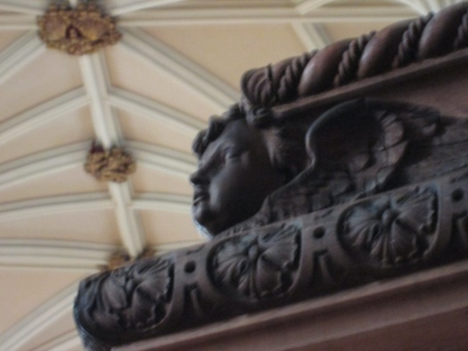
As the Lambert Walker team continued to clean up the dust, we were delighted to accept the offer of cleaning the canopy above the pulpit. Look up when you are next in Church.
The archway is now looking impressive, particularly in the “spring” or “late winter” sunshine. But remember when you walk up the hill from Asda to look at the water fountain. It may not actually contain water, but looks the part having now been restored.
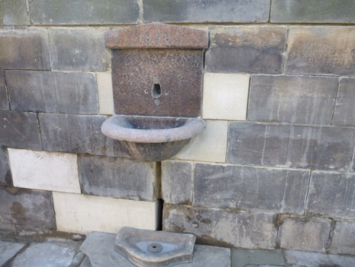
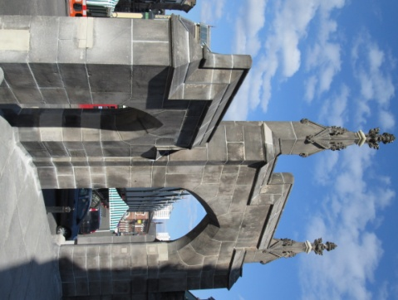

As work draws to a close we can but say “thank you” to all concerned – we may have snags to sort, but what progress! What joy it is to see – and what a priviledge to have been here to witness (and take part) in this chapter in the life of St Mary’s in the Marketplace. Securing the future for the next 100 years.

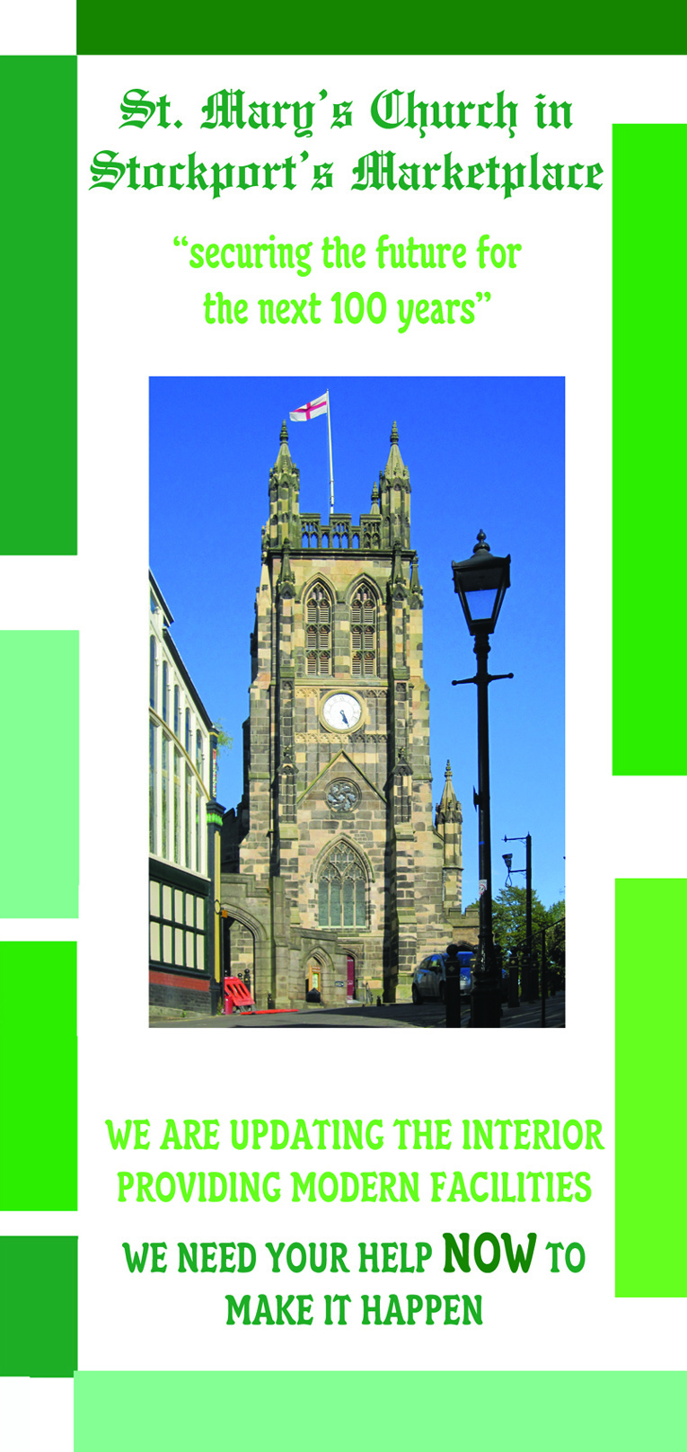
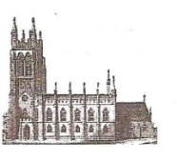
St Mary’s in the Marketplace.

Issue No 37 (31st March 2013)

“Securing the future for the next 100 years”
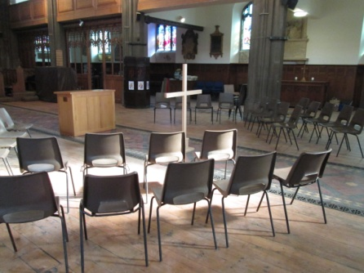
The contractors finished work on Thursday afternoon to start their Easter break, leaving St Mary’s neat and tidy in preparation for a special Maundy Thursday, evening service of Holy Communion. The doors were open again on Good Friday for our 10am Family Service, 12 noon Ecumenical Service and “An Hour at the Cross” from 2.00 – 3,00pm.
[Roger and Andrew leave St
Mary’s heading towards Tiviot Dale for the annual “walk of witness”]
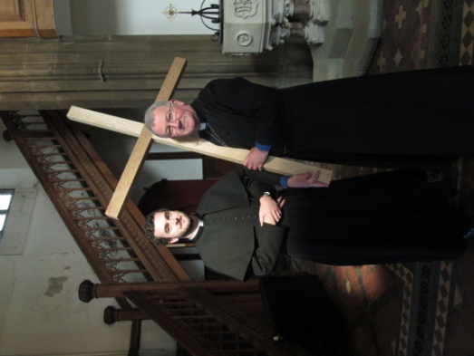
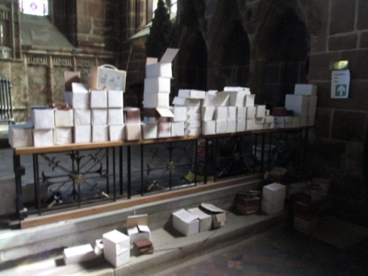
The piles of tiles still left in the Chancel would indicated that there is still a lot of work to be done

