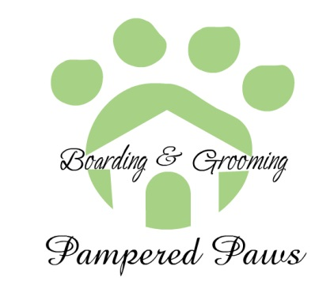
Non-Altered Dog Owner’s Agreement

- I understand that Pampered Paws has made an exception to allow my non-spayed or neutered dog to be cared for at its place of business.
- I understand that I will take full responsibility financially and/or otherwise for the results of any actions caused by or to my dog.
- All information is true to all of my knowledge.

Female Last Heat Cycle_______________

Signature or Owner: ________________________ Date: ____________
Printed Name: _____________________________

