**Amelia-Nottoway Technical Center News 11/13/2020**

**ANTC STUDENT SPOTLIGHT!**

**Kaylee Clark, ACHS Senior**

**Cosmetology II**

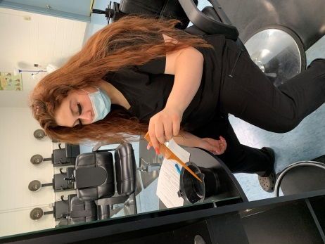 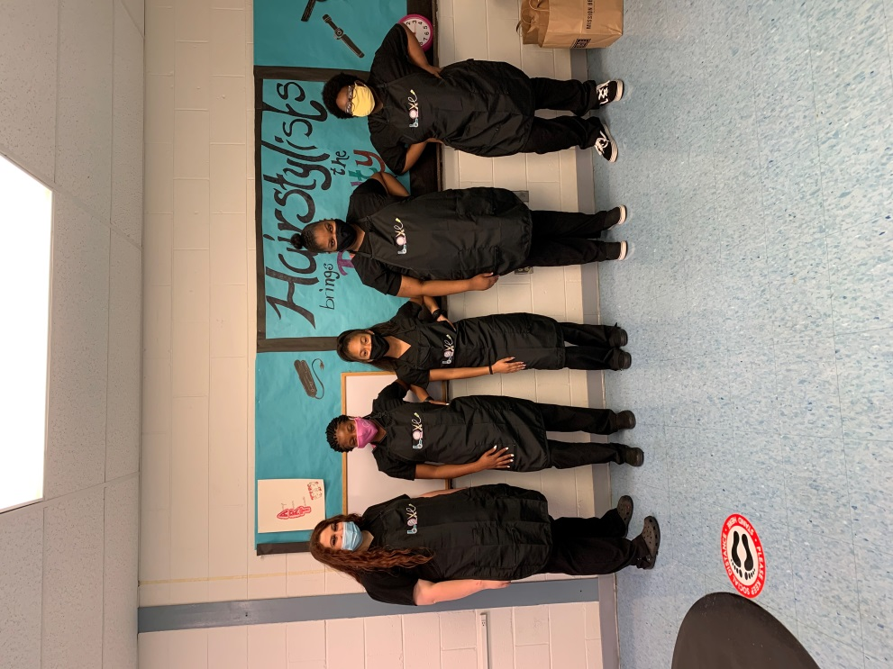 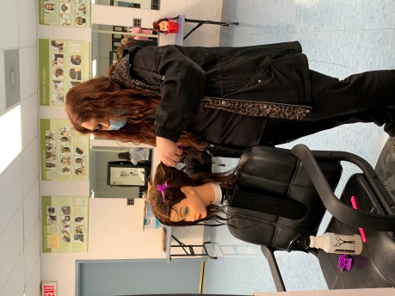

**What brought you to ANTC?** The Cosmetology Program

**What is your dream job?** A Cosmetologist

**What is your favorite class that you have taken so far? Why?** Cosmetology

**What is the best advice you have been given by your instructor at ANTC?** “Never give up.”

**What is your favorite memory at ANTC?** When the salon opened

**What was the first feeling you had when you attended ANTC?**  A good feeing

**What words of wisdom do you have for other students?** Be patient and take the time to learn

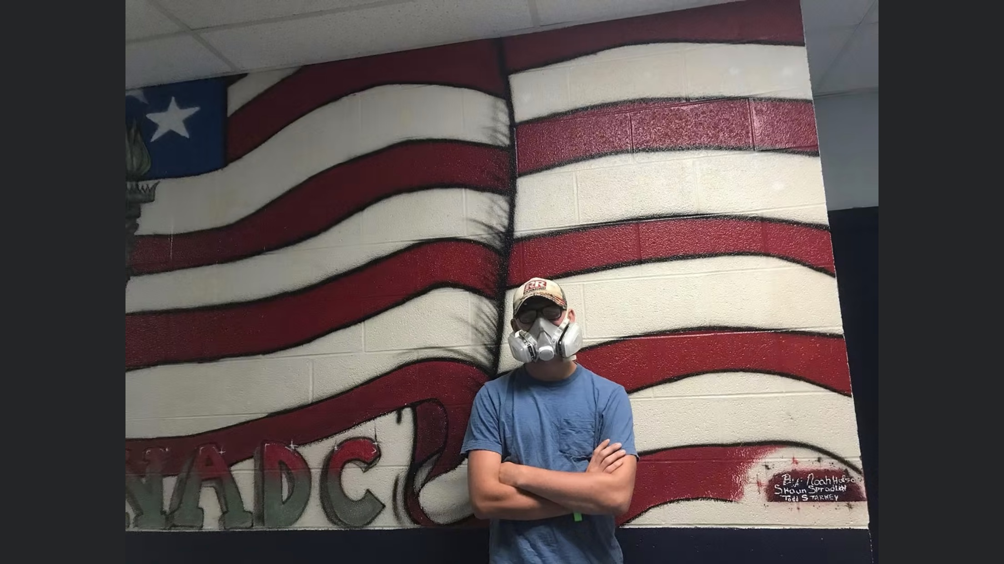

**The above picture is taken in front of a display at Nashville Auto Diesel College created by our own Auto Body Instructor, Mr. Spradlin when he attended NADC 19 years ago!**

**We are so proud of both Jacob and Mr. Spradlin.**

**ANTC ALUMNI HIGHLIGHT!**

**Jacob Wegner**

**High School:** Nottoway High School

**ANTC Program:** Auto Body

**Career:** Attending Nashville Auto Diesel College

Future Diesel Mechanic

**DID YOU KNOW?**

**Mr. Shaun Spradlin**

**Current Position:** Auto Body Instructor, ANTC

**Previous Positions:** Allstate Insurance, Damage Evaluator; Body Shop Owner; Body Technician for Sheehy Ford; Traveling Welder

**Hobbies:** Music, Riding his motorcycle

**Other Interest:** Volunteer Firefighter, Amelia Company 1

**Family:** Mr. Spradlin and his wife Tonya have three children Brendan, Hannah and Shane.

**ANTC serving our Alumni!**

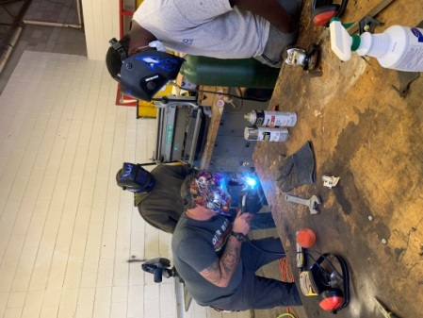 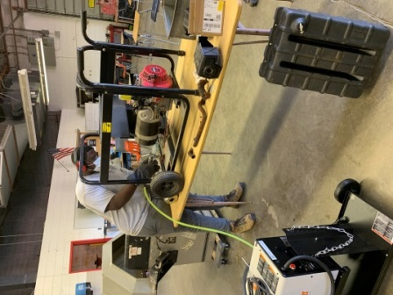 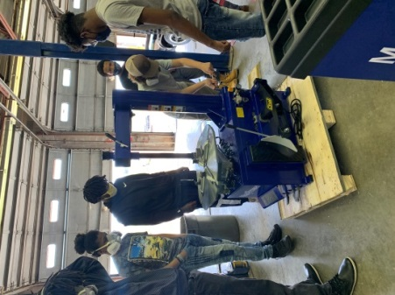

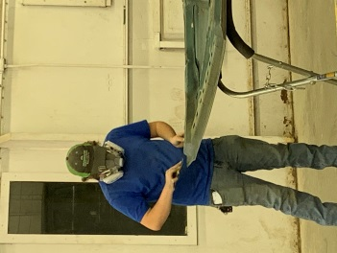 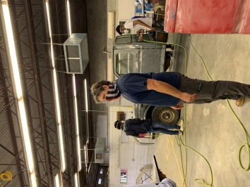 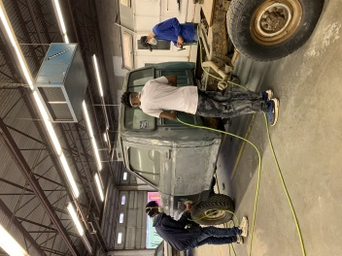

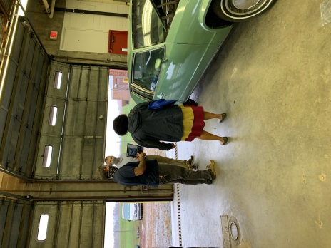 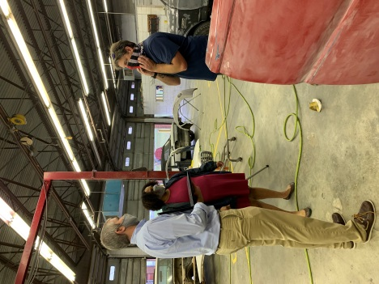 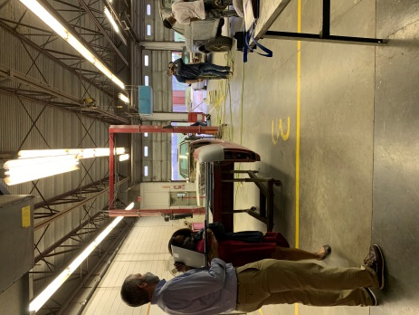

**Thank you to the NHS School Counselors for conducting live Zoom interviews to promote ANTC programs.**

**Current Program Feature:** Amelia and Nottoway Students

**Skills:** Assisting in Physical Examination

**Tasks/Competencies:** Collect specimens

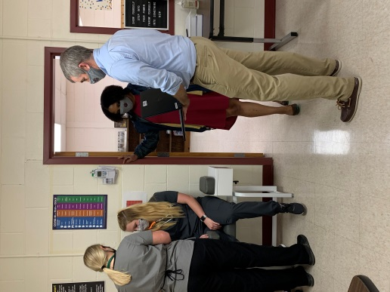 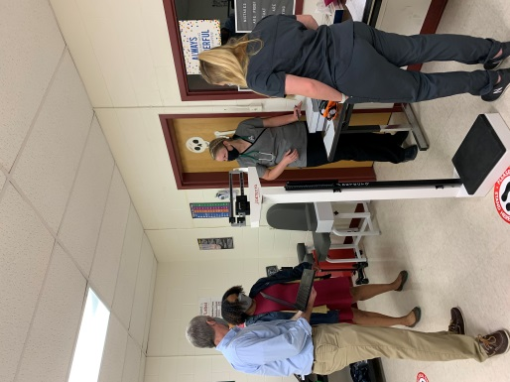 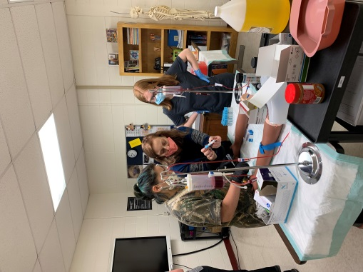

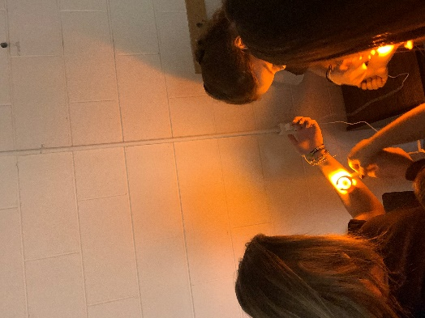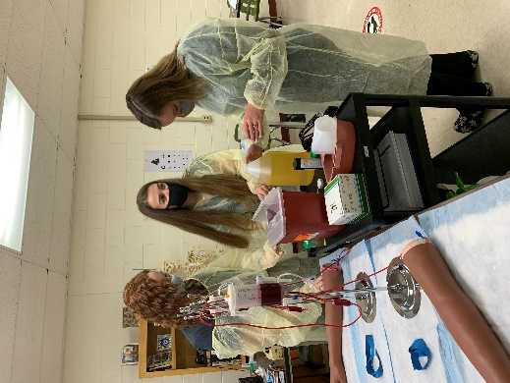 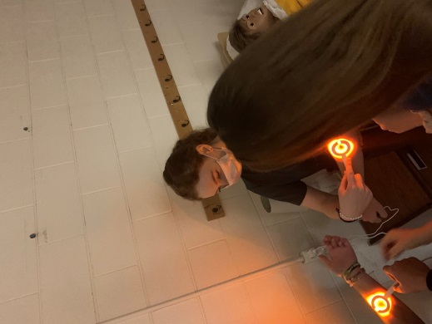

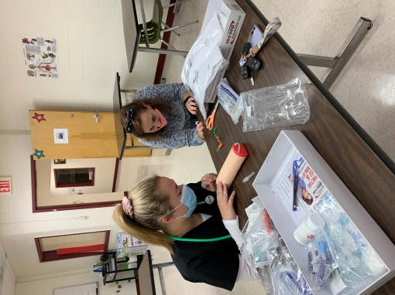 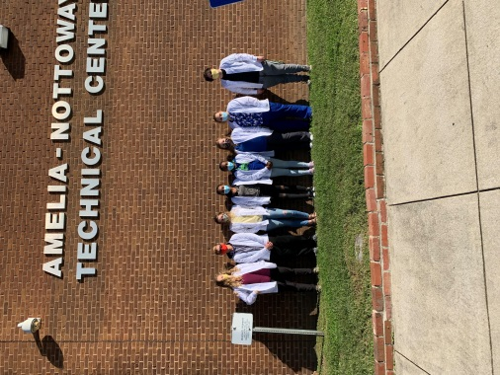 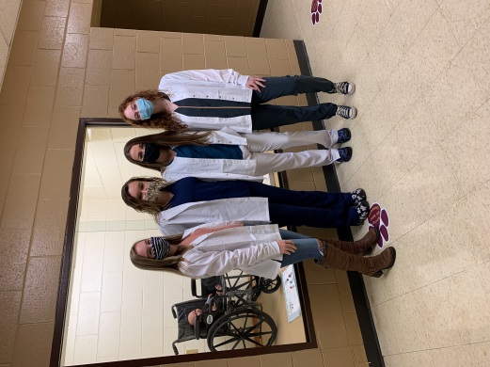

**New Lab Jackets!**

**Cosmetology:** Amelia, Cumberland, and Nottoway Students

**Skills:** Styling Hair

**Tasks:** Create a hair style!

