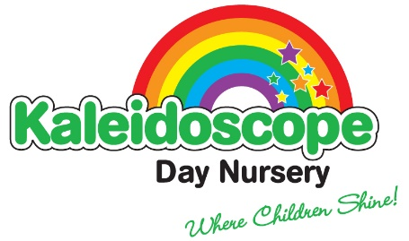
Issue 5
Review date: November 2022

No Smoking

Kaleidoscope is committed to protecting employees, visitors and those attending the setting from exposure to tobacco smoke and to comply with the legislative requirements.

Policy

- In accordance with the 2006 Smokefree Legislation, smoking is not permitted inside the place of work or in work vehicles
- In addition to this, smoking will not be allowed anywhere on site, this includes: - The grounds (i.e front and back garden, driveway, playground) - Entrances to the setting (i.e doorways, ramps, stairs) - On walls or near entrances to the front, side or back of the building.
- No smoking signs are displayed at the entrance to the setting
- Employees, managers, owners will not be allowed additional ‘smoking breaks’ during work hours.
- Employees , managers, owners who wish to smoke may only do so on designated work breaks (i.e lunch break) though this is not encouraged
- Employees, managers, owners who do smoke on a designated break must cover up their uniform and thoroughly wash their hands and freshen their breath afterwards. Any deodorant used for these purposes must be used in the staff bathroom only. Staff must ensure that they smoke a reasonable distance away from the nursery site.
- All staff are made aware of this policy via our Health and Safety Notice Board and during the induction process.
- Breaches of this policy will be subject to normal disciplinary procedures
- Information about stopping smoking will be made available throughout the building, we will promote the importance of having smoke free homes and cars
- The setting is able to signpost and support people to local stop smoking services.
- This policy also cover electronic cigarettes

In response to the new legislation on 1st Oct 2015 ‘It’s illegal to smoke in a vehicle with anyone under 18’ If nursery staff observe anyone smoking in the car within the presence of a young child, they will speak to the person concerned and discuss the risk to the child’s health.

