INTRODUCTION
One Step Cassette Style Gonorrhea Test is a rapid direct binding test for the visual detection of gonorrhea antigen, in the secretory specimen and urine from urogenital system, as an aid in the diagnosis of gonococcus infection. It is based on the principle of double sandwich immunoassay for the detection of gonorrhea antigen in the secretory specimen or urine. Monoclonal and polyclonal antibodies are employed to identify gonorrhea specifically. Both sensitivity and specificity of the test are higher than those of the present methods, which often involve long hours of culturing the collected specimen. Test results are not affected by any medication that is being taken. Results are read visually without any instrumentation. This test is ideal for screening specimen samples containing at least 1 x 10⁵ bacteria per ml.

SPECIAL FEATURES
- Test result is unambiguous and can be read in 10-20 minutes.
- Test kit is easy to operate and does not involve washing or comparison to standards.

MATERIALS PROVIDED
1. Test kit 2. Specimen Diluent 1 3. Specimen Diluent 2 4. Plastic Pipette

SPECIMEN COLLECTION
- Use a swab to collect specimen in the following suggested method:
- Male patients: Swab discharge from the opening of the urinary tract. If no discharge is present, insert the swab 2-3cm into the urinary tract, gently move a few turns and retrieve the swab.
- Female patients: Swab discharge from the vaginal opening, then insert swab into vagina for half a minute and retrieve the swab.
- Place the swab into a microtube and add 6 drops (300μL) specimen diluent 1 on the swab, rorate swab and squeeze. Discard the swab into an appropriate biohazard disposal container. Then add 2 drops (100μL) diluent 2 into the microtube and mix well. Specimen collected in the diluent should be stored at 4-8°C and tested within 24 hours.
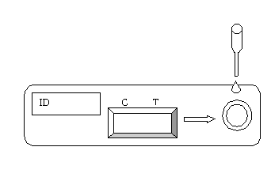
TEST PROCEDURE
- When you are ready to begin testing, open the sealed pouch by tearing along the notch. Remove the test kit from the pouch.
- Using the pipette provided, dispense 4 drops (0.2mL) of the specimen sample onto the sample well of the cassette.
- Wait 10-20 minutes and read results. Do not read results after more than 30 minutes.

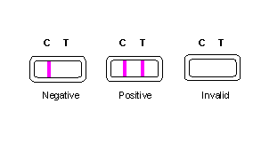
INTERPRETATION OF RESULTS
- Negative: Only one colored band appears on the control (C) region. No apparent band on the test (T) region.
- Positive: In addition to a pink colored control (C) band, a distinct pink colored band will also appear in the test (T) region.
- Invalid: A total absence of color in both regions is an indication of procedure error and/or the test reagent deterioration. Repeat the test with a new kit.

STORAGE AND STABILITY
The test kits can be stored at room temperature (18 to 30°C) or in a refrigerator (0 to 4°C) in the sealed pouch to the date of expiration. The test kits should be kept away from direct sunlight, moisture, and heat. If the test kit package was refrigerated, allow it to reach room temperature first before usage. Do not freeze.

PRECAUTIONS
- For in vitro diagnostic use only.
- Patient specimens may contain infectious agents and should be handled as though capable of transmitting disease. Wear disposable gloves throughout the specimen collection and assay procedures.
- Do not use the test kit beyond the expiry date.
- The test device should not be reused.

Latest revision 09.05.2011

ATLAS LINK, INC USA Headquarters:
No. 811 Zeyang Plaza, No.166 Fushi Road 10758-A Ambassador Drive
Shijingshan Dist., Beijing 100043, China MANASSAS, VA 20109 USA
Tel: 86-10-88909112 Fax: 86-10-88909115 Tel: 703-3663851

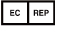
CIRIANO GLOBAL S.L. (UNILATEX GROUP)
CIF: B50927532 C/Blancas 4-6, 1 B Oficina 1
50001 Zaragoza Spain
Tel: 34-976910399

