PASTOR’S CORNER But our citizenship is in heaven…
Philippians 3:20a
November this year is a time of election, and it has worked its way in to almost every area of life. Our mailboxes, both physical and on e-mail, receive political material daily, our social media feeds and news channels are full of the latest polls and scandals, and there is a simmering tension just about everywhere. People are on edge, and who knows when the tension will be released?
Christians, of any nation on earth, always live in tension. On the one hand, we are members of our societies, active in civic discourse and (in democracies, at any rate) invited to vote. Yet, as our passage above reminds us, our true citizenship is not allegiant to a flag or banner or country first; our citizenship is in heaven. The way of Christ is the guiding light in our lives, not a partisan platform or even a legal document as powerfully symbolic as the US Constitution. Thus, even in the midst of tensions around us which we may well share, we have an extra tension: we are called to live as resident aliens. We are called to be followers of Jesus who look at the world through his kingdom-focused eyes.
In practical terms, that means each follower of Jesus must carefully consider the social and political realities around them, and prayerfully decide how to engage with them. That might mean voting for one candidate or another, one party or another; it might also mean choosing not to exercise a right to vote because of conviction. Each of us may arrive at a different conclusion and still remain faithful to the way of Jesus.
Yet one thing we all are to do, as followers of Jesus, is to pray. Jesus prayed for his community and world, even when he disagreed with how it was governed, and Paul and Peter and other New Testament writers instructed their fellow Christians to pray for the public life around them: for peace and for justice, for the common welfare and for the common good. So for this coming week, I invite you to join me and take up this prayer (from the Book of Common Worship) as your own:
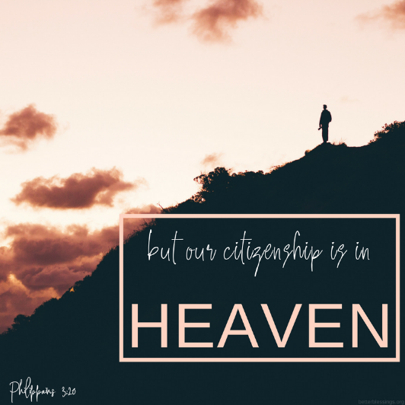
Almighty God, ruler of all the peoples of the earth, forgive, we pray, our shortcomings as a nation;
purify our hearts to see and love truth;
give wisdom to our counselors and steadfastness to our people;
and bring us at last to the fair city of peace, whose foundations are mercy, justice, and goodwill, and whose builder and maker is you.
Under your law we live, great God, and by your will we govern ourselves.
Help us as good citizens of heaven and resident aliens of earth to respect neighbors whose views differ from ours, so that without partisan anger, we may work out issues that divide us, and elect candidates to serve the common welfare;
through Jesus Christ the Lord. Amen.
Be well, my brothers and sisters!
Adam
From the Deacons
The beauty of the fall season reminds us that some things are the same in the pandemic we continue to experience. Yet, too few things are normal for us. Our church is an important constant in the midst of all that has changed. It feels good to be together in worship and fellowship as God’s people. Deacons continue to seek to ways to minister to the needs of church families and regular attendees with Christian love and service.
The Deacon Council met in person in the church social hall in October. The focus of our meeting was on serving those in need in our congregation and community. We discussed new ways of responding through benevolent assistance during this time of lost income and plans to reach out to our schools and teachers. The requests for food, rent, electrical bills, and shelter are increasing. Your donations to the Benevolence Fund are making it possible for us to show Christian love to these individuals and families in our community. Thank you, Grace Hills!
As of the writing of this article for the newsletter, nominations for new deacons has taken place. Four individuals accepted the call for consideration. Following the procedures set forth in the Church Operations Manual, three deacons will be elected. Those not elected will be eligible to serve if there is a vacancy on the council. Due to a change in our by-laws, absentee balloting is allowed for those not able to be present for voting at the business meeting. We express appreciation to Bethany Hunter, Linda Lipscomb, Dennis Torrence, and Renee Wingfield for their willingness to serve, if elected. We ask that you pray for these individuals and express your loving support to them.
The three deacons rotating off the council as of December 31st are Hank Davis, Linda Mays, and Janice Marston.
The Deacon Council is a servant ministry of service and love. The Church Council is the Administrative Council at Grace Hills. All of us together are leading the way for good in our church. Please let us know if you are aware of those for whom we should pray, visit, or assist.
May the grace and peace of God and His great blessings be with you. Stay well and safe.
Janice Marston, Chair
____________________________________________________________________________________________________________________
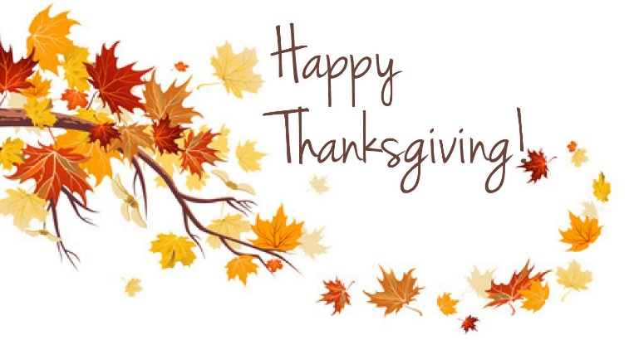
🎶 🎶 MUSIC NOTES 🎶 🎶
We are not singing in worship (inside), so I trust that you are singing in your hearts all the time. Brandon Loving will be with us Sunday, November 1st, since pandemic guidelines allow us to have a soloist. We welcome Brandon back and plan to enjoy his worshipful music. Bells will ring on November 8th, a second Sunday of live music! We have lots of spaces at inside worship; come and see!
Nancy Williams
…Let us love one another.
1 John 4:7

The Pandemic continues! Our call to be good neighbors in our community is one we can all respond to with love and concern. During the past several months, Good Neighbor focused on responding to those needs in our church and community. The Good Neighbor Council continues regular monthly meetings with social distancing and masks as we meet inside the church.
For the eighth consecutive year, Good Neighbor is sponsoring the Centra Mammography Unit. Each year, we have a full schedule of those seeking this service. This year’s date is Tuesday, November 24 at Grace Hills. For more information, please contact Shirley Walton.

The council is working with a young mother who is relocating to Appomattox in search of secure housing and new opportunities for herself and her children. As of now, we are engaging in preliminary efforts to respond to this situation. We will keep you informed and included in our work, and in ways you can be a part of this effort as we go forward. Please be in prayer for God’s will regarding the decisions which will need to be made as we initially step out in faith.
If you are aware of those in need, please tell them about Good Neighbor or call us. If you want to help in efforts to reach others, you may use a direct cell phone number (434-660-4873) as an immediate contact. The Good Neighbor Council and volunteers will continue to communicate on a regular basis.
We pray God’s protection and blessings for wellness and safety for all.
Prayer: Father, help us to always realize that we are on a mission for You.
Blessings,
The Good Neighbor Team
_______________________________________________________________________________________________________________

WMUV ANNUAL MEETING – WATCH PARTY
On Saturday, November 7th, from 2:00pm to 3:30pm, we will be hosting a watch party of the WMUV Annual Meeting. Laura Davis will have a session on Missions Involvement at 4:00pm, and between meetings we will provide snacks. Please let me know if you plan to attend (lindamays123@msn.com or 434-352-5509). We need to let WMUV know how many are watching! Also, our own Lucianne Warren is nominated for President of WMUV and we want to support her!!
Blessings,
Linda Jo
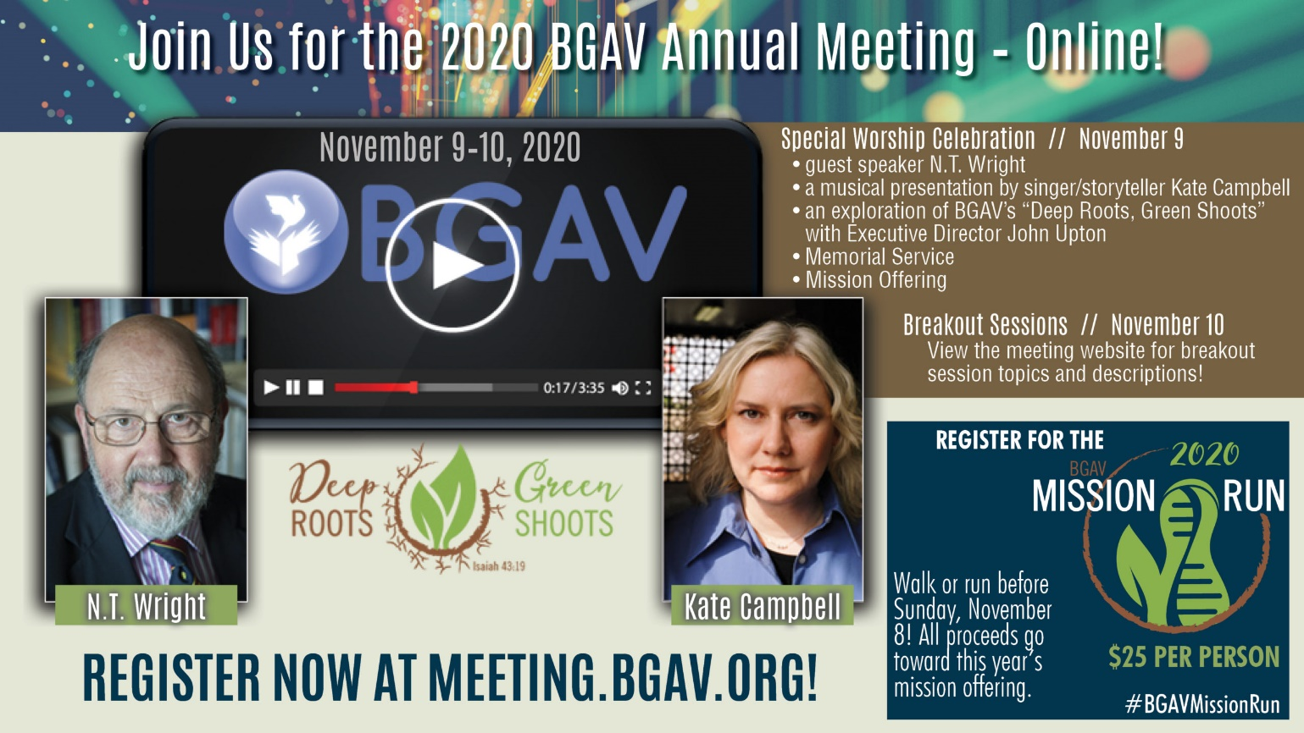
_______________________________________________________________________________________
Grace Hills Early Learning Center News
Director: Leslie Galloway Bookkeeper: Lisa Dawson
Phone: (434) 352-2273 Email: gracehillselc@aol.com
Temporary Attendance: Full Time Students: 83 School Age Students: 35

Praying all is well with everyone during these unpredictable times.
October Happenings: This month we have been talking about fire safety and what to do in case of a fire. We had a visit from the Fire Department.
Since we could not go to the Pumpkin Patch, the Pumpkin Patch came to us! The children were able to pick pumpkins and enjoy barrel rides.
Each month, all of our Preschool classes have colors, numbers, shapes, and letters they work on to prepare them for the next class. Each class also has monthly Bible Verses!
___________________________________________________________________________________________
Grace Hills Baptist Church
gracehillsbaptist.com
PO Box 807 (for mail) (434) 352-8847
4320 Pumping Station Road ghbcoffice@yahoo.com (Monica)
Appomattox, VA 24522-0807 gracehillsbaptist@gmail.com (Ruth)

