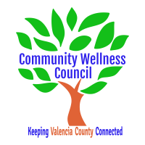
Board Meeting
April 3, 2019
1:00pm-3:00pm Wellness Center

1:00PM-1:10PM

- Call Meeting to Order
- Welcome Guests
- Agenda
- Consent Agenda
  - Minutes of 3/13/19
  - Treasurer Report March
  - Coalition Reports
- Social Media/Website Report
- Consent Exemptions
Business
- Coordinator’s Report (Noelle) 1:10 PM-1:25 PM
- Grant, Grant deliverables/Activities Update (Diana/Noelle) 1:25 PM-1:35PM
- Anna Age 8 Community Planning Meeting Next Steps (All) 1:35PM-1:50PM
- Wings for Life United Way Grant Debrief and follow up (All) 1:50PM-2:05PM
- KAH Local Trainings (Noelle) 2:05pm-2:15PM
- CRUNCH Fuel Your Family Debrief (All) 2:15-2:25PM
- OSAP/Community Survey update (Linda) 2:25-2:35PM
- MRGDA Update (Noelle/Diana) 2:35pm-2:45pm
- Tracking Volunteer Hours and Fiscal Management Update (Carol/Peggy/Noelle) 2:45pm-2:55PM
- Review of Activities/Time Line/Action Items 2:55 PM-3:00PM

Additional Items of Discussion
- Adjourn

