Lynnhaven Shores Service Unit
Pay Pal Guide
SECTION 1: Setting up an Account
- Navigate to www.paypal.com. Choose Sign Up.
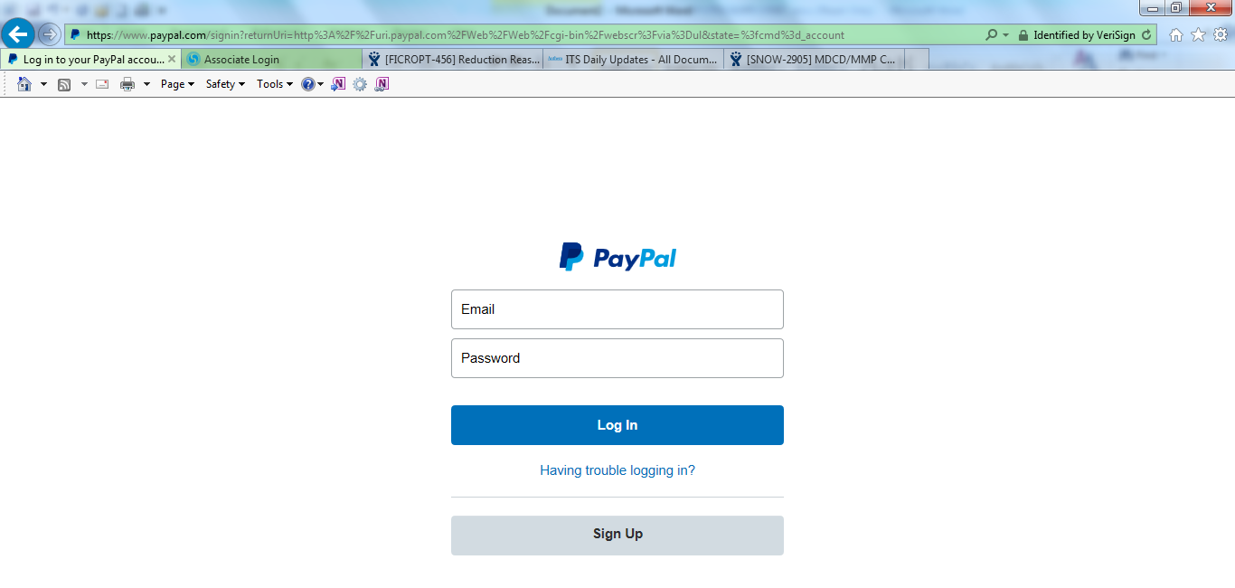
- Choose Personal Account
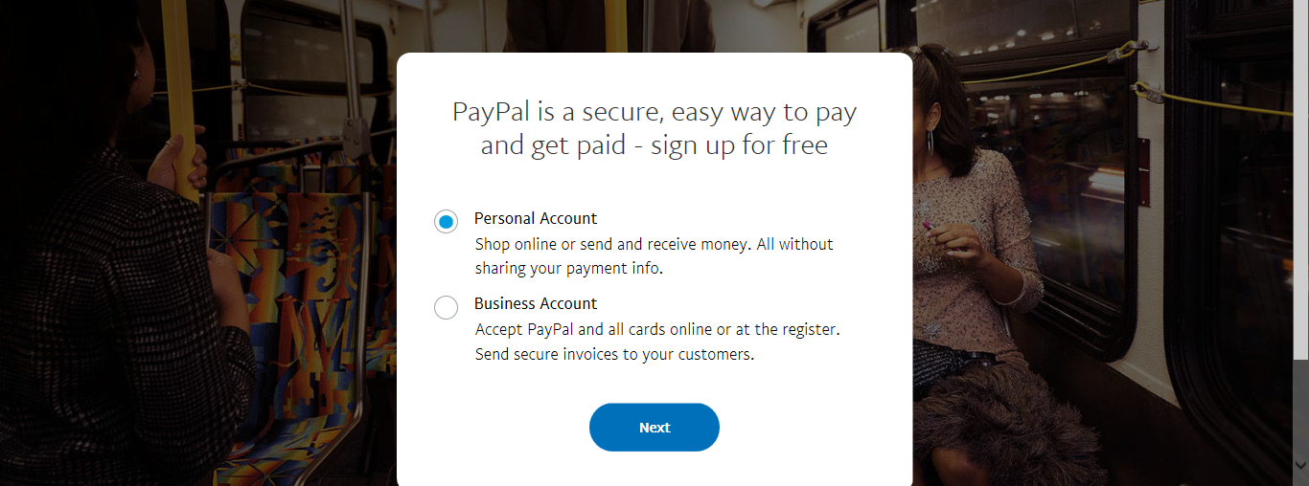

- Create account using email address. NOTE: You may want to create a troop email for this.
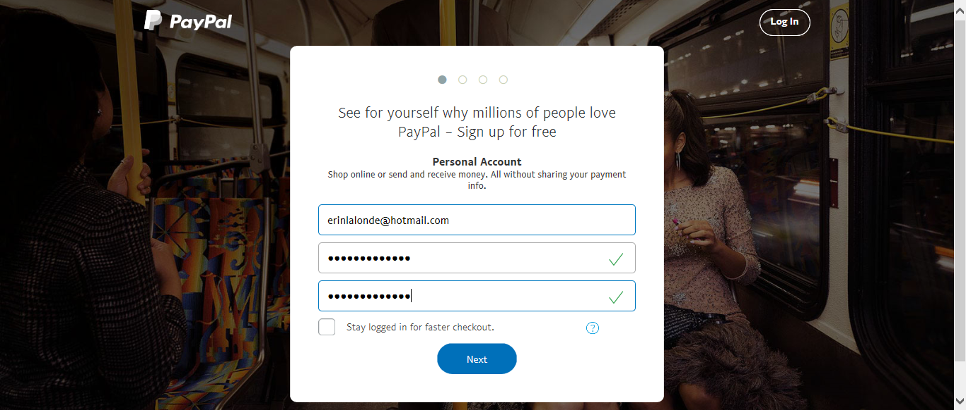
- Enter the information of the Bank Account signer.
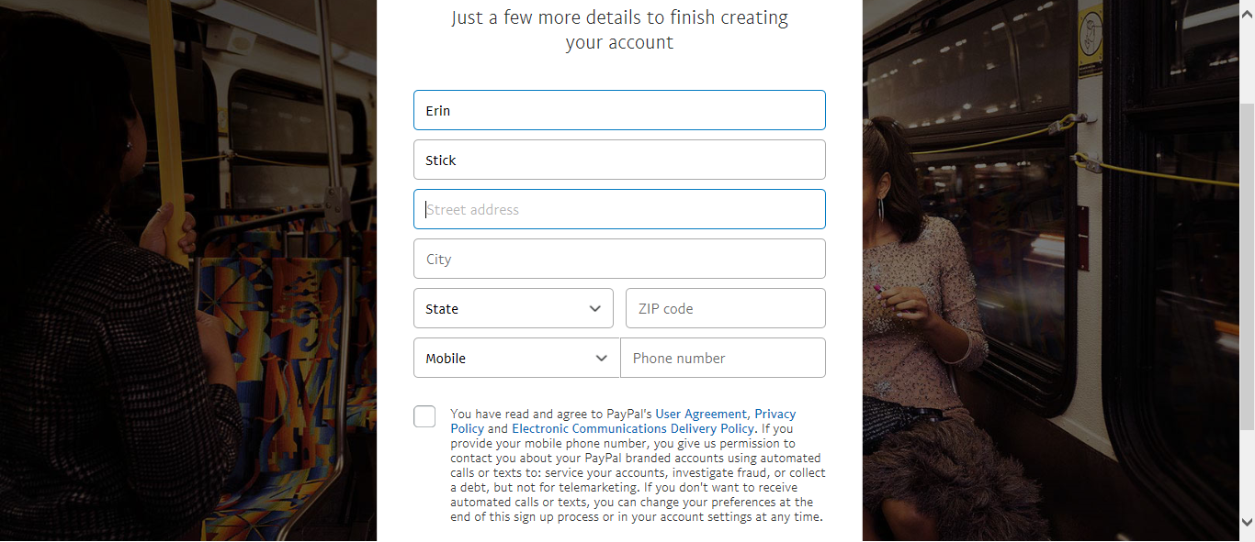

- Choose “Link Bank Account Instead”
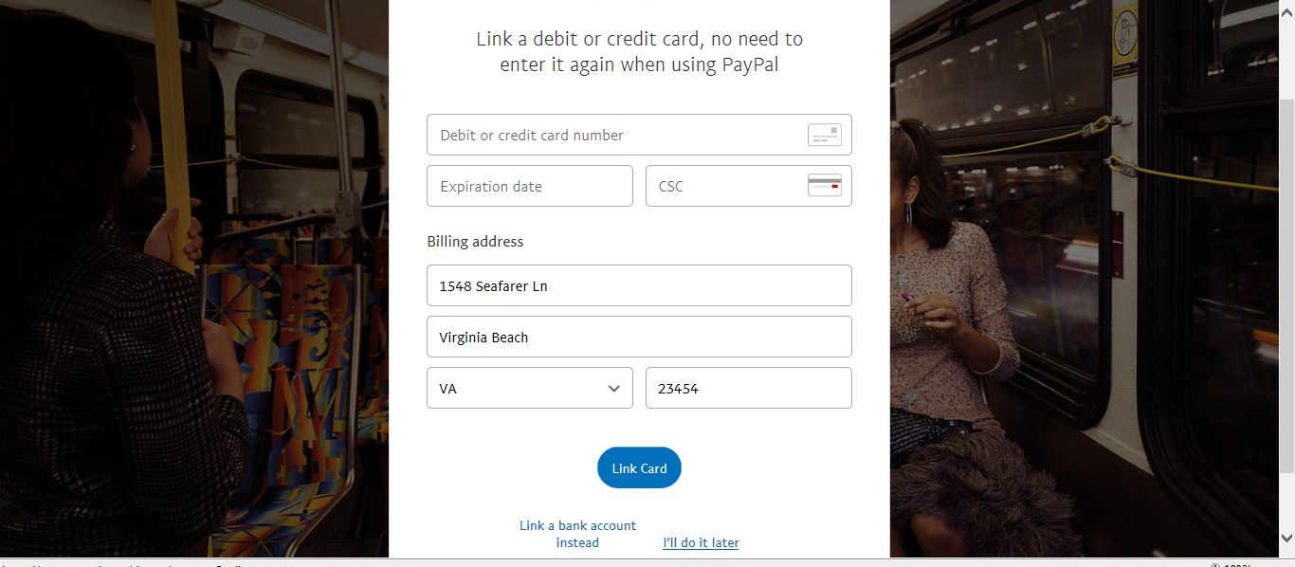
- Enter Bank Account Information. After finishing signup you will be emailed confirmation and a link you can provide to those paying you without paypal accounts.
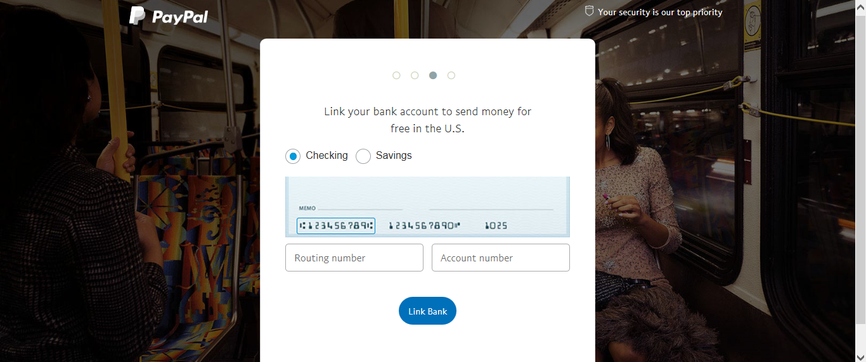

SECTION 2: Making Payments
- Log into your Pay Pal Account. Choose “Send and Request”
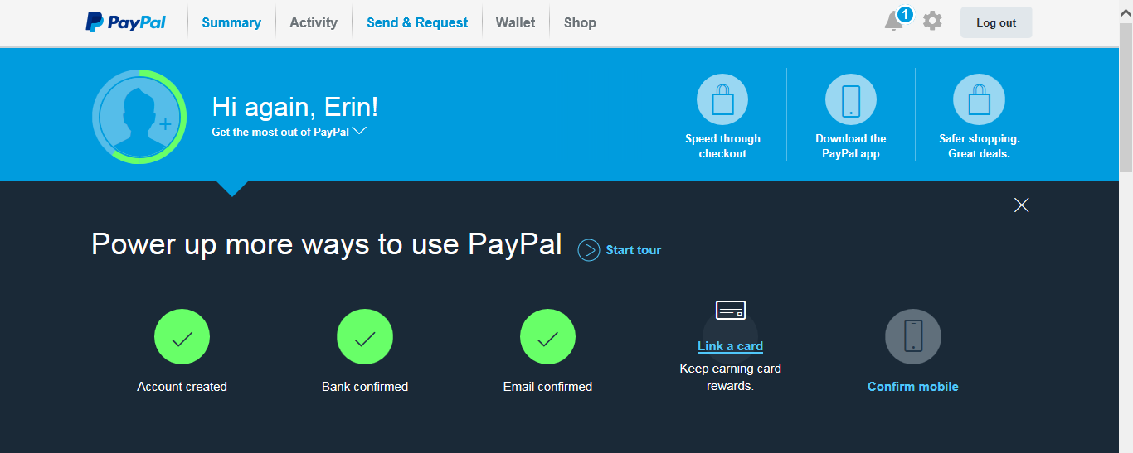

- Choose “Send to friends and family in the US”. NOTE: Do not choose pay for goods, there are fees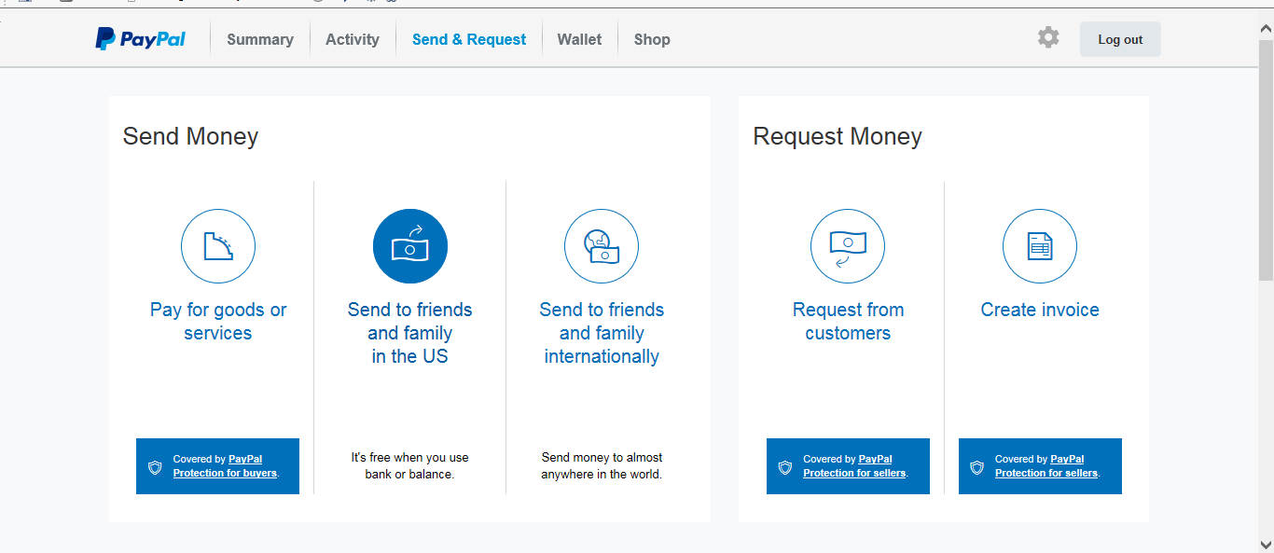

- Enter the email of the recipient.

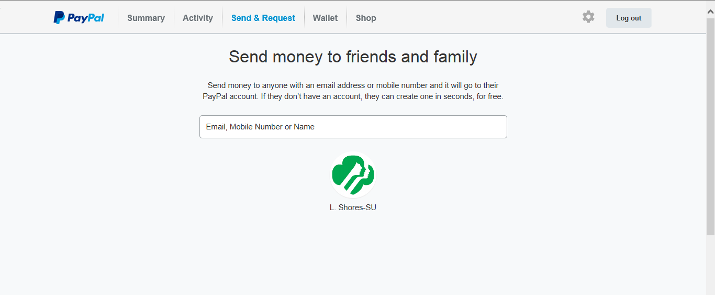

- Confirm the email and enter the amount and choose continue. A confirmation email will be sent once transfer has occurred.
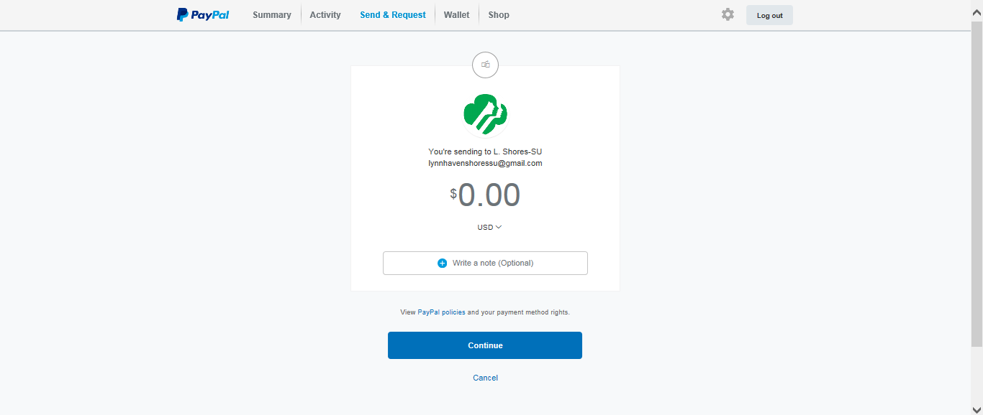

STEP 3: Receiving Payments

- After receiving email notification of payment. Login to paypal account and go to “Wallet”. Choose Transfer to your back (it will know your back account from registering with it)
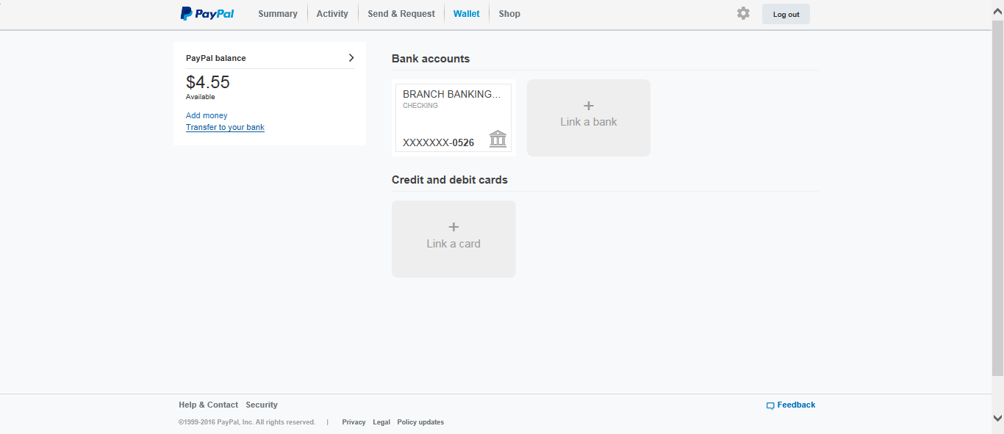

- Enter the amount to transfer. (I usually leave my paypal balance at 0) Select Continue
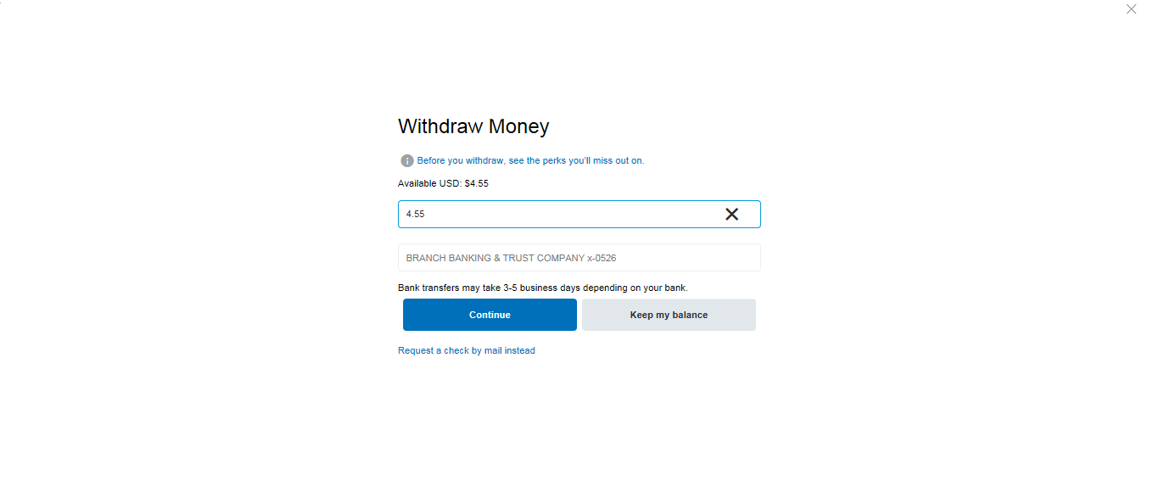

- Review transaction and confirm transfer

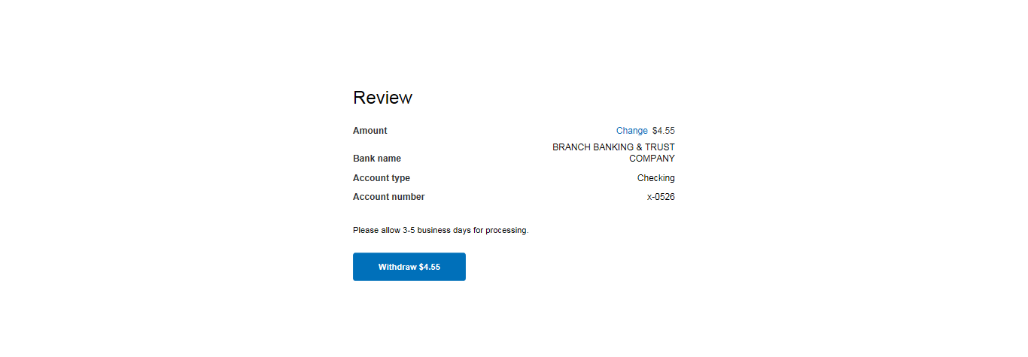

- An email confirming the transfer will be sent and you will see in back in the next few days

