DIY Window Pass Through
For casement window
by Dave Guernsey, KJ6CBS

Materials:

1x4 as long as window is tall. (Mine was 5 feet).

Barrel connectors (SO-239) for each antenna (I used 5) with retainer nuts.

5 inch piece of threaded stock (I used ¼ in) for grounds with four nuts.

2 pieces of 1/8 thick sheet metal 4 in wide and as long as you need to accommodate number of barrel connectors and ground (I used about 2 ½ feet each)

Felt type weather strip to seal sides of 1x4 (I used self-stick).

Screws to hook sheet metal to 1x4 (I used 8 on each side of 1x4).

Dowel material to secure window after pass through installed.

Construction: (See photos on last page)

Cut 1x4 to length needed to fit tightly in window.

Put sheet metal pieces on either side of 1x4 with screws.

Drill holes for barrel connectors. Then place connectors through the holes and secure with retainer nuts.

Drill hole for ground and secure with nut on each side. Other two nuts are for securing ground wires.

Put weather stripping on sides of 1x4 and put into window. Close window and secure with doweling so window cannot be opened

Notes:

I used stainless sheet metal to stop corrosion. I painted outside of 1x4 to match house trim. Sheet metal could be painted if stainless steel is not used. I painted outside of 1x4 same color as house’s exterior trim and the inside of 1x4 same color as inside trim.

Feel free to ask any questions you have.

Photos of the finished project:

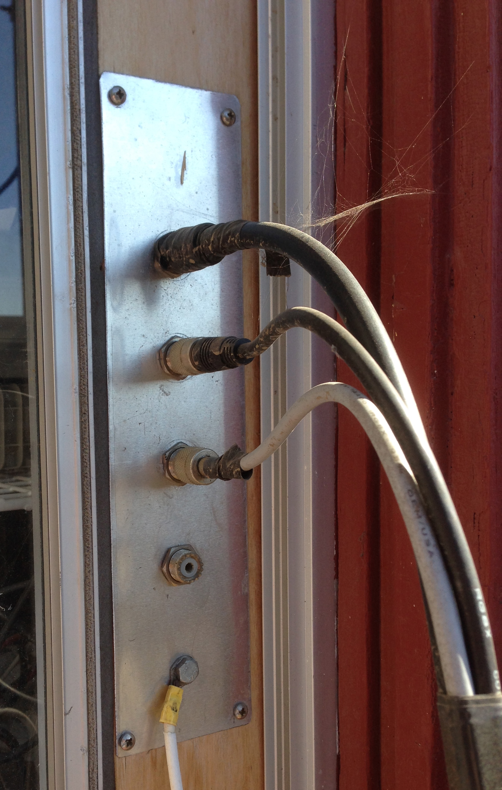
Stainless Steel plate.

This shows the pass through assembly mounted inside the window framework. Note the use of a Stainless Steel plate to prevent rusting. Also note the use of a GROUND wire which goes to a stake in the ground as a safety measure.

Ground Wire.

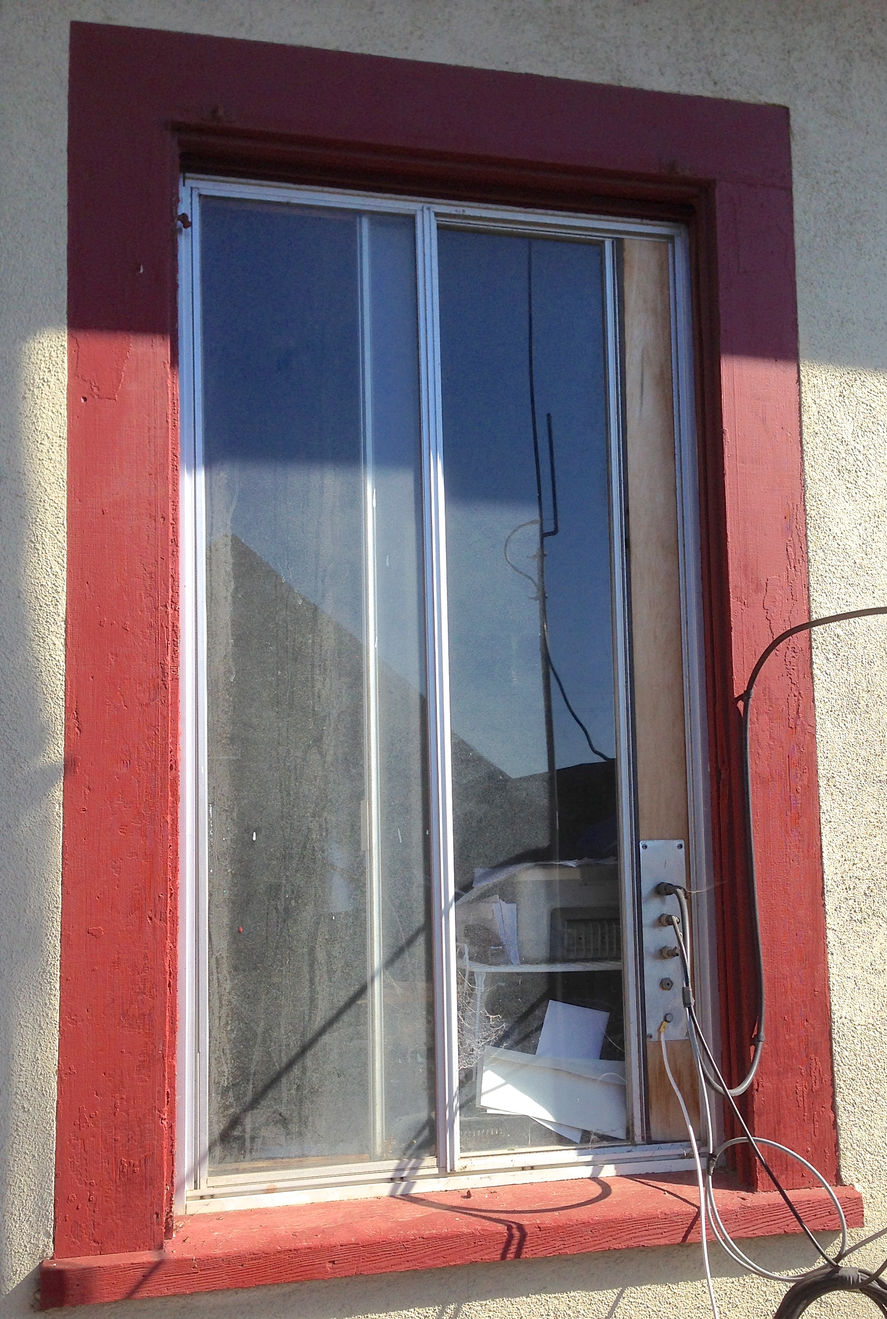

Wood support for Pass Through Assembly.

Here you can see The entire casement window with the pass through assembly installed. The mounting board runs the entire height of the window frame to completely fill the gap.

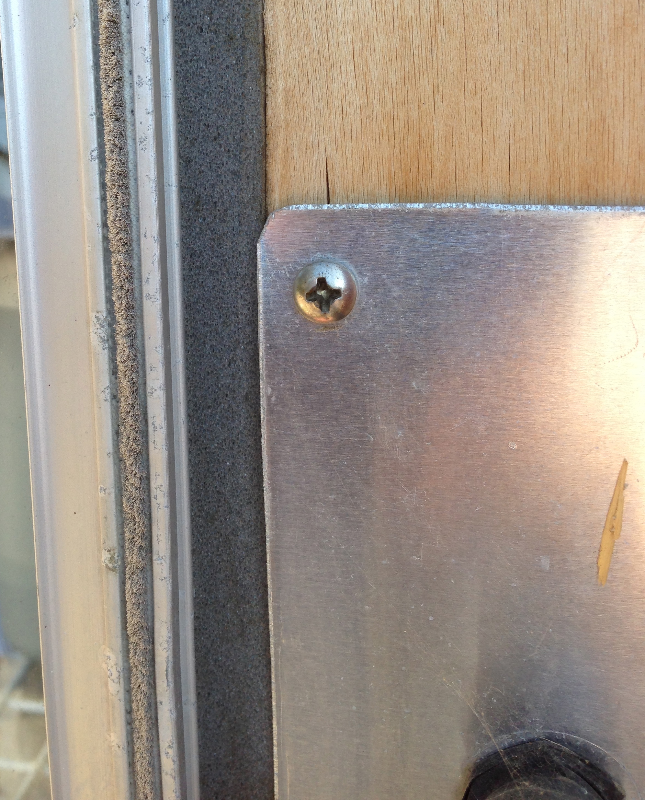
Foam Insulation used to seal between fixture and the window frame.

Here is a close up of the foam insulation that is used between the pass through assembly and the sliding window frame. It makes a nice weather seal to keep the home heating and cooling inside and keeps the elements outside!

Here you can see the SO-239 barrel connectors used in the pass through assembly.

Barrel Connector.

