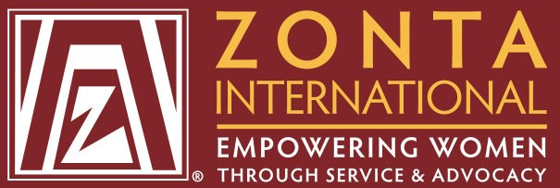
ZONTA Club
Mid-Maryland Chapter
January 1,2017

January 2017
ZONTA INTERNATIONAL
Zonta International (ZI) is a leading global organization of dedicated professionals with the mission of empowering women worldwide through service and advocacy. The organization was established in Buffalo, NY in 1919 and has grown to over 300,000 members and nearly 1,200 clubs in 67 countries around the world.

HISTORY OF ZONTA CLUB OF MID-MARYLAND
The Zonta Club of Mid-Maryland was the vision of Linda White Andrews, a member of Zonta who recognized the need for a new local club to help serve the 900, 000 people in Prince George's County, Maryland and the surrounding area. The club serves the region of Prince George's County as well as other nearby regional counties in Maryland, and continues the mission of ZI to empower women. The club's mission is to educate local residents and sponsor service projects to support the needs of women within the region.

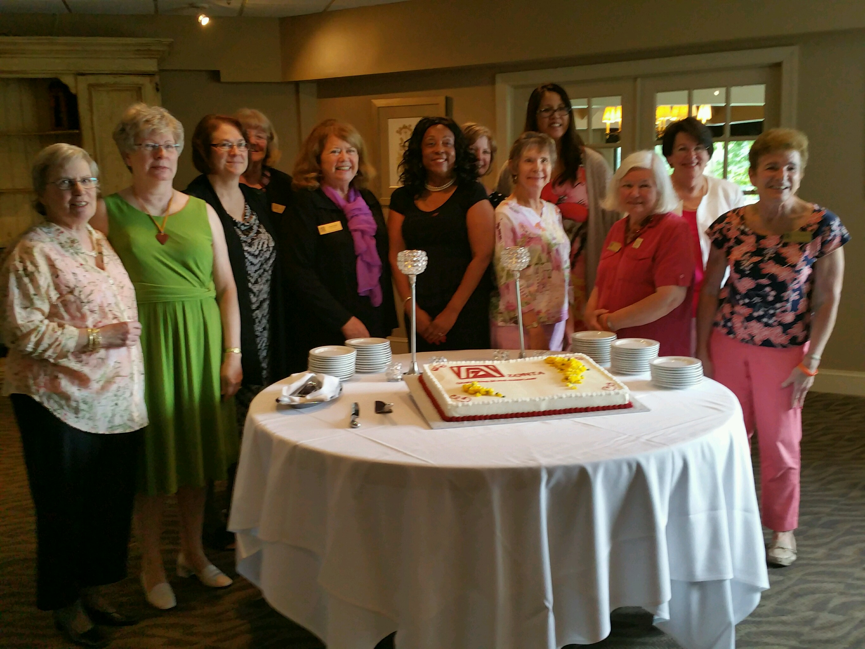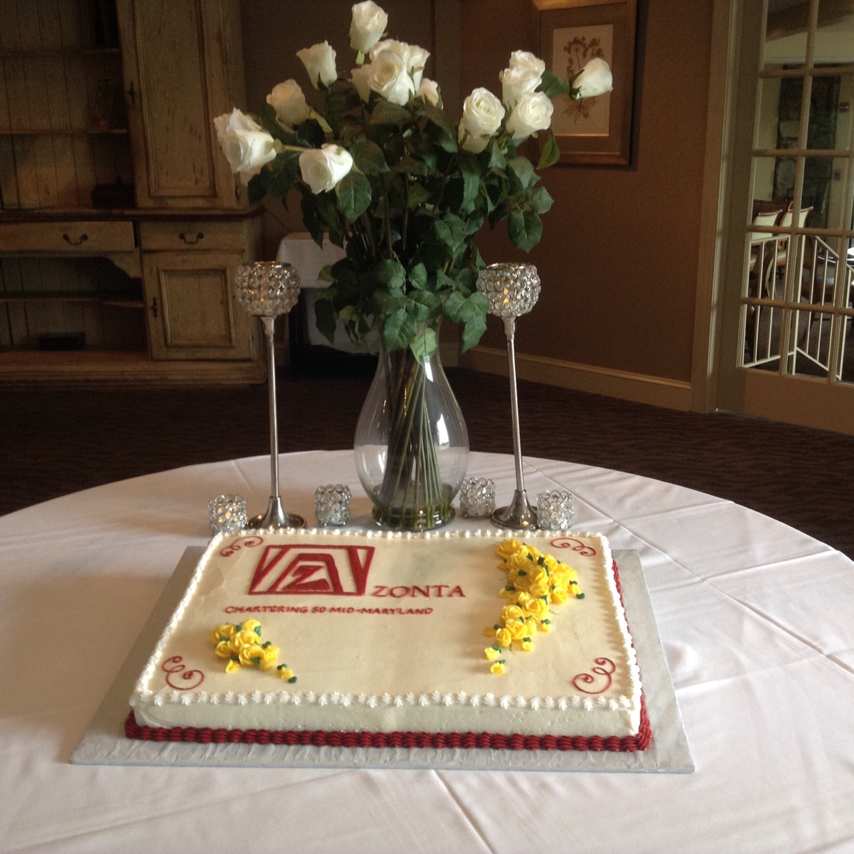
Zonta Club Members from state districts Zonta Club of Mid-Maryland

CHARTERING CEREMONY

& LUNCHEON
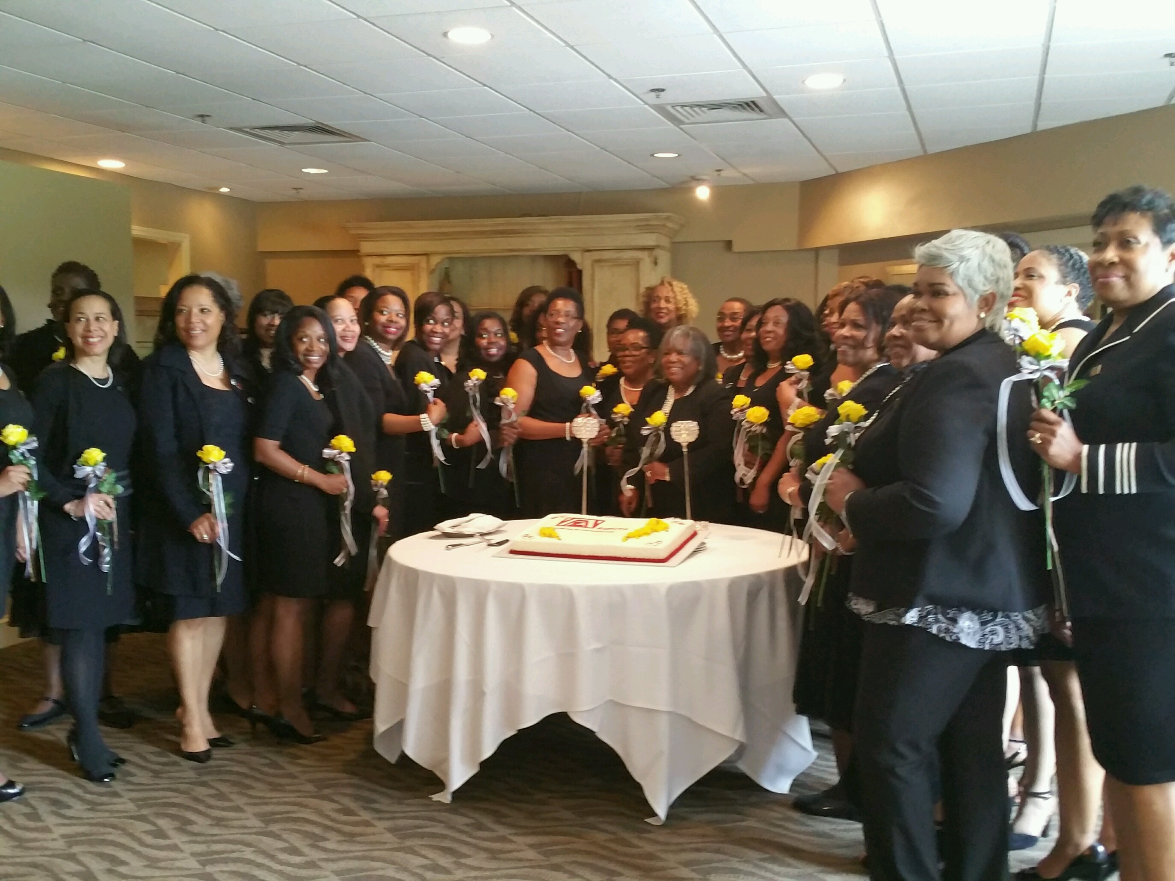
Yellow Rose Ceremony Induction
Zonta Club of Mid-Maryland was inducted as a new club in a Chartering Ceremony held on Saturday
June 4th 2016 at the Country Club of Woodmore in Mitchellville, MD. This was an exciting day for Zonta members as delegates from the local community and neighboring Zonta clubs gathered in support of the new club.

The Zonta Governor of District 3, Ms. Margo Sheridan was hosted by the club and presented each member with a yellow rose, as a token of the advocacy and service commitment of Zonta International. The keynote speaker for the Chartering Ceremony was Dr. E. Faye Williams, Esquire National President & CEO of National Congress of Black Women, Inc. Other guests included a member of the County Executive for Prince George's County, Rushern L. Baker's cabinet as well as The Honorable Dannielle Gianos, Vice President of Prince George's County Council. The Zonta Club of Mid-Maryland is notable for its membership of the largest number of African-American women within the District 3 region.
The Chartering Committee led by Co-Chairs Stanita Scott and Virginia Moore, was congratulated for an extraordinary effort in organizing this special event, Other members of the committee include Erma Barron, Rhonda Caldwell, Karen Mitchell Fenner, Andrea Green-Horace, Jennifer Jones-Peoples, Denise Dobson McDonald, Roberta McLeod-Reeves and Cleopatra White.

SERVICE COMMITTEE
Committee Chair: Nicole Barnes
Contact Info : nlawans315@gmail.com
The Service Committee Launched into its New Duties with “SERVICE”!
The Zonta Club of Mid-Maryland’s newly formed Service Committee launched into its duties with Solidarity, Excitement, Responsiveness, Vitality, Interest, Commitment and Exhilaration! -- SERVICE! The first meeting was held at committee chair Nicole Barnes’ home to plan for the screening of the film Sold. It was the perfect environment for brainstorming, event planning, and fellowship over a wonderful, home-cooked meal and dessert prepared by chef extraordinaire Nicole Barnes. It was a joint effort, and members of the Public Relations and Social Media Committee and the Advocacy Committee, were also present for event planning and preparation.
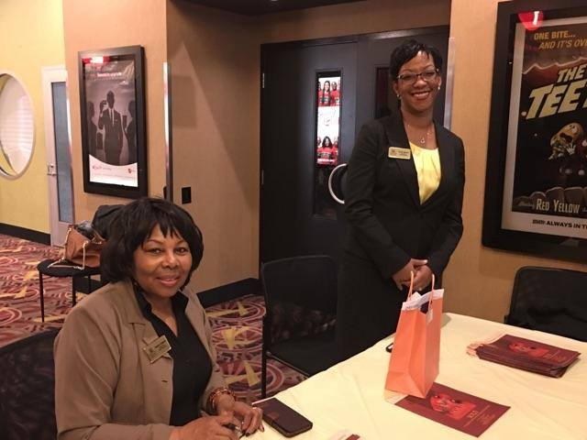
The service committee members arrived at the screening with colorful giveaway bags, and were diligent in welcoming and registering attendees. Each guest received a goodie bag with pamphlets and information on human trafficking, as well as a Zonta Club of Mid-Maryland wrist band with the words “#end trafficking” to commemorate the event
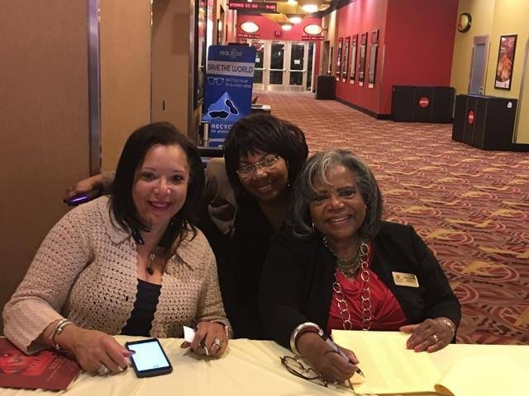
.
Kudos to the Service Committee Members – Chair: Nicole Barnes, Members: Patricia Allen, Marie-Morilus Black, Sharon Dowell, Sheila Eggleston, Miyoshi Feaster, AJ James, Eunice Johnson, Gwen Terry, and Stanita Scott.

Service Committee Obtains its Goal of “Tracking it Forward”
One of the service committee’s goals this year was to find a timesaving, online tool capable of tracking members’ volunteer hours. “Track it Forward” turned out to be the perfect tool to facilitate the annual reporting of volunteer hours to ZI and to keep individual members aware of their respective volunteer hours. Zonta Mid-Maryland members can access this service via Zonta Club of Mid-Maryland’s website at www.zontaclubofmid-maryland.org and/or by going to www.trackitforward.com.
Nicole Barnes created and distributed a “Quick Guide on how to use Track it Forward”, and this guide is available on the website’s Members Only page.
“Track It Forward” also allows each member to create events, schedule committee meetings, and send communications to other Club members. For example, if you need volunteers for a shoe drive. You can create an event called “Shoe Drive”; identify the number of volunteers needed; schedule meetings and conference calls; and send reminder messages to the volunteers.
This timesaving tool is the perfect solution for maximizing time and volunteer activities. So, let’s Track it Forward!

ADVOCACY COMMITTEE
Committee Chair: Felicia Saddler
Contact Info: Feliciathejeweler@yahoo.com
SOLD
Movie Premiere
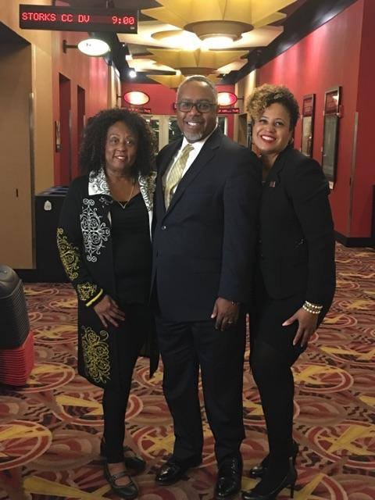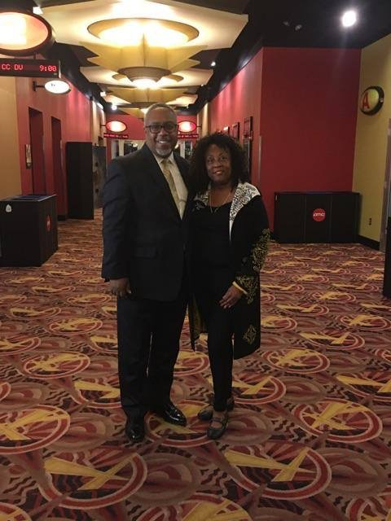
Sold Movie Premiere
The screening of the movie SOLD at the Magic Johnson AMC Theater in Largo, MD was one of the first joint service and advocacy events and it was a huge success! The event was held on Tuesday, October 1st, the International Day of the Girl, and more than 150 tickets were sold. It was well attended by the local community, and provided an opportunity for education on human trafficking, a global and regional problem. The movie highlights the struggle of a young Nepalese girl who was sold into prostitution, and viewers are drawn into her world of desperation and lost hope and are struck by the brutality of those who exploit young children. The movie ends on an uplifting note as she escapes to an organization that rescues and rehabilitates these abused children. This in itself highlights the need for organizations like Zonta, which, through advocacy and action, can bring hope and strength to young girls within the region.

ZONTA SAYS NO TO DOMESTIC VIOLENCE
16 Days of Activism
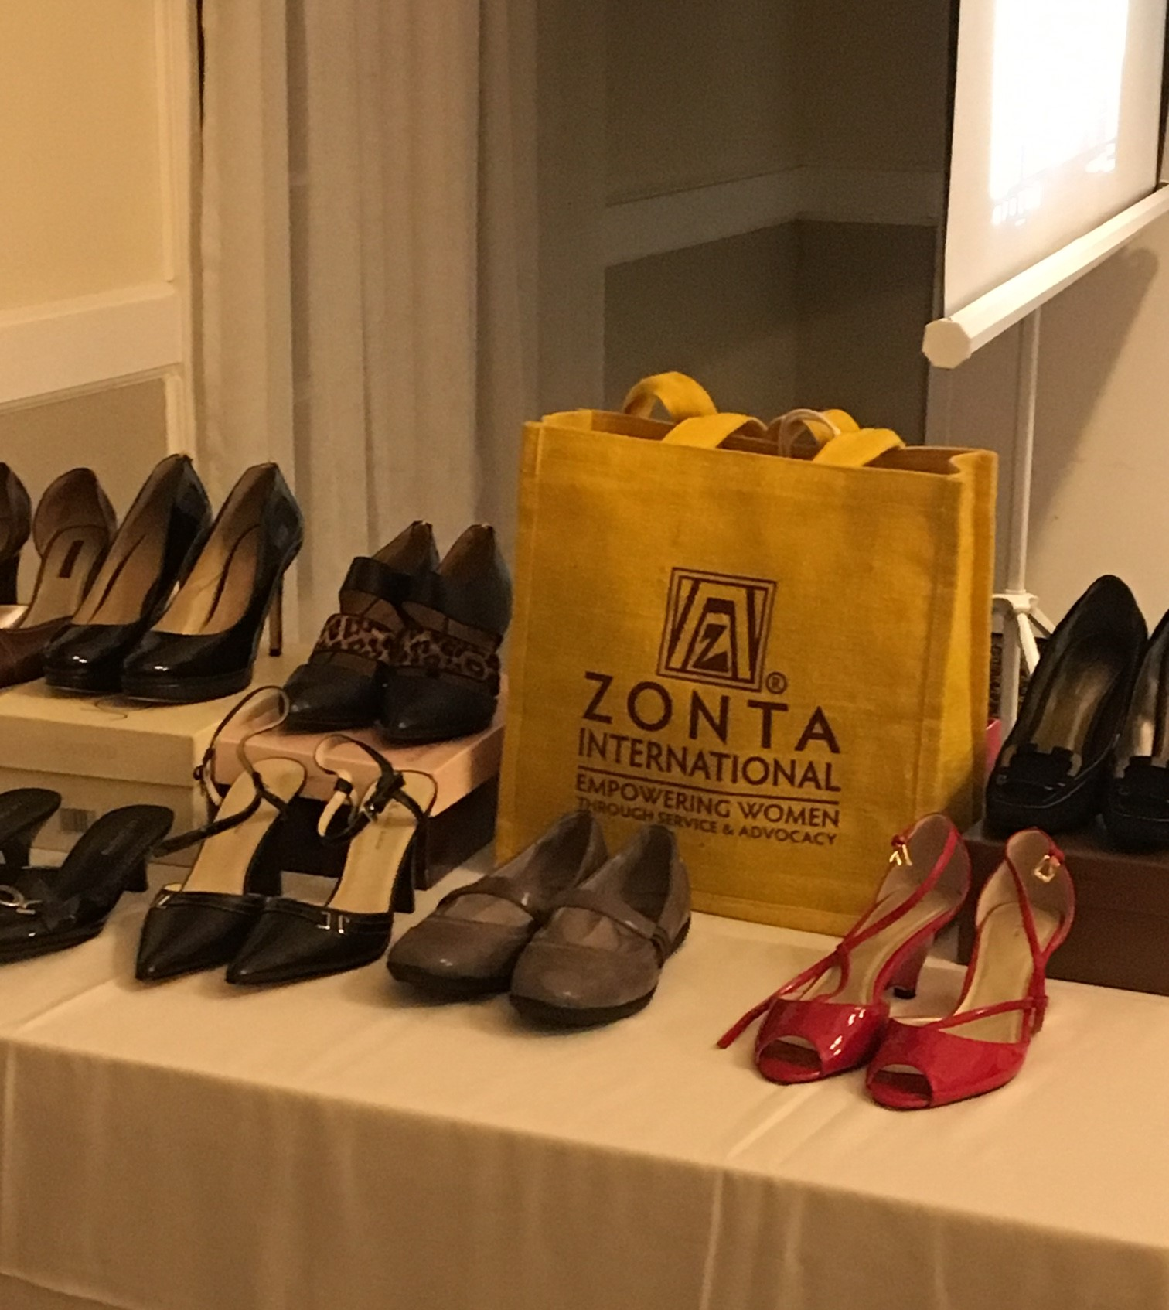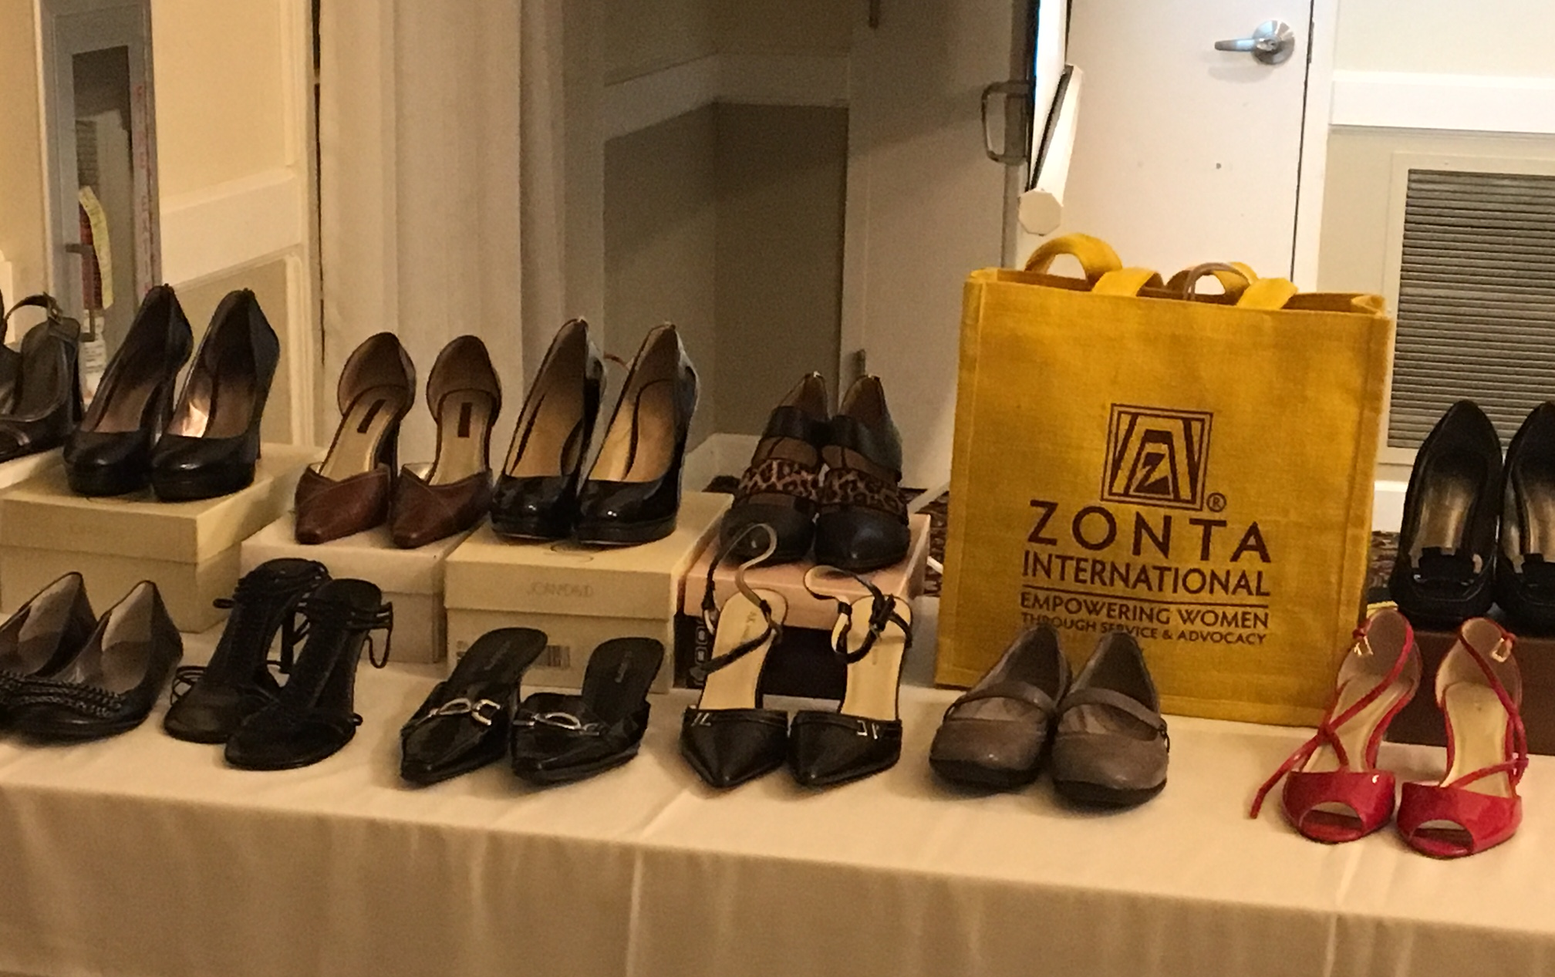
Zonta Says No to Domestic Violence
November 25th to December 10th marks the 16 Days of Activism where Zonta Clubs across the world focus on issues of domestic violence. Zonta Club of Mid-Maryland hosted a “Walking in my Shoes” exhibit at the WE3 Women’s Empowerment conference on Saturday December 10th 2016 at Jabbok Ministries in District Heights, MD. Each pair of ladies’ shoes represented a woman affected by domestic violence and spoke to the individual experience of domestic violence of women from all walks of life.
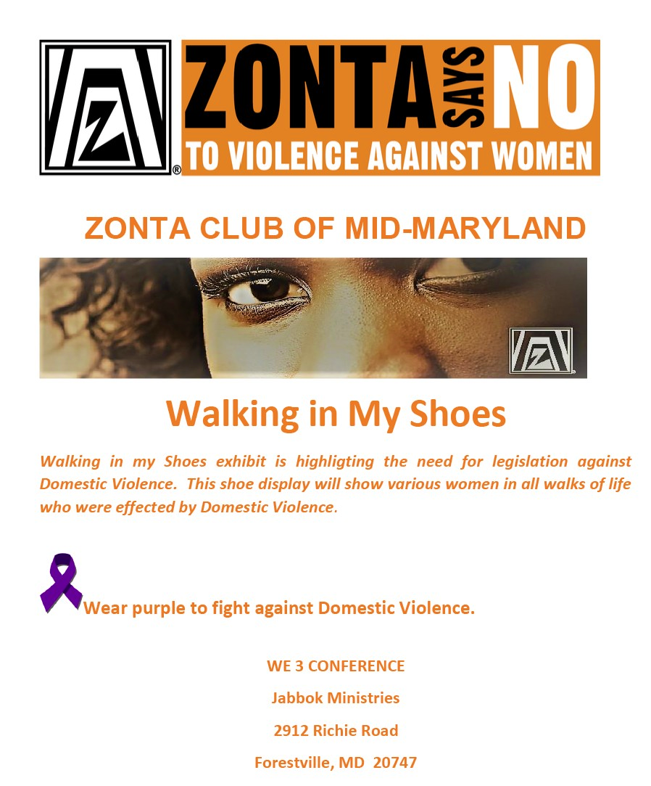

PROGRAM COMMITTEE
Committee Chair: Virginia Moore
Contact Info: vhmoore78 @yahoo.com

The Programs Committee has been phenomenal in their efforts to engage and educate members.
Breast Cancer Awareness Month: October 2016
Guest Speaker: Ms. Ricki Fairley, Founder of DOVE Marketing
Ms. Fairley is the Founder of DOVE Marketing, and her current clients include AARP, TV One, Donnie Simpson, Michelle Wright, Dr. Julianne Malveau, and Chick-Fila. Ms. Fairley holds a BA from Dartmouth College and an MBA from Kellogg School of Management at Northwestern University. She is the President Emeritus of the Black Alumni of Dartmouth Association and a member of the 2011 Class of Leadership Atlanta. She is a member of the Board of Trustees and chairs the marketing committee for the Triple Negative Breast Cancer Foundation and works diligently to garner publicity for breast cancer awareness. As a Stage 3a triple negative breast cancer survivor /thriver, she speaks regularly to advocate for awareness of the disease.
Honoring Zontian Amelia Earhart: January 2017
Guest Speaker: Dr. Aprille Ericsson, NASA
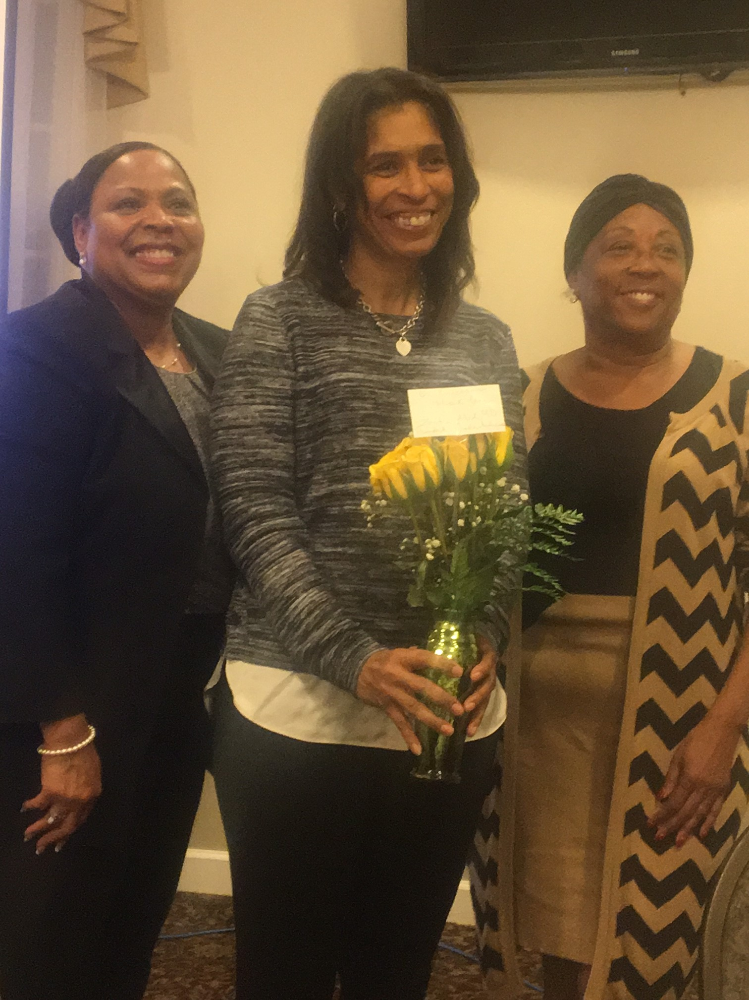
Dr. Ericsson grew up in Brooklyn, NY, and attended the Massachusetts Institute of Technology, receiving a B.S. in Aeronautical and Astronautical Engineering. She received her Masters of Engineering and Ph.D. in Mechanical Engineering in Aerospace from Howard University. Her graduate research focused on the development of procedures for the design of ‘optimal digital controllers’ for future large orbiting space structures. Dr. Ericsson has been a guest researcher at Harvard/Radcliffe University and has a certificate for leadership and management from John Hopkins University. Dr. Ericsson spent most of her engineering career at NASA’s Goddard Space Flight Center (GSFC). She worked in Guidance Navigation & Control, conducting spacecraft simulations to analyze and predict spacecraft dynamic behavior during flight, and to determine the best control methods for spacecraft attitude and structural vibration. She has also worked at NASA HQ as a Program Executive for the Earth Science Enterprise and a Resource Manager for the Space Science Enterprise. She has been an Instrument Manager in NASA Goddard’s Instrument Systems Branch, leading and managing teams of scientists and engineers on various instrument proposals and flight missions.
Dr. Aprille Erickson, NASA Aerospace Engineer

FUNDRASING COMMITTEE
Commitee Chair: Stanita Scott
Contact Info : stanitascott@aol.com
FEBRUARY Fundraiser 2017
Valentine's Murder Mystery Dinner & Dance
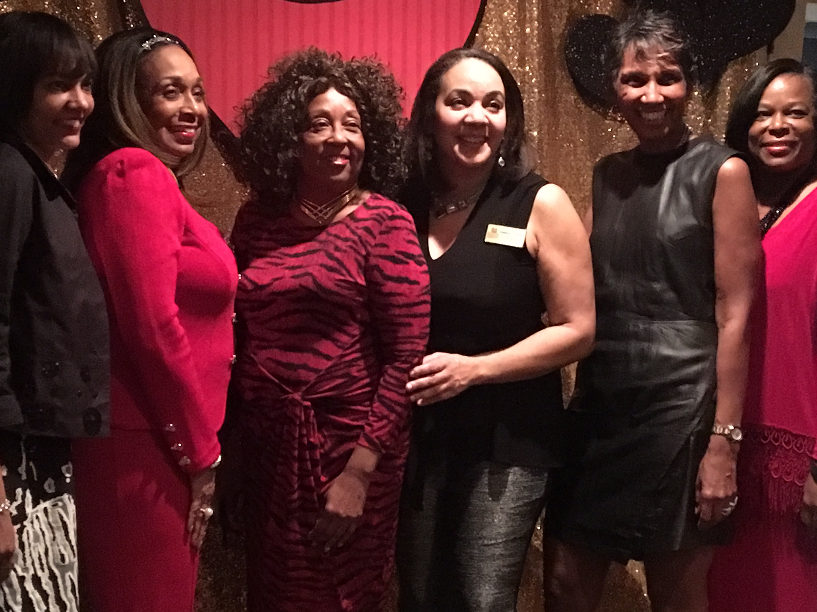
Valentine's Day Murder Mystery & Dance
Look out for the phenomenal February fundraiser for 2017! The club will be hosting a Murder Mystery Dinner & Dance at the Woodmore Country Club in Mitchellville, MD on Saturday February 11, 2017 from 7:30pm-11:00pm. Tickets for the dance will be $75.00 per person and can be purchased through Eventbrite. Please contact the committee chair, Mrs. Stanita Scott for further details

MEMBERSHIP COMMITTEE
Committee Chair: Erma Barron
Contact Info : ebarronzonta@gmail.com

Members are encouraged to attend monthly meetings, an important source of fellowship, information and inspiration for our Mission. Committee members will contact members in advance of meetings via email reminders.
To facilitate team building within the club, biographies and photos of current members will be posted to the Zonta Club of Mid-Maryland website in a "Getting to Know You " page viewed in the Members Only section of the website. Members are encouraged to submit information about their careers, families and likes and dislikes to the membership committee.

ZONTIAN JENNIFER JONES
Women's March in Washington, D.C

The Women's March in Washington, D. C on January 21, 2017, was an opportunity to advocate for women’s rights and protest injustices to women around the world. Representatives from Zonta International and local Zonta clubs were present for this global coordinated effort, and marched in step with women around the world. Zontian Jennifer Jones shares her views of the event:
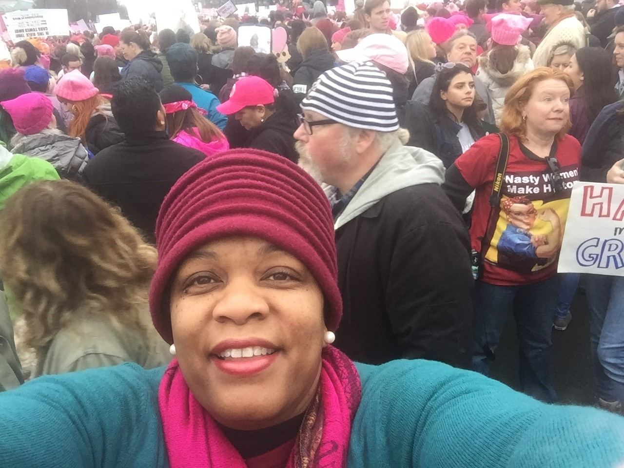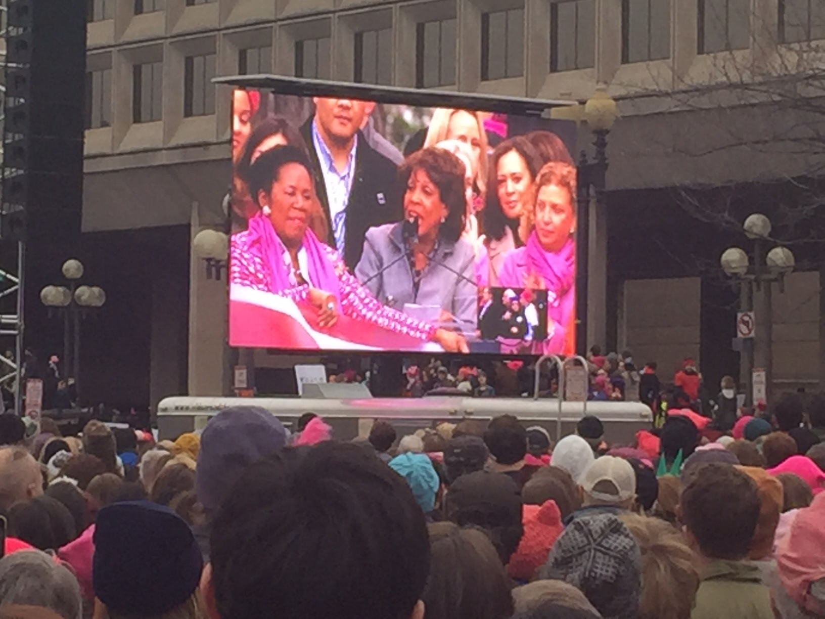
The Advocacy Continuum with Jennifer Jones: Why do we serve?
It's about the quality of our lives, our children, our communities and our future!
We MUST organize, prioritize and execute strategies in EVERY HIGH SCHOOL, BOARDROOM and CHURCH to enrich, build up and support our community! Hurting ready to heal, healed ready to transform and transformed elevated! We can do it!!!! We must build up existing organizations that tutor and mentor and expand or create new ones to build our capacity and provide education for our children to give them a chance. We must elect representatives who support "we the people" and run for office to serve the public! We are fortunate in Prince George's and Maryland to have some GREAT leaders who truly engage us! We must empower economic sustainability through financial literacy and education, entrepreneurship, social entrepreneurship and business ownership to employ our community and create opportunities on every level! We must celebrate the arts, the creative and the talented who don't fit traditional or standard norms but who have the capacity to add music, beauty, meaning and expression to our lives! We must "put our own oxygen mask first" so that we are able to give our best to serve, work and lead missions greater than ourselves for our communities of interest! And, as we grow, evolve and transform to a "greater expression of ourselves"....we serve those who have not traveled our journey! And finally, we must exercise our faith!!!! And as we SHOW UP, STEP UP and STAND UP for our interests, we STEP UP, STAND UP and SHOW UP for each other and bless our communities! As Chereace Richards would say, "It's Go Time!" Cheryl Wood would say, "Play Time IS Over!" And, Nakia Wright would agree it is time to hear "A Woman's Voice!" and Renee Allen would co-sign "BAM, Boom, Well alright!"
If you have EVER wondered what the Call to Action in your personal, professional or civic life felt like....if today's pictures of Women's Marches moved you as we saw PURPOSE, PASSION and EMPOWERMENT spill over into the streets in over 600 locations in these United States of America and 50 countries all over the world, the seas of women and men witnessed on Saturday, January 21st....that movement, feeling, wanting to get up and do something MORE was your call!!!
You are called...to serve, to be the change you want to see, to do what you can in your corner of the world to make a difference!
I close today's message with this plea, 2 Chronicles 7:14 If my people who are called by my name will humble themselves and pray....
PRAY, WATCH, LEVERAGE, STRATEGIZE and ACT!

https://www.facebook.com/zontamidmd/
https://www.linkedin.com/groups/8538820
https://twitter.com/ZontaMidMD/

ZONTA Club
Mid-Maryland Chapter
P.O. Box 187
Glenn Dale, MD 20769
Email: zontamidmaryland@yahoo.com
Website: http://www.zontaclubmidmaryland.org

