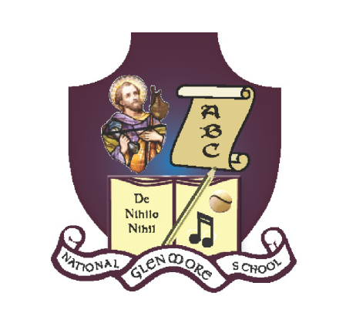
GLENMORE NATIONAL SCHOOL
S.N. SEAMUS NAOFA
GLENMORE, CO. KILKENNY

051 – 880269 glenmorens@gmail.com Roll No: 18158L

Internet Acceptable Usage Policy

Educationalists believe in the benefits of curriculum-based internet use. The purpose of the Internet Acceptable Usage Policy is to ensure that pupils will benefit from learning opportunities offered by the school’s internet resources, and will be protected from harmful and illegal use of the Internet.

SN Seamus Naofa will employ a number of strategies to maximise learning opportunities and reduce risks associated with the Internet. These strategies are as follows:

- Acceptable Usage Policy
- Education
- Filtering/Monitoring

Pupil Access to the Internet
The school is pleased to offer the internet as an available resource to both pupils and teachers for reference purposes, researching project materials, playing interactive educational games, learning to touch-type and for lesson reinforcement. Access to online resources will enable pupils to explore thousands of libraries, databases, and bulletin boards throughout the world.

Electronic information research skills are now fundamental to preparation for living and working in this information age. The school will integrate such information as appropriate within the curriculum, and staff will provide guidance and instruction to pupils in the appropriate use of such resources, as outlined in this policy.

- Pupils will not be given access to the Internet without teacher supervision
- Internet will be used for educational purposes only
- Internet sessions will always be supervised by a teacher
- Filtering software will be used to minimise the risk of exposure to inappropriate material
- The school will regularly monitor pupils’ internet usage
- Pupils will receive training in the area of internet safety
- Pupils will be taught to evaluate the content of internet sites
- Teachers will be made aware of internet safety issues
- Uploading and downloading of non-approved material is banned
- Virus protection software will be used and updated on a regular basis
- The use of personal external storage devices or CD-ROMS in school requires a teacher’s permission
- Pupils will observe good ‘netiquette’ (etiquette on the internet) at all times and will not undertake any action that may bring a school into disrepute
- ‘YouTube’ (and similar sites) can be accessed only under the supervision and direction of the teacher.

Email
Pupils are not permitted to use email in school.

Social Media
Students are not permitted to use social media in school.

School Website & Social Media
Pupils may create projects, artwork, writing or audio-visual recordings which would be suitable for publication on our school’s website. Designated teachers will manage the publication of material on the school website adhering to the stipulations below.

- Personal pupil information, home addresses and contact details will not be published on the school website
- Class lists will not be published
- Pupils’ full names will not be published beside their photograph
- Digital photographs, video clips and audio clips will focus on groups and group activities rather than on individual pupils when possible
- Pupils will be given an opportunity to publish projects, artwork or school work on the school website
- Teachers will select work to be published and decide on the appropriateness of such
- Permission to publish a photograph of student’s work will be sought from pupil’s parents/ guardians. This permission may be withdrawn at any time.

Education and Internet Awareness
SN Seamus Naofa will undertake an education programme to educate children on the safe, responsible use of the Internet as part of the school’s SPHE programme. Cyber-bullying has become a significant threat for teenagers. Through education and awareness, we aim to limit our children’s susceptibility to it as they progress to secondary school. 21st century life presents dangers including violence, racism and exploitation from which children and young people need to be protected. At the same time, they need to learn to recognise and avoid these risks – to become internet wise.

Resources that may be used to implement this programme include:

- NCTE Internet Safety Awareness Video
- Internet safety talks for children and parents
- Use of the ‘Kids’ section on the www.webwise.ie website
- SAFT Internet Safety Awareness Education Programme and exemplars

Filtering
The school will use the Internet provided and filtered by the NCTE (National Centre for Technology). ‘Filtering’ is a term used to describe a way of limiting the content of web pages, emails, chat rooms and other electronic data to which users may be exposed. [Insert School Name] also uses additional filtering software on all our machines, which, while not foolproof, thus filtering pupils’ access to the internet further. No filter is 100% accurate. The most effective filtering tool is adult vigilance. At [Insert School Name], we believe that the advantages to pupils having access to information resources and increased opportunities for collaboration far exceed the risk of disadvantages.

The access to websites from all school computers is monitored and regularly reviewed by the NCTE. Websites are only allowed through following a verification of their suitability.

Many browsers have their own built in filtering tool e.g. Google. Google’s search engine has a built-in “Safe Search”. This filter eliminates sites that contain pornography and explicit sexual content from search results. It is easily applied by clicking on the Preferences link on any Google page. Unfortunately it is also easily removed

Sanctions
If a pupil deliberately misuses the internet or email, is found running searches on inappropriate topics or attempting to access inappropriate/unsuitable websites, this will result in disciplinary action, including the withdrawal of access privileges. Deliberate misuse of the internet or email is seen as a serious breach of the rules, and, under the Code of Conduct and Discipline of Glenmore NS, appropriate sanctions will follow. Parents/guardians will receive notification of misuse by a pupil. Further misuse will result in longer or extended withdrawal of access of privileges. Further consequences under the Code of Conduct and Discipline will be sought, as determined by the seriousness of the incident.

This policy was adopted by the Board of Management on ______________________

Signed: ____________________________________
Chairperson of Board of Management

Date: ____________________

Date of next review: ________________

