THE COACH HOUSE, NEWLAND

Accessibility Guide

Parking is either in the court yard (room for one car) or on the lane. Further parking is available in the grounds of The Lecturage which is next door.

There are two accesses into the property. The main access is gained through the conservatory. Additional ground floor doorway directly into Bedroom Three.

Main Access
Approximately 4 metres from lane and one metre from parking area
The main access (79cm) into the property through the conservatory has a threshold and single step down onto a quarry tiled floor. There is a movement activated security light. To the left is a cupboard with a step up to access to the storeroom containing the electricity trip-switch. In front is another glazed door (77cm) across a threshold with access to the upper lounge.

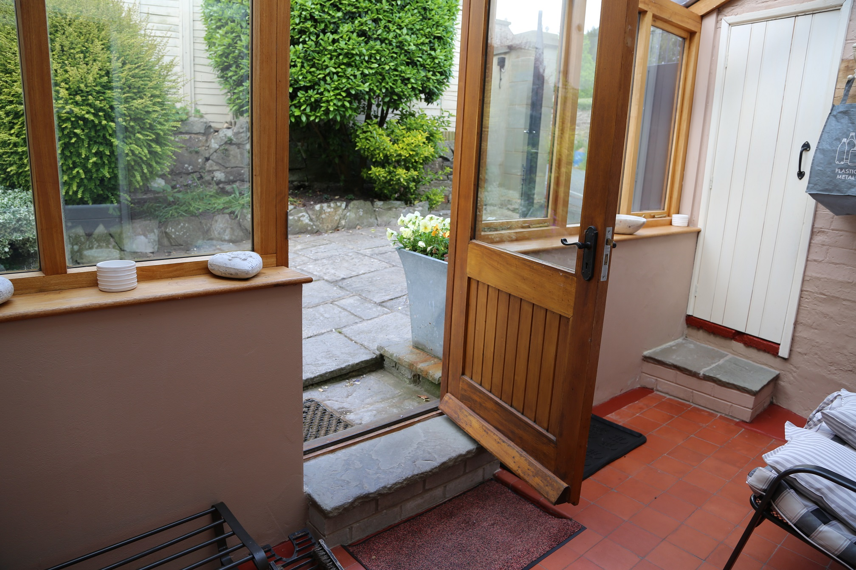

Access to the kitchen and laundry area is gained from the upper lounge/dining area. There is no change in floor level at these access points.

The stairs to the upper floor leave from the upper lounge/dining area. There are two carpeted steps onto a small landing. A further 10 open tread steps lead to the first floor. There is a hand-rail on each side of the open tread stairs and one hand-rail on the left of the two carpeted steps.
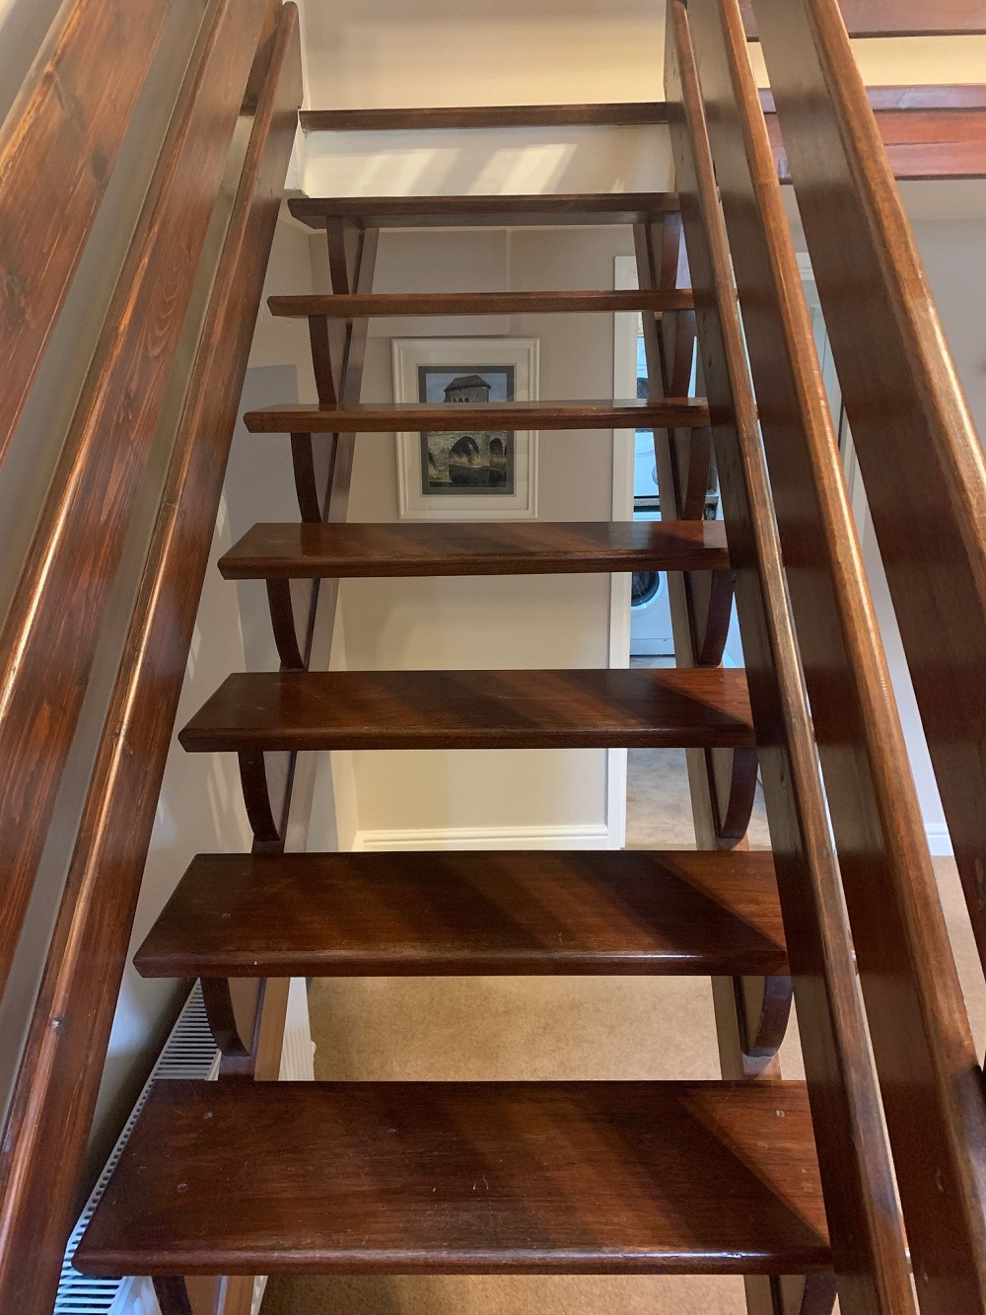

The Lower lounge is accessed down one carpeted step through a glazed door (75cm) and then down three carpeted steps to a wooden floor.

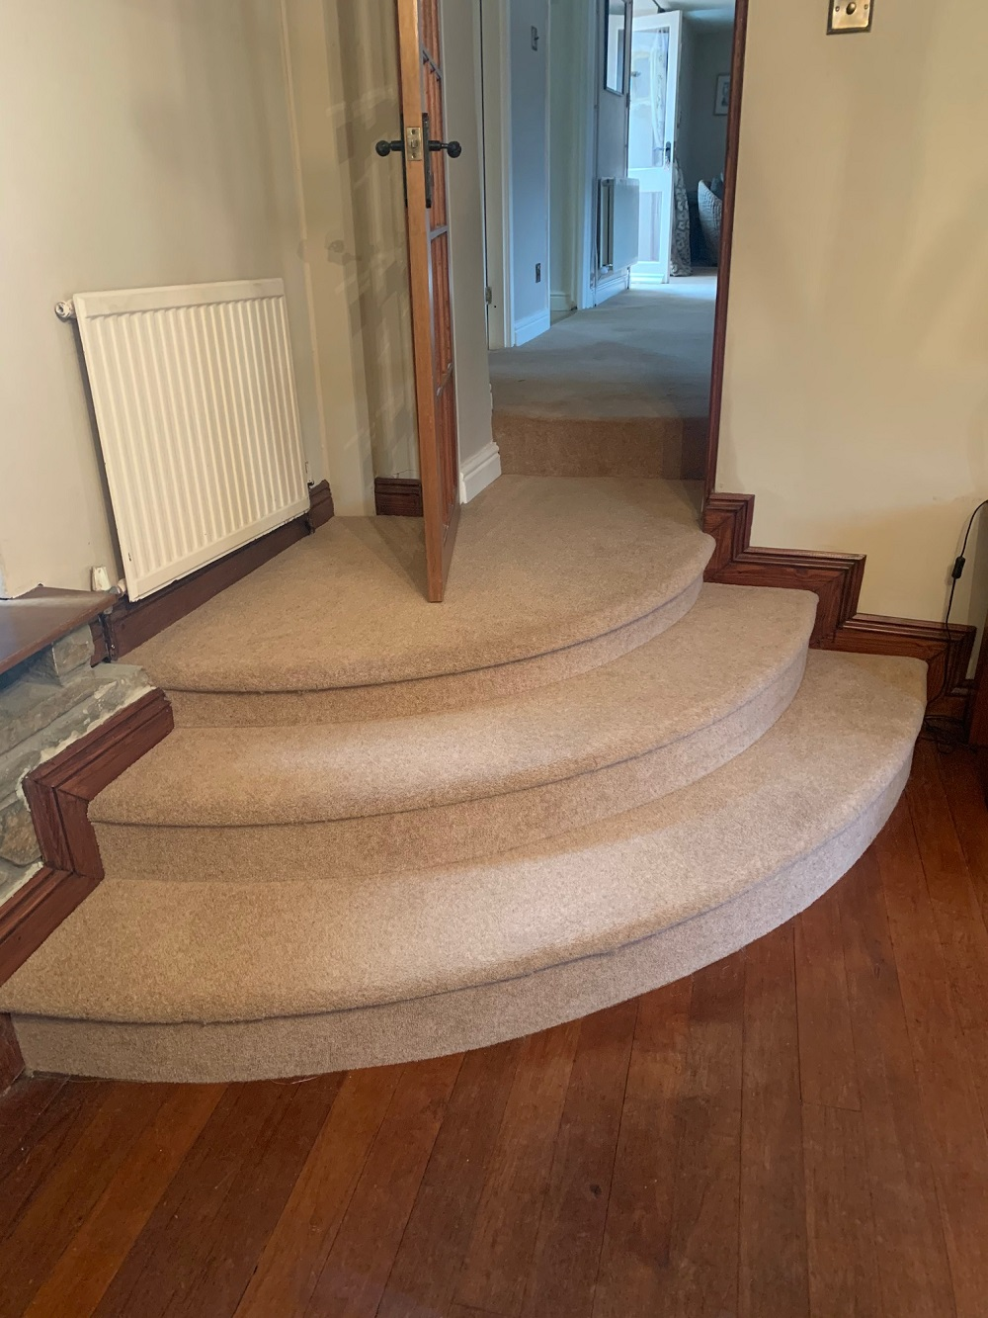

The door (58cm) to the ground floor toilet and bathroom area is accessed through an opening (65cm) from the lower lounge containing two stone steps up.

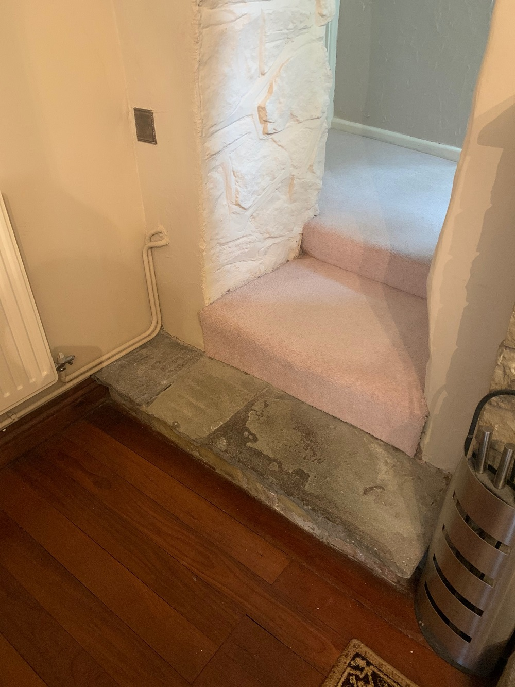

Access via Bedroom Three
Approximately 10 metres from lane and 6 metres from parking area
A gentle slope of paving leads to a door (83cm) directly into Bedroom Three onto a carpeted floor. Access to the bathroom is through the door (77cm) at the far end of the room and turn right to reach the bathroom door (58cm). There are two stone steps down through the opening (65cm) to the lower lounge.
This room suitable with someone with Limited mobility
.Accommodation Ground Floor
Upper Lounge & Dining Area
This has a seating area for 4-5 and a dining table which seats 8. There are 5 wall lights each with 60w bulbs, together with one ceiling halogen down-lighter over entrance door and one table light (60W). There is also a five-bulb (each 60W) ceiling light over the area to the stairs.

Kitchen
The access to the kitchen is open (100cm). There are two halogen ceiling lights and under-shelf lighting. Ample natural light fills this room during daylight. The kitchen floor is wood laminate. The fridge and oven are integrated into the Kitchen units and are at waist level. The dishwasher is at floor level. The kettle is cordless.

Laundry Room
Door (66cm). Laundry room has a floor-mounted washing machine and a work-surface-height vented tumble dryer. One ceiling 60w light and vinyl sheet non slip flooring.

Lower lounge
Door (75cm). Has seating for 6-8. Open fireplace (log-burning), wooden floor, 3-bulb (each 60w) ceiling light, 1 table-light and 1 double reading light.

Ground-Floor Bathroom
Has 1 WC, shower, hand-basin, 3 LED down lighters and separate mirror light. tiled floor.

Bedroom Three
This room has one ceiling light, (60w) two bedside table-lights, light on Dressing table and a floor-standing light.

Upper accommodation
There is a wooden galleried landing. To the left from this landing is access via two steps down to:

Bedroom Two
Door (76cm) This room has one ceiling light (60w), two bedside table-lights and one mirror light.

Bedroom One
Door (75cm) is at the opposite end of the landing. This room has two ceiling lights (60w) and two bedside table lights and light on dressing table.

First Floor Bathroom
This room has four ceiling lights and one mirror light. The floor is fully tiled. There is a separate 1.1m x 0.76m shower unit. There is a double ended bath and a hand-basin. 4 LED lights. Door (70cm) gives access to cupboard containing boiler unit.

Generally

All internal walls are painted in crown emulsion and the wood work in eggshell.

The property is fully centrally heated using a propane gas combi-boiler.

The outside area is paved and with mature flower beds.

All areas are considered well lit – with more lighting than is required by Visit England.

************************

Help with handling of luggage can be made available

Written material can be enlarged if required

Assistance Dogs Welcome

