Freedom Town Board 2019
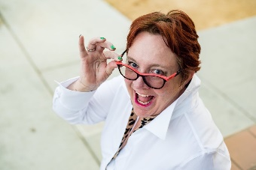Diane Erihg is a healer on all fronts! While she is a medical nurse, she has an incredible understanding of spiritual and self-healing! Her family is no stranger to off grid living and self-reliance so she brings knowledge, experience and healing to this movement!
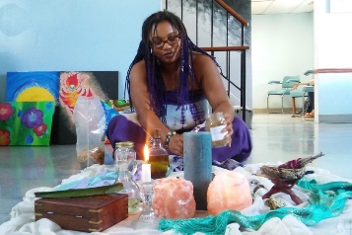Nicole Fullard will bring light love and energy to this movement for sure! She is all about everything natural and works with Gaia to create and bring forth greatness! Excited to build with her indeed!
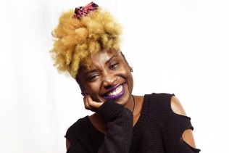 Crystal Quarles is an artist with an herbal flare and passion for spirituality and sovereign! We are so excited for the great energy and skills she brings to this movement!
Moushira Carter known as Moe is an aid to special needs children full time and has many connections in the community that will play a key role in finding resources for our builds and she is a loyal supporter turned team member!
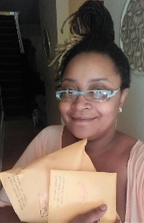I am Sweetie Cheresse Hamlett the organizer Of the Freedom Town Movement for Sovereignty through Conscious Living and Sweetie Consulting. Since 2004 I have been an advocate for natural solutions for home health and beauty and now, I am a master gardener and the proud initiator of this movement to educate and create a sustainable world!

