Three Year Policy Review Cycle
2014+
Board of Management Scoil Bhríde Nurney
2014+
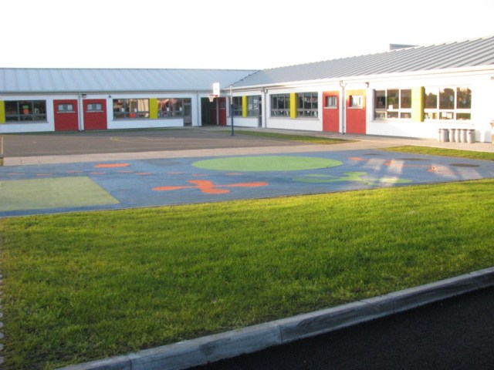
YEAR ‘A’

Sept: 2014, 2017, 2020, 2023, 2026, 2029, 2032, 2035 etc.

- Child Protection Policy
- Anti - Bullying Policy
- Supervision policy
- Attendance policy
- Code of behaviour policy
- Commercialism policy
- Complaints policy
- EPV days policy
- Mobile phone and electronic devices policy
- Party invitation policy
- Safety statement
- School accident and first aid policy
- Substance use policy
- Acceptable Internet Use policy

YEAR ‘B’

Sept: 2015, 2018, 2021, 2024, 2027, 2030, 2033, 2036 etc.

- Child Protection Policy
- Anti - Bullying Policy
- Administration of medicines policy
- Work experience / Teaching practice policy
- SEN – Learning language support and resource teaching (support teaching) policy
- CCTV policy
- Custody / access / separation policy
- Class and classroom allocation policy
- Data protection policy
- Education management software policy
- Exemption from Irish policy
- School transport policy
- Special needs assistant policy

YEAR ‘C’

Sept: 2016, 2019, 2022, 2025, 2028, 2031, 2034, 2037 etc.

- Child Protection Policy
- Anti - Bullying Policy
- Admissions and enrolment policy
- RSE policy
- SPHE policy
- Maths policy
- Assessment policy
- Book rental scheme policy
- Parents as partners policy
- Use of school premises policy
- SEN policy
- Assistive Technology policy
- School Prefect policy
- Whistle Blower policy

YEAR ‘D’

Sept: 2017, 2020, 2023, 2026, 2029, 2032, 2035, 2038 etc.

- Child Protection Policy
- Anti - Bullying Policy
- ?

YEAR ‘E’

Sept: 2018, 2021, 2024, 2027, 2030, 2033, 2036, 2039 etc.

- Child Protection Policy
- Anti - Bullying Policy
- ?

YEAR ‘F’

Sept: 2019, 2022, 2025, 2028, 2031, 2034, 2037, 2040 etc.

- Child Protection Policy
- Anti - Bullying Policy
- ?

YEAR ‘G’

Sept: 2020, 2023, 2026, 2029, 2032, 2035, 2038, 2041 etc.

- Child Protection Policy
- Anti - Bullying Policy
- ?

Ratification of “Three Year Policy Review Cycle”

This policy was adopted by the Board of Management on _________________

Signed: _________________________ Signed: __________________________
Chairperson of Board of Management Principal

Date: __________________________ Date: __________________________

Date of next review: __________________

