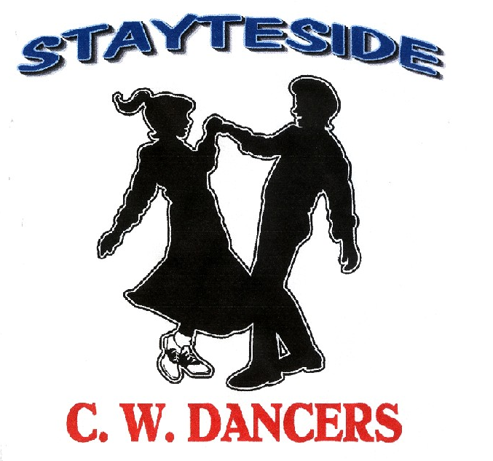

A Dollar Short

Description: Partner Dance. (64 Counts)
Start position: Right Open Promenade, holding inside hands, facing LOD. Opposite footwork throughout.
Choreographer: Carol* & George Stayte. (UK) * Fully Qualified D & G Instructor. 02392 423925 carol.stayte@ntlworld.com
Music: “Two Weeks Late” by Ashley Monroe. CD: Like a Rose. (115Bpm) Intro: 16 Count.
Alternative: “Carmen” by Gene Watson. CD: Best of the Best. (114Bpm) Intro: 32 Count.
“Sunshine” by Charlie Landsborough. CD: Movin’ On. (110Bpm) Intro: 16 Count.
Tracks available from iTunes And Amazon

GENT: LADY:

1 BOTH: 1/4 TURN TOUCH. 1/4 TURN. BRUSH FORWARD. WALK FORWARD (X3). POINT
1 – 4 ¼ turn on right, touch left next to right. (Face to Face) ¼ turn left on left, touch right next to left.
¼ turn left on left brush right fwd. LOD ¼ turn right on right, brush left fwd. LOD
5 – 8 Step fwd on right, left, right, point left to left side. Step fwd on left, right, left, point right to right side.
Note: Count: 1 – 4 Tap Gent’s Left to Lady’s right hand.

2 BOTH: CROSS, SIDE, CROSS, POINT. (X2). (CHANGING SIDES)
1 – 4 Step left behind right, to side on right, step left over right. Step right over left, to side on left, step right behind left. Point right to right side. (Changing sides) Point left to left side. (Changing sides)
5 – 8 Step right behind left, to side on left, step right over left. Step left over right, to side on right, step left behind right.
Point left to left side. (Changing sides) Point right to right side. (Changing sides)
Note: Count: 1 – 4 (Gent Travelling behind Lady) Release hands, rejoin Gents left, Lady’s right, (Inside Hands)
Count: 5 – 8 (Gent Travelling behind Lady) Release hands rejoin Gent’s right, Lady’s Left, (Inside Hands)

3 BOTH: ROCK 1/2 TURN. STEP FORWARD BRUSH. STEP PIVOT 1/2 TURN. STEP FORWARD, HOLD.
1 – 4 Rock fwd on left, recover on right. Rock fwd on right, recover on left.
½ turn left stepping fwd on left, brush right fwd. RLOD ½ turn right stepping fwd on right, brush left fwd. RLOD
5 – 8 Step fwd on right, pivot ½ turn left, step fwd on right. Hold. LOD Step fwd on left, pivot ½ turn right, step fwd on left. Hold. LOD
Note: Count: 1 – 4 Release Hands. Count: 5 – 8 Rejoin inside hands.

4 BOTH: STEP LOCK STEP. BRUSH. JAZ BOX, 1/4 TURN. TOUCH.

1 – 4 Step fwd on left, lock right behind left. Step fwd on right, lock left behind right.

Step fwd on left, brush right fwd. Step fwd on right, brush left fwd.

5 – 8 Cross right over left, step back on left, Cross left over right, step back on right.

¼ turn right on right, touch left next to right. ¼ turn left on left, touch right next to left.
Note: Count: 5 – 8 Rejoin hands into double hand hold. (Face to Face)

5 GENT: LEFT VINE. TOUCH. RIGHT VINE. TOUCH. LADY: RIGHT VINE TOUCH. FULL TURN. TOUCH.
1 – 4 Step to the side on left, right behind left, side on left. Step to the side on right, left behind right, side on right.
Touch right next to left. Touch left next to right.
5 – 8 Step to the side on right, left behind right, side on right. Full turn left on left, right, left, touch right next to left.
Touch left next to right.
Note: Count: 5 – 8 Release Gent’s left hand, Lady’s right. Lady turning under joined hands.

6 BOTH: BACK ROCK 1/4 TURN. BRUSH FORWARD. CROSS ROCK SIDE. HOLD.
1 – 4 Rock back on left, recover on right, ¼ turn left on left. Rock back on right, recover on left, ¼ turn right on right.
Brush right fwd. LOD Brush left fwd. LOD
5 – 8 Rock right over left, recover on left, step to side on right. Hold. Rock left over right, recover on right, step to side on left. Hold.

7 CROSS ROCK 1/4 TURN. HOLD. STEP PIVOT 1/2 TURN. STEP FORWARD. HOLD.
1 – 4 Rock left over right, recover on right, ¼ turn left on left. ILOD. Hold. Rock right over left, recover on left, ¼ turn right on right. OLOD. Hold.
5 – 8 Step fwd on right, pivot ½ turn left, step fwd on right. Hold. Step fwd on left, pivot ½ turn right, step fwd on left. Hold.
Note: Count: 1 – 4 Release hands.
Count: 5 – 8 Rejoin Gent’s right hand, Lady’s left. (Face to Face)

8 SIDE TOGETHER 1/4 TURN (LADY: 3/4 TURN). BRUSH FORWARD. ROCKING CHAIR.
1 – 4 Step to side on left, slide right next to left. ¼ turn left on stepping back on right, ½ turn left stepping fwd on left,
¼ turn left on left. Brush right fwd. LOD Step fwd on right, brush left fwd. LOD
5 – 8 Rock fwd on right, recover on left, rock back on right, recover on left. Rock fwd on left, recover on right, rock back on left, recover on right.
Note: Count: 1 – 4 Lady turning under joined hands, Gent’s right, Lady’s left, Count: 5 – 8 Inside Hand Hold.
START AGAIN

