
Breast Self Examination (BSE)
- Is done monthly
- 7-10 days from the first day of your period ... Same day every month if you are not menstruating
- LOOK and FEEL what is normal for you ... for any spontaneous change, see your health care professional without delay
- Record your observations and mark your calendar for BSE next month
- Make sure you compliment your BSE with a yearly physical exam of your breasts by a trained professional
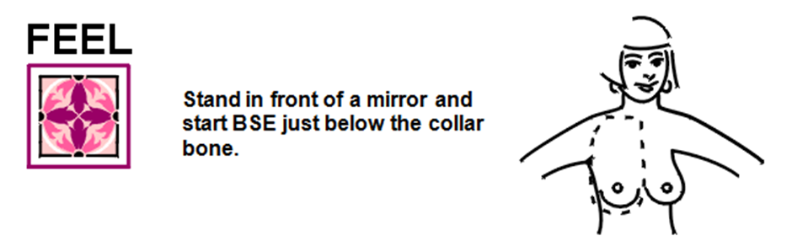

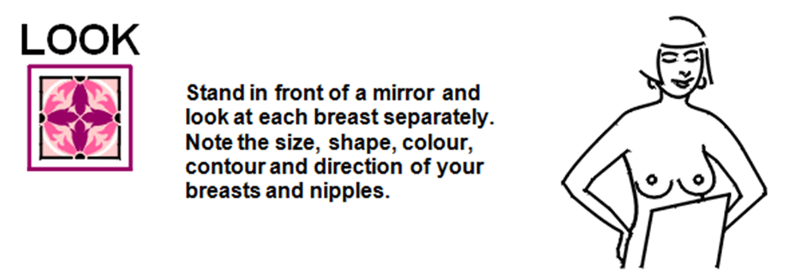

Stand in front of a mirror and look at each
breast separately. Note the size, shape, colour,
contour, and direction of your breasts and nipples.

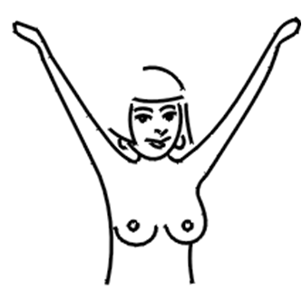

Raise your arms over your head and look at your
breasts, as you turn slowly from side to side.

Press your hands on your hips and push your
shoulders forward. Look at each breast separately.

For more information on the CAUSE & PREVENTION of Breast Cancer, contact:

Stand in front of a mirror and start BSE just below the
collar bone.

- Use the left hand for the right breast. Moisten
the pads of your three middle fingertips with
body lotion. Apply firm pressure and make small
circles as you go back and forth (up or down,
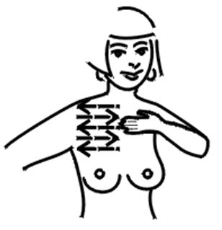
circular or spoke style) in a pattern covering
all the breast area, including the nipple.

- Extend the examination to the breast tissue in
the underarm.

- Change your hand and repeat BSE on the
opposite breast.
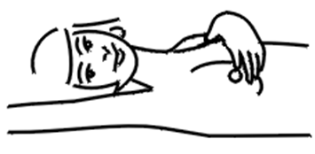
Lie down and raise one arm above your head. Examine
your breasts as before, omitting the underarm.

- Change your arm and repeat BSE on the opposite
breast.

